**GraphQL**

What is wrong with REST?

Imagine we have this task:

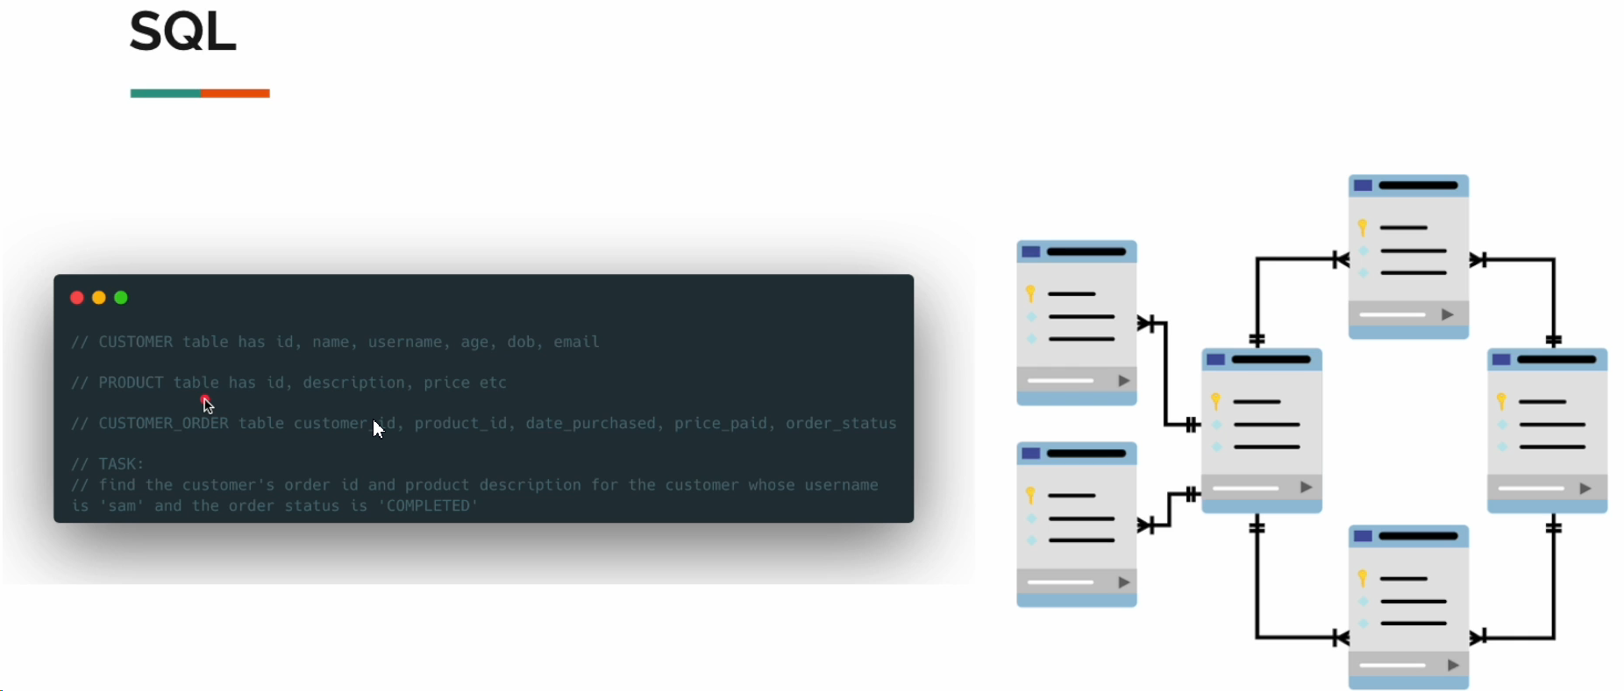

How the REST will do it is the way like this below:

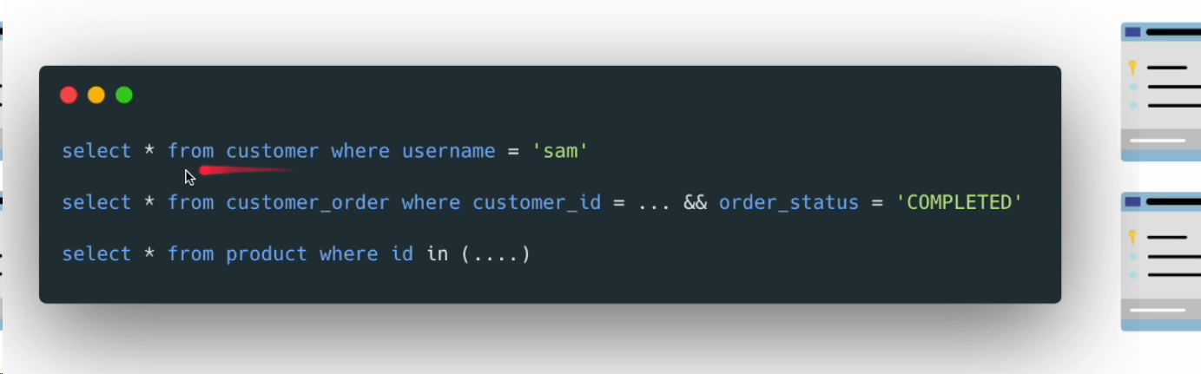

But we have better query:

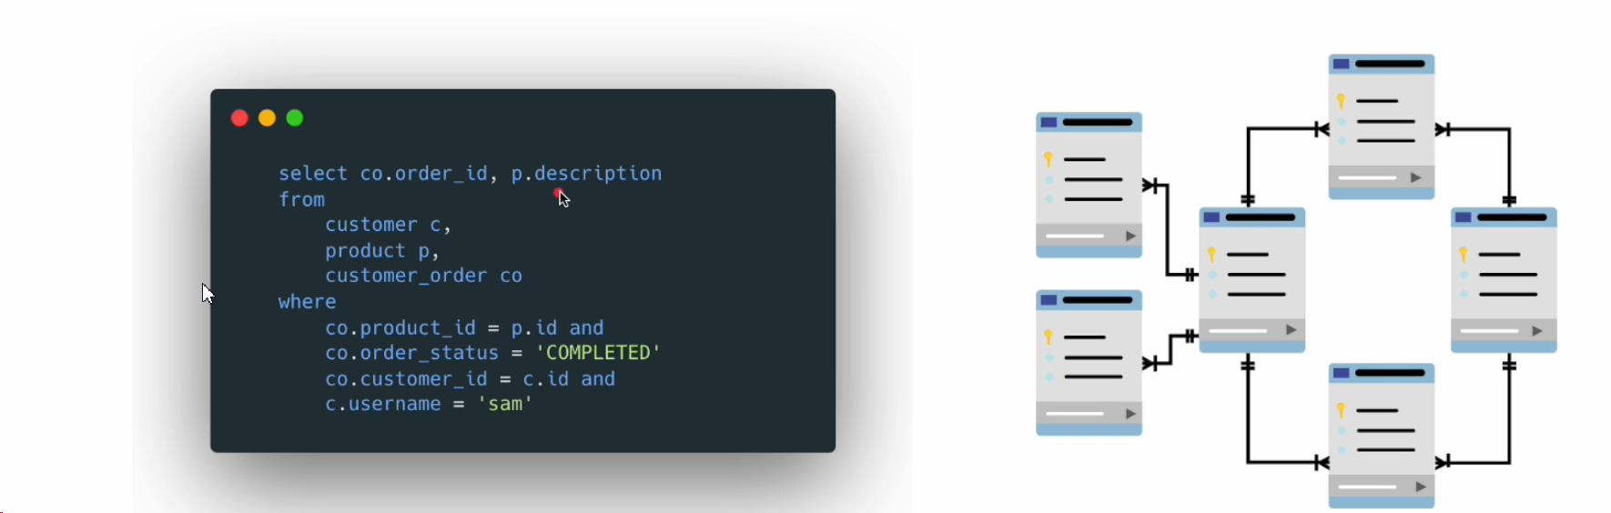

So, as per REST it is the more or less the same as previous query: And there is many back and forward communication on the back-end between server and client: it is called over fetching.

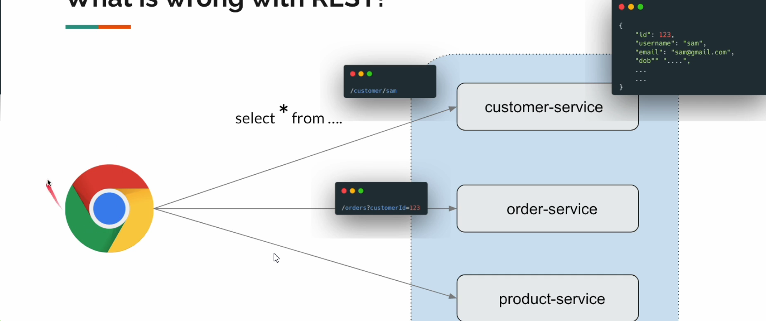

And the better way is GraphQL: Exactly what information we need.

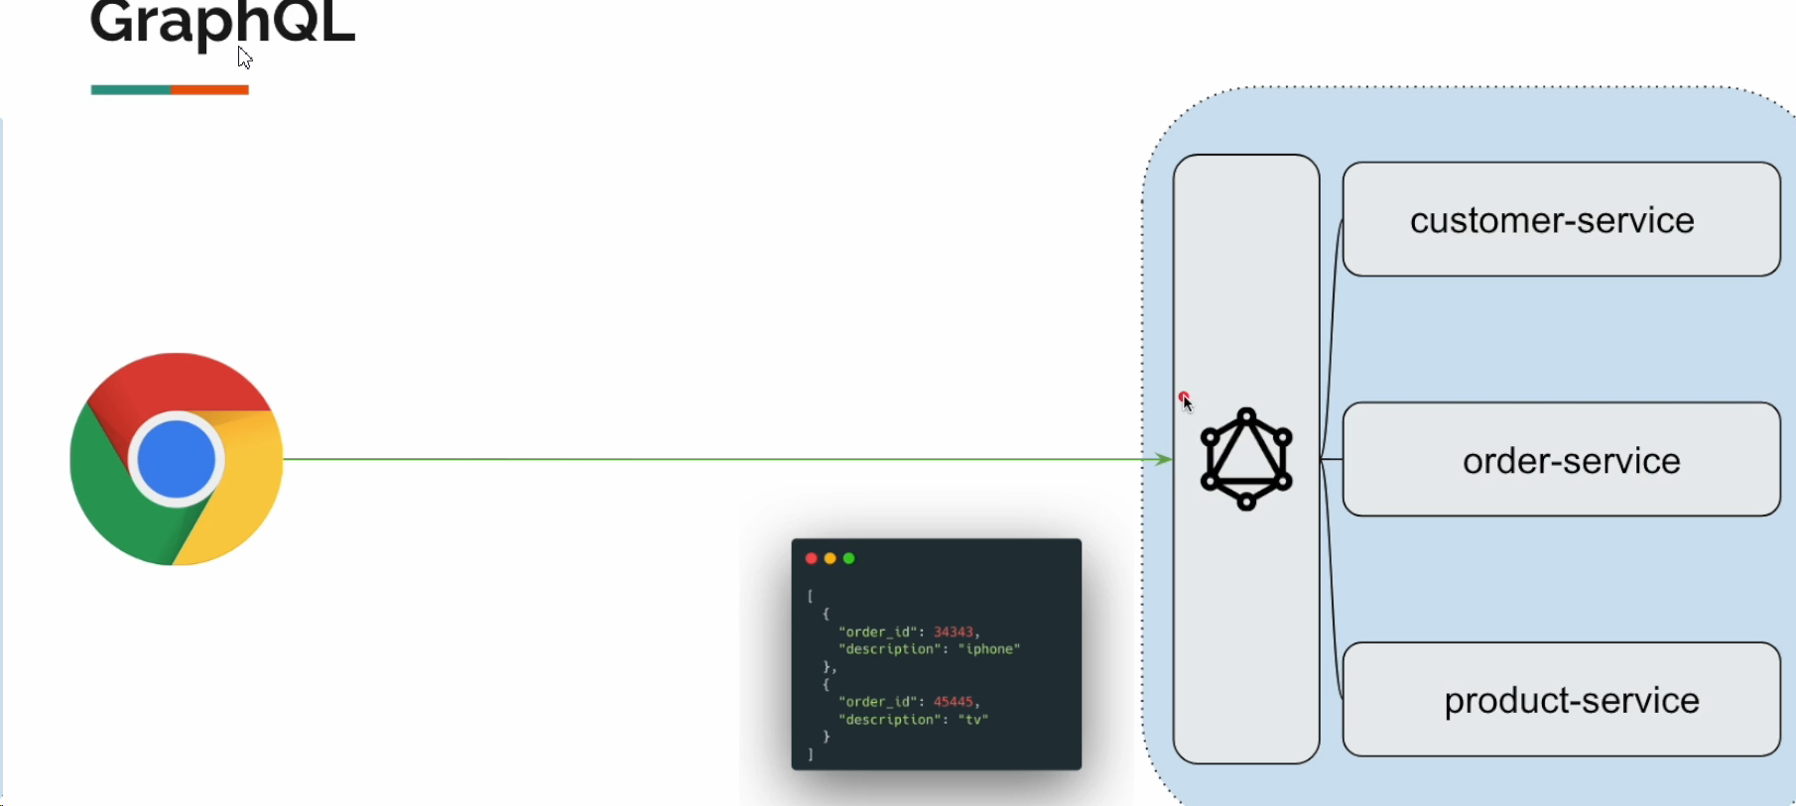

And as you see there is no back and forward calls between client and the server.

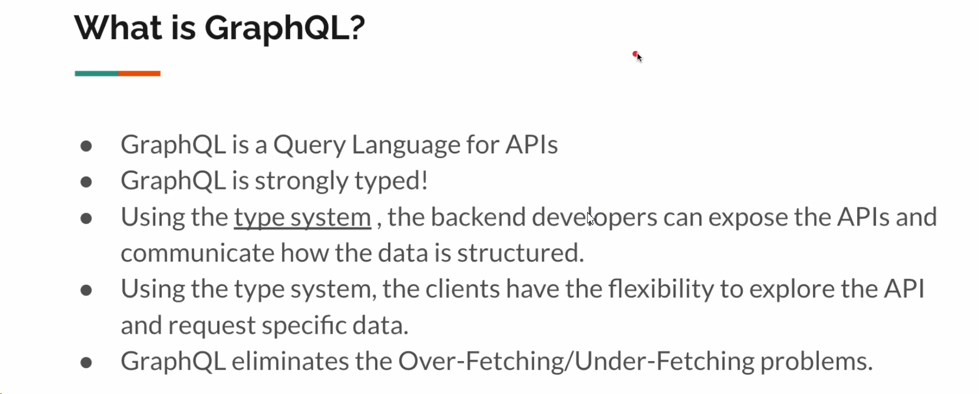

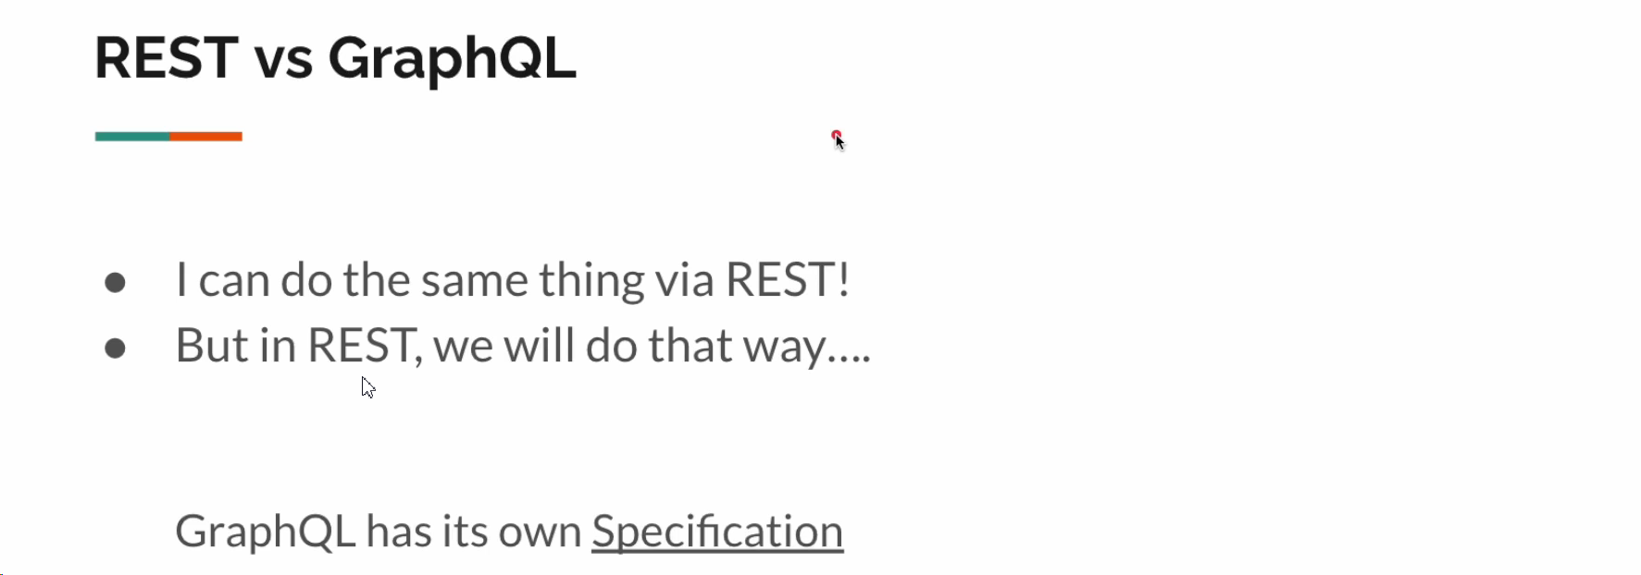

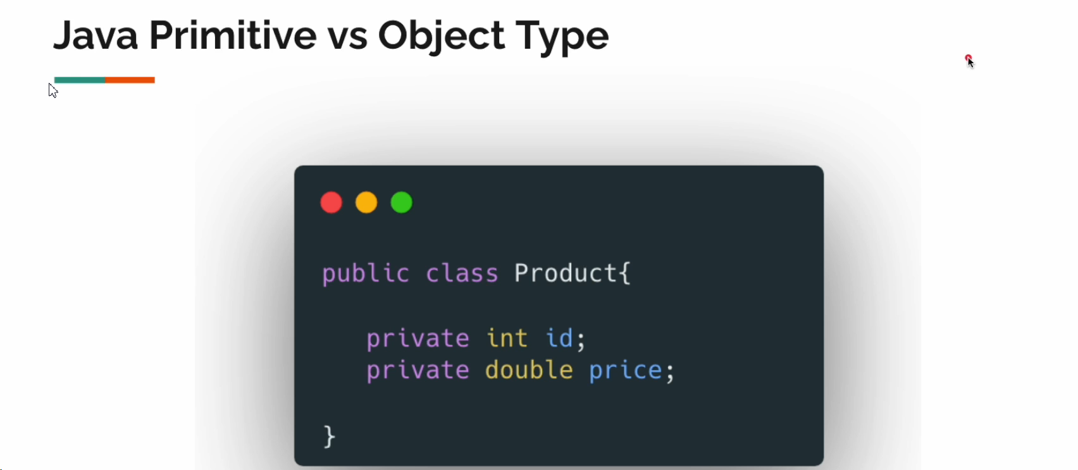

In GraphQL:

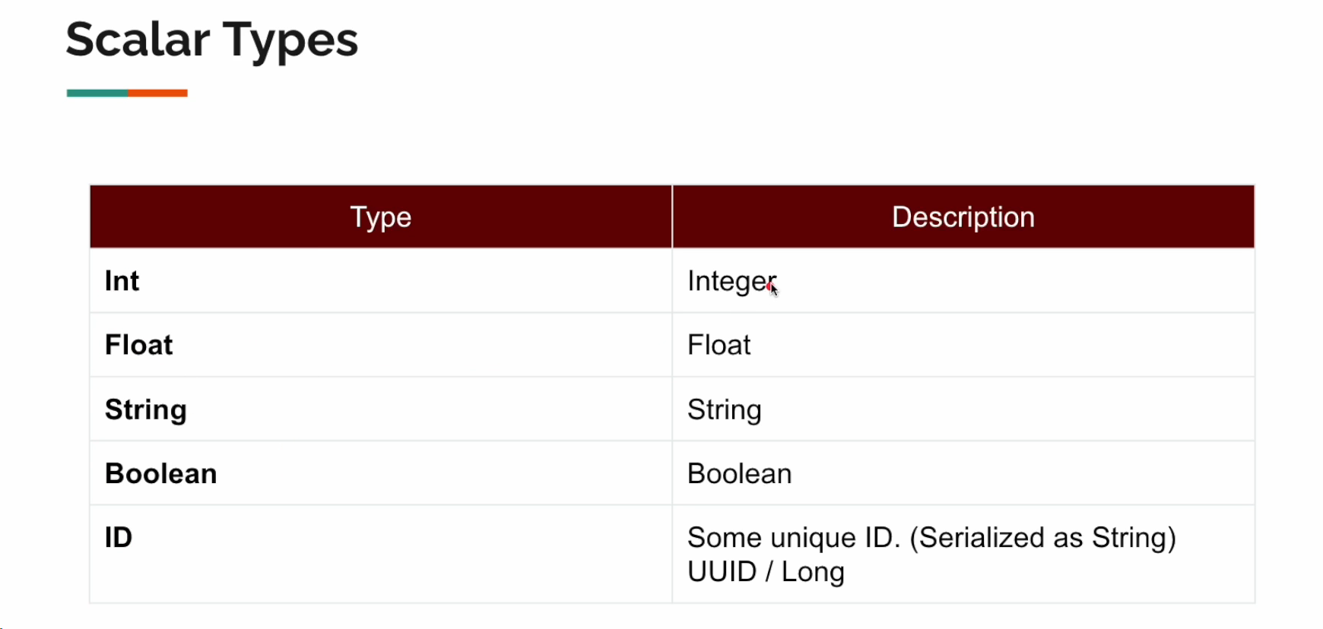

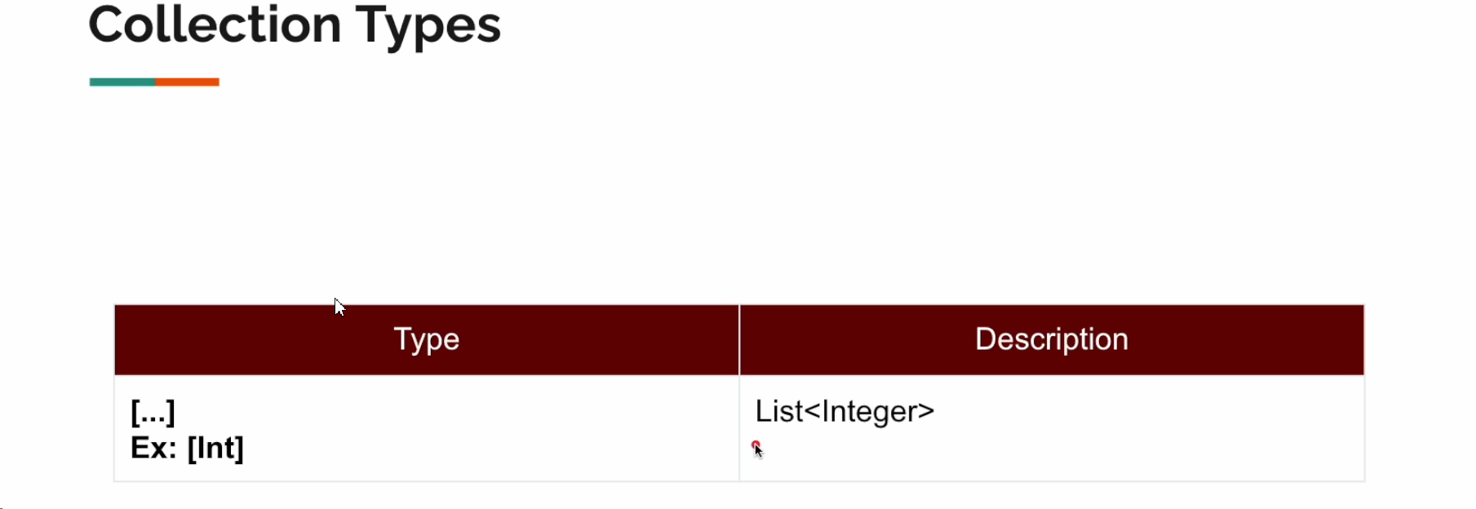

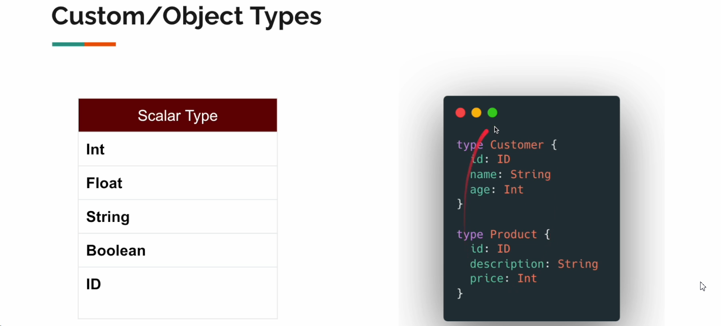

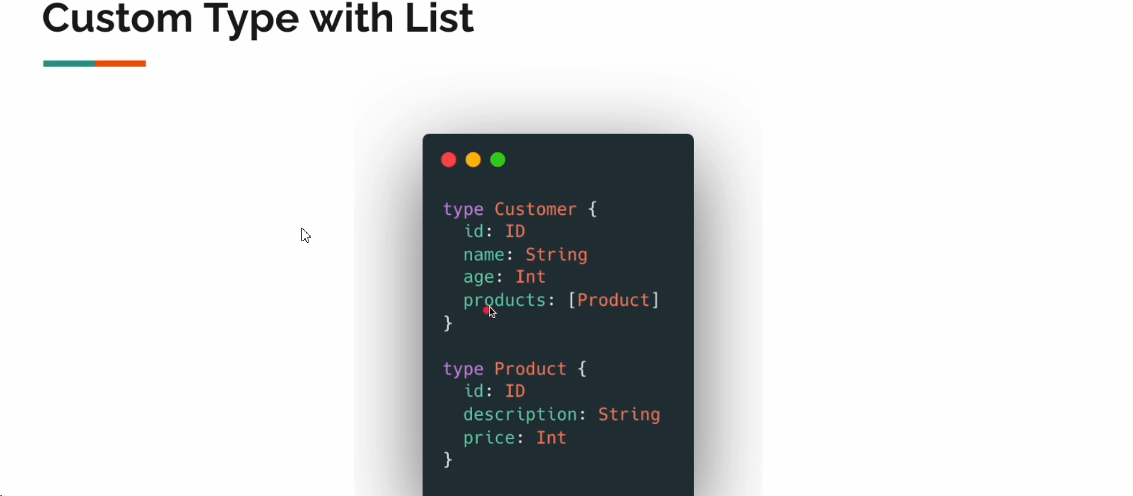

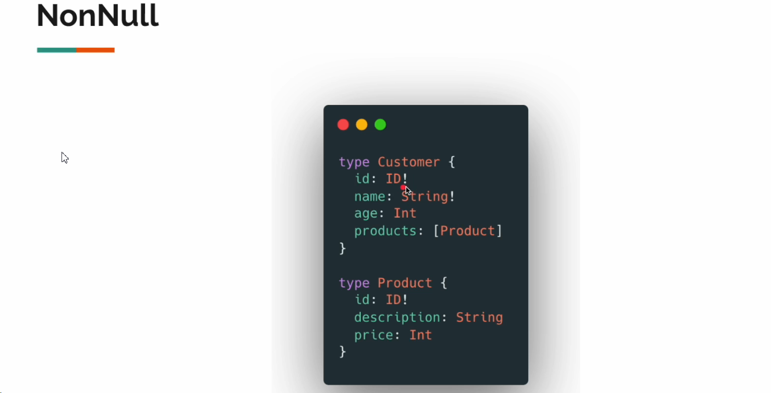

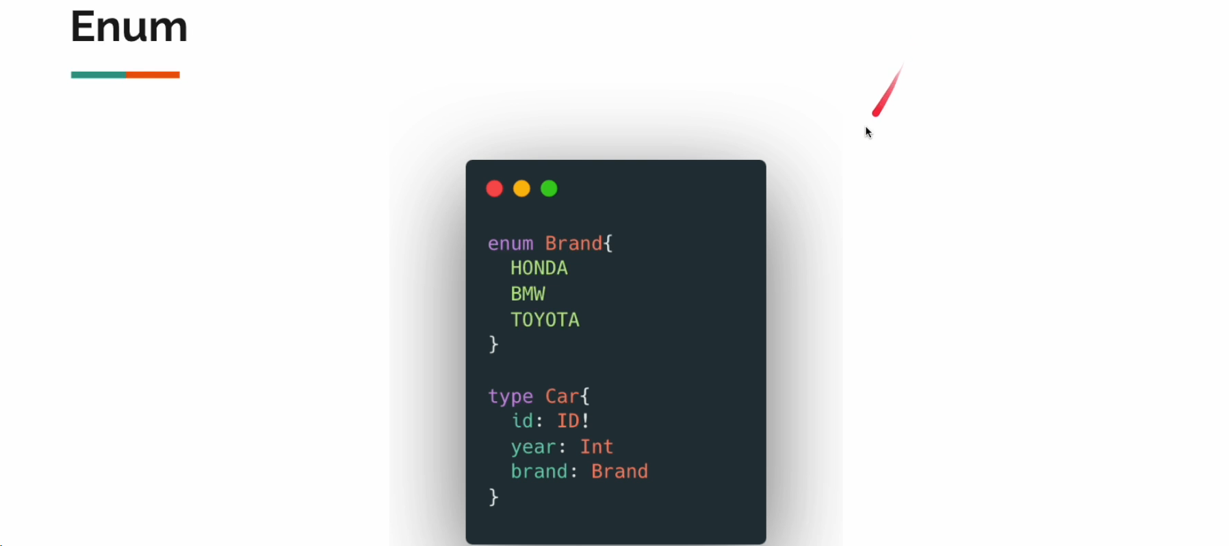

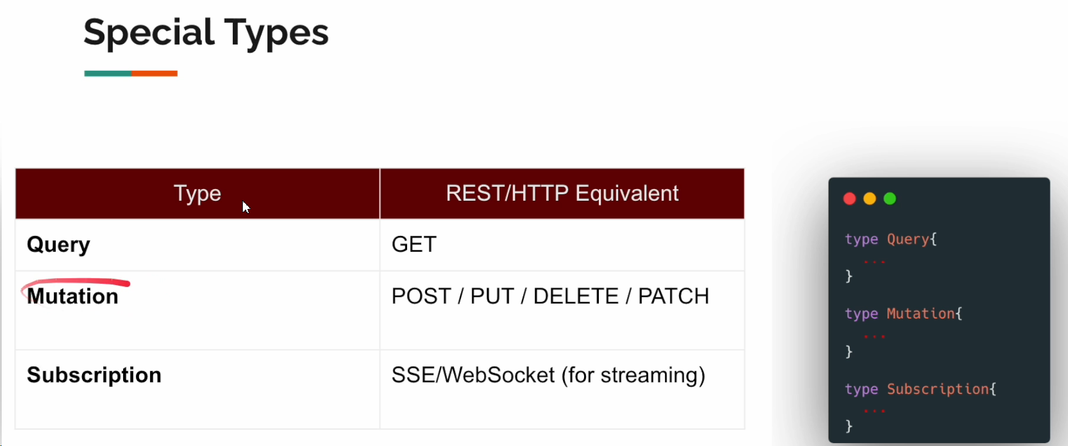

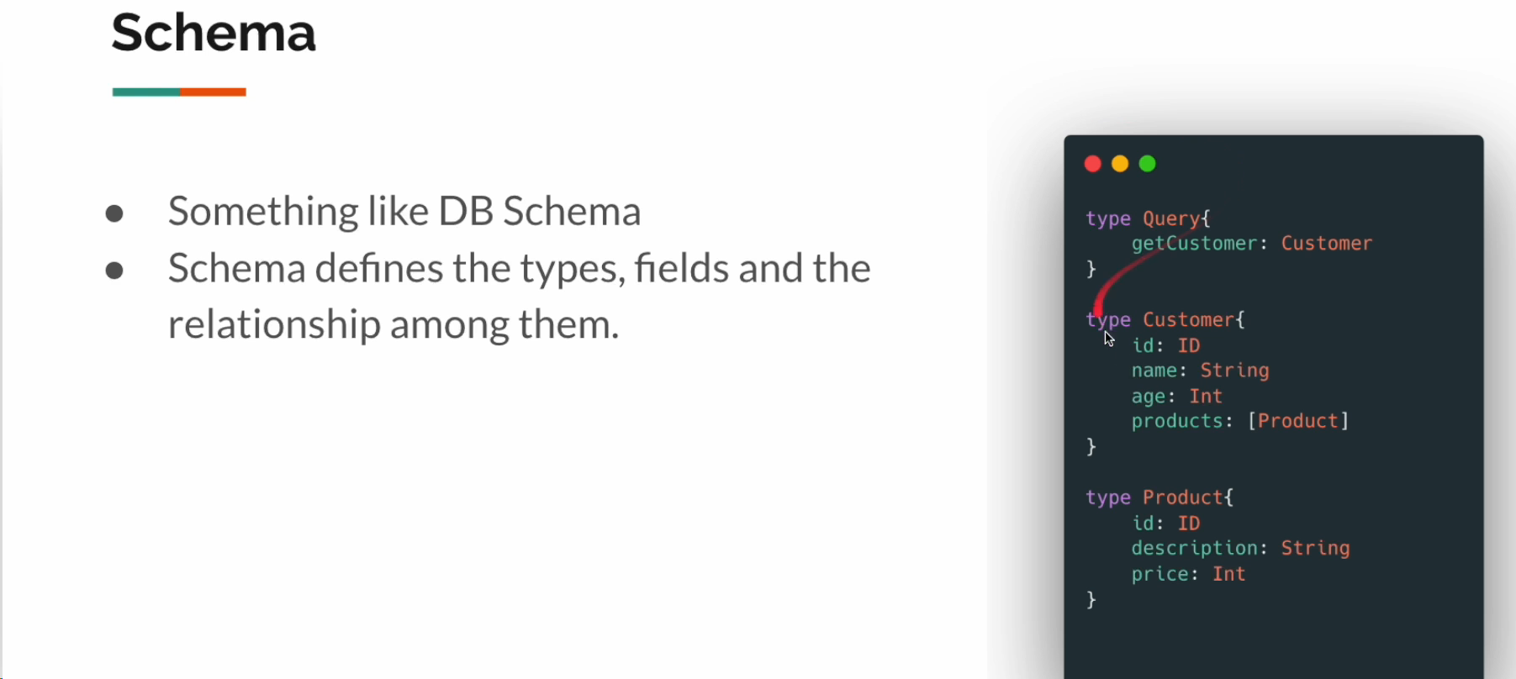

**Project Setup**

#graphql schema file location and it is default property  
spring.graphql.schema.locations=classpath:graphql  
#endpoint: like localhost:8080/graphql  
spring.graphql.path=/graphql  
  
  
#graphiql - user interface - playground  
spring.graphql.graphiql.enabled=true  
#endpoint  
spring.graphql.graphiql.path=/graphiql

Now we need to create schema.graphqls in the resources;

type Query{  
 sayHello: String!  
}

And now create controller class:

import org.springframework.graphql.data.method.annotation.QueryMapping;  
import org.springframework.stereotype.Controller;  
import reactor.core.publisher.Mono;  
  
@Controller  
public class GraphqlController {  
  
 @QueryMapping  
 public Mono<String> sayHello(){ //should be the same as in schema.graphql  
 return Mono.*just*("Hello");  
 }  
}

Now we can open our playground: <http://localhost:8080/graphiql>

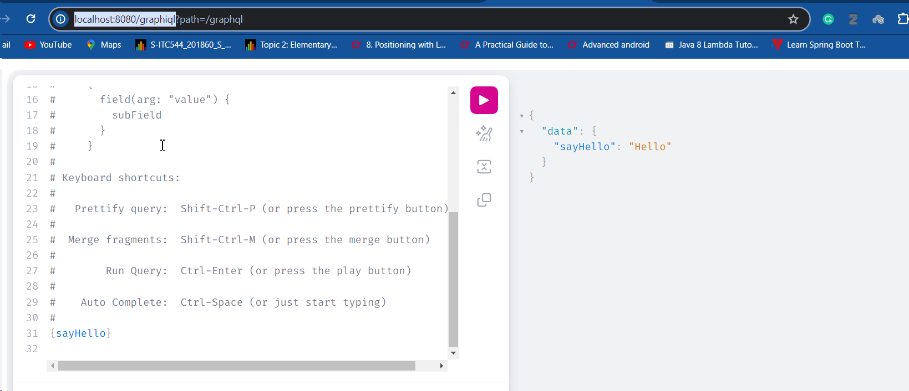

But as we said the name in the schema.graphqls must be the same as name of the method OR we must specify the name in The Annotation:

@Controller  
public class GraphqlController {  
  
 @QueryMapping("sayHello")

public Mono<String> sayHello2(){

return Mono.*just*("Hello");  
 }  
}

type Query{  
 sayHello: String  
}

We also can create the method with arguments:

@QueryMapping()  
public Mono<String> sayHelloTo(@Argument String name){  
 return Mono.*fromSupplier*(() ->"Hello" + name);  
}

And the schema:

type Query{  
 sayHello: String

sayHelloTo(name: String): String #http://localhost:8080/sayHello/{age}  
}

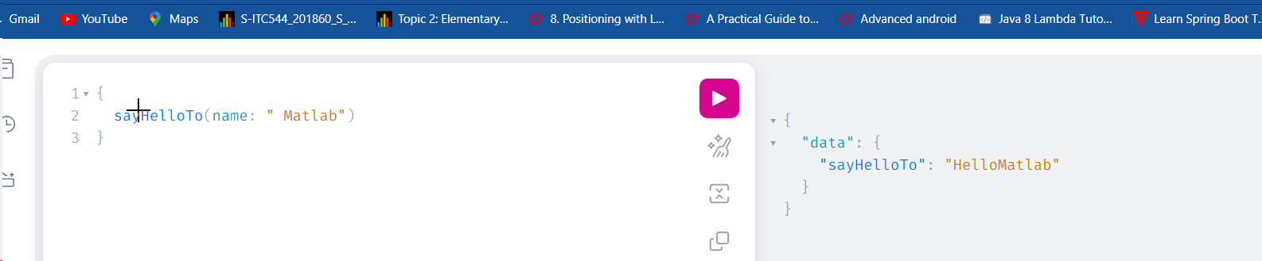

If the fields are different in the argument name, we need to specify it in the argument name as well:

@QueryMapping()  
public Mono<String> sayHelloTo(@Argument("name") String value){

return Mono.*fromSupplier*(() ->"Hello" + value);  
}

----------------------------------

type Query{  
 sayHello: String

sayHelloTo(name: String!): String #http://localhost:8080/sayHello/{age}  
}

[The best thing about the GraphQl is we can call all the API in once and without back and forward querying](#Multiple_Mutation):

If say we have 3 API:

type Query{  
 sayHello: String  
 sayHelloTo(name: String!): String #http://localhost:8080/sayHello/{age}  
 random: Int!  
}

@Controller  
public class GraphqlController {  
  
 @QueryMapping("sayHello")  
 public Mono<String> sayHello2(){  
 return Mono.*just*("Hello");  
 }  
  
 @QueryMapping()  
 public Mono<String> sayHelloTo(@Argument("name") String value){  
 return Mono.*fromSupplier*(() ->"Hello" + value);  
 }  
  
 @QueryMapping()  
 public Mono<Integer> random(){  
 return Mono.*just*(ThreadLocalRandom.*current*().nextInt(1, 100));  
 }  
}

Now we can call them in one call:

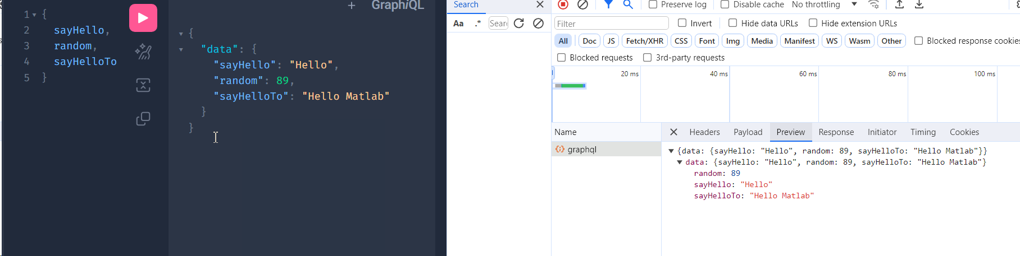

How QueryMapping works in GraphQL:

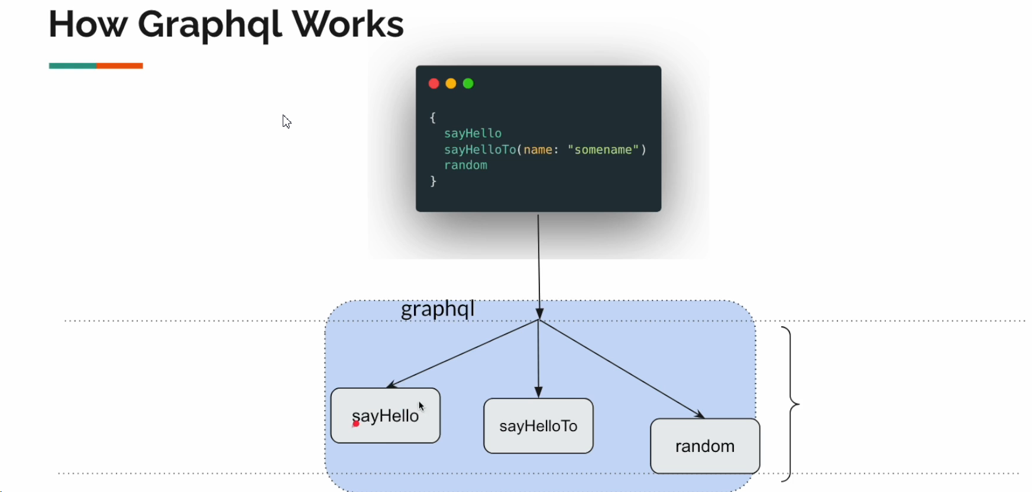

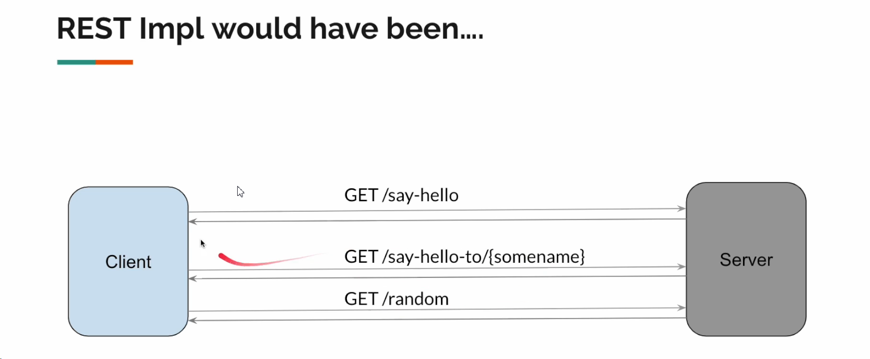

For example for fetching this, graphql needs maximum of 1.2 sec. So, all the API request will be in parallel and it will be collected in the top and returned as a one response.

@Controller  
public class GraphqlController {  
  
 @QueryMapping("sayHello")  
 public Mono<String> sayHello2(){  
 return Mono.*just*("Hello")  
 .delayElement(Duration.*ofMillis*(1000));  
 }  
  
 @QueryMapping()  
 public Mono<String> sayHelloTo(@Argument("name") String value){  
 return Mono.*fromSupplier*(() ->"Hello" + value)  
 .delayElement(Duration.*ofMillis*(800));  
 }  
  
 @QueryMapping()  
 public Mono<Integer> random(){  
 return Mono.*just*(ThreadLocalRandom.*current*().nextInt(1, 100))  
 .delayElement(Duration.*ofMillis*(1200));  
 }  
}

**Custom type With GraphQL:**

**Schema:**

type Query {  
 #use this to fetch all customers  
 customers: [Customer!]!  
 #Get Customer by id  
 customerById(id: ID!): Customer!  
 #filtered customers by name  
 customersNameContains(name: String!): [Customer!]  
}  
  
  
type Customer{  
 id: Int,  
 name: String,  
 age: Int,  
 city: String  
}

**Entity**

@Data  
@NoArgsConstructor  
@AllArgsConstructor(staticName = "create")  
public class Customer {  
  
 private Integer id;  
 private String name;  
 private Integer age;  
 private String city;  
}  
  
//(staticName = "create"): This part of the annotation specifies that a static factory method named create  
// should be generated along with the constructor. The staticName attribute allows you to specify  
// the name of the static factory method.  
//  
//So, with @AllArgsConstructor(staticName = "create"), the generated code includes not only the constructor  
// but also a static factory method like this:  
//  
//java  
//public static Customer create(Integer id, String name, Integer age, String city) {  
// return new Customer(id, name, age, city);  
//}

**Controller**

import com.graphql.praphqlplay.sec01.lec02.entity.Customer;  
import com.graphql.praphqlplay.sec01.lec02.service.CustomerService;  
import org.springframework.beans.factory.annotation.Autowired;  
import org.springframework.graphql.data.method.annotation.Argument;  
import org.springframework.graphql.data.method.annotation.QueryMapping;  
import org.springframework.stereotype.Controller;  
import reactor.core.publisher.Flux;  
import reactor.core.publisher.Mono;  
  
@Controller  
public class CustomerController {  
  
 @Autowired  
 private CustomerService service;  
  
 @QueryMapping  
 public Flux<Customer> customers(){  
 return this.service.allCustomers();  
 }  
  
 @QueryMapping  
 public Mono<Customer> customerById(@Argument Integer id){  
 return this.service.customerById(id);  
 }  
  
 @QueryMapping  
 public Flux<Customer> customersNameContains(@Argument String name){  
 return this.service.nameContains(name);  
 }  
}

**Service.class**

@Service  
public class CustomerService {  
 private final Flux<Customer> flux = Flux.*just*(  
 Customer.*create*(1, "sam", 20, "Wollongong"),  
 Customer.*create*(2, "Josh", 20, "BlackTown"),  
 Customer.*create*(3, "Ota", 20, "Parramatta"),  
 Customer.*create*(4, "Jaym", 20, "CBD")  
 );  
 public Flux<Customer> allCustomers(){  
 return flux;  
 }  
 public Mono<Customer> customerById(Integer id) {  
 return flux.filter(c -> c.getId().equals(id))  
 .next();  
 }  
 public Flux<Customer> nameContains(String name){  
 return flux.filter(c -> c.getName().equals(name));  
 }  
}

Now we can Query our app:

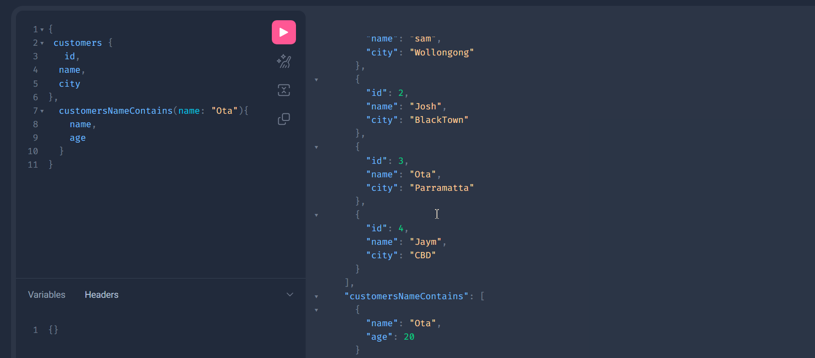

Special type - > **INPUT:**

Imagine we have many input arguments. But we can use “input” type for this scenario:

Here is what we want to achieve:

#filter customer by age  
customersByAgeRange(minAge: Int!, maxAge:Int!): [Customer]!

And here is the exact the same with input:

#filter customer by age  
# customersByAgeRange(minAge: Int!, maxAge:Int!): [Customer]!  
 customersByAgeRange(filter: AgeRangeFilter!): [Customer]!  
}  
  
input AgeRangeFilter{  
 minAge: Int!,  
 maxAge: Int!  
}

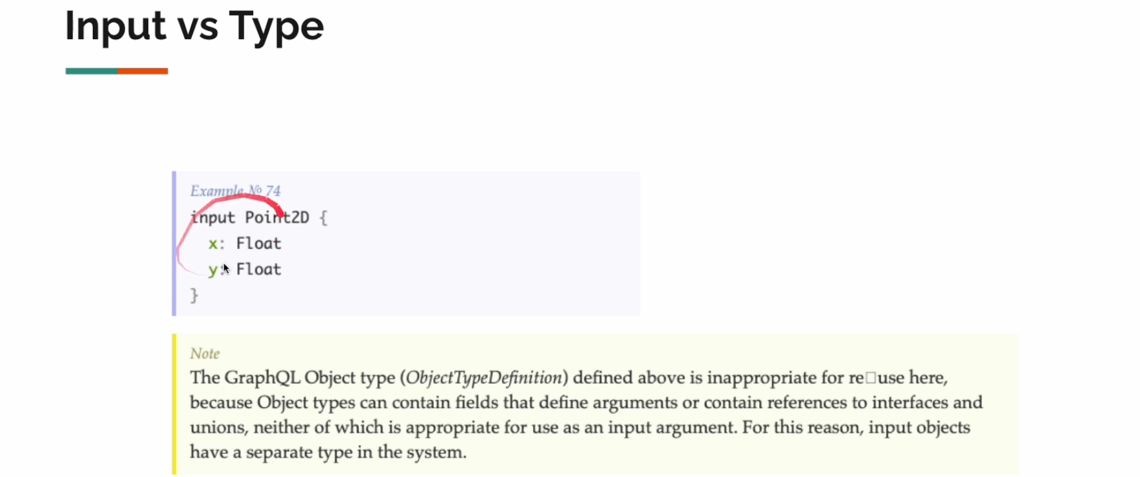

How we implemented it:

Entity.class:

@Data  
public class AgeRangeFilter {  
  
 private Integer minAge;  
 private Integer maxAge;  
}

Service:

public Flux<Customer> withinAge(AgeRangeFilter filter){  
 return flux  
 .filter(c -> c.getAge()>= filter.getMinAge() && c.getAge()<=filter.getMaxAge());  
}

@QueryMapping  
public Flux<Customer> customersByAgeRange(@Argument AgeRangeFilter filter){  
 return this.service.withinAge(filter);  
}

Now our demo in Playground:

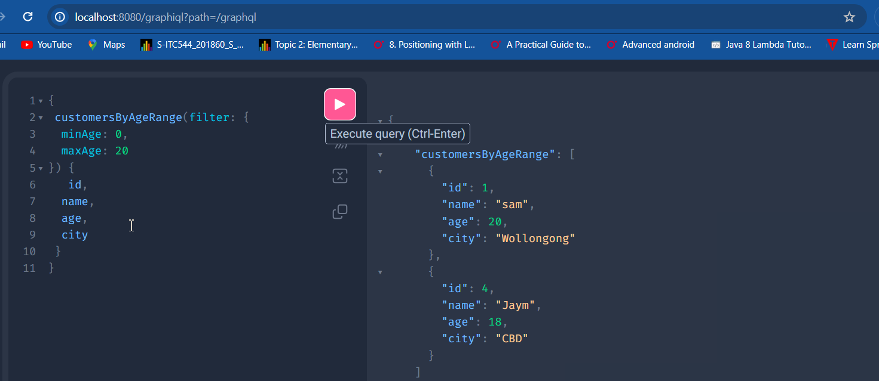

**Nested Objects:**

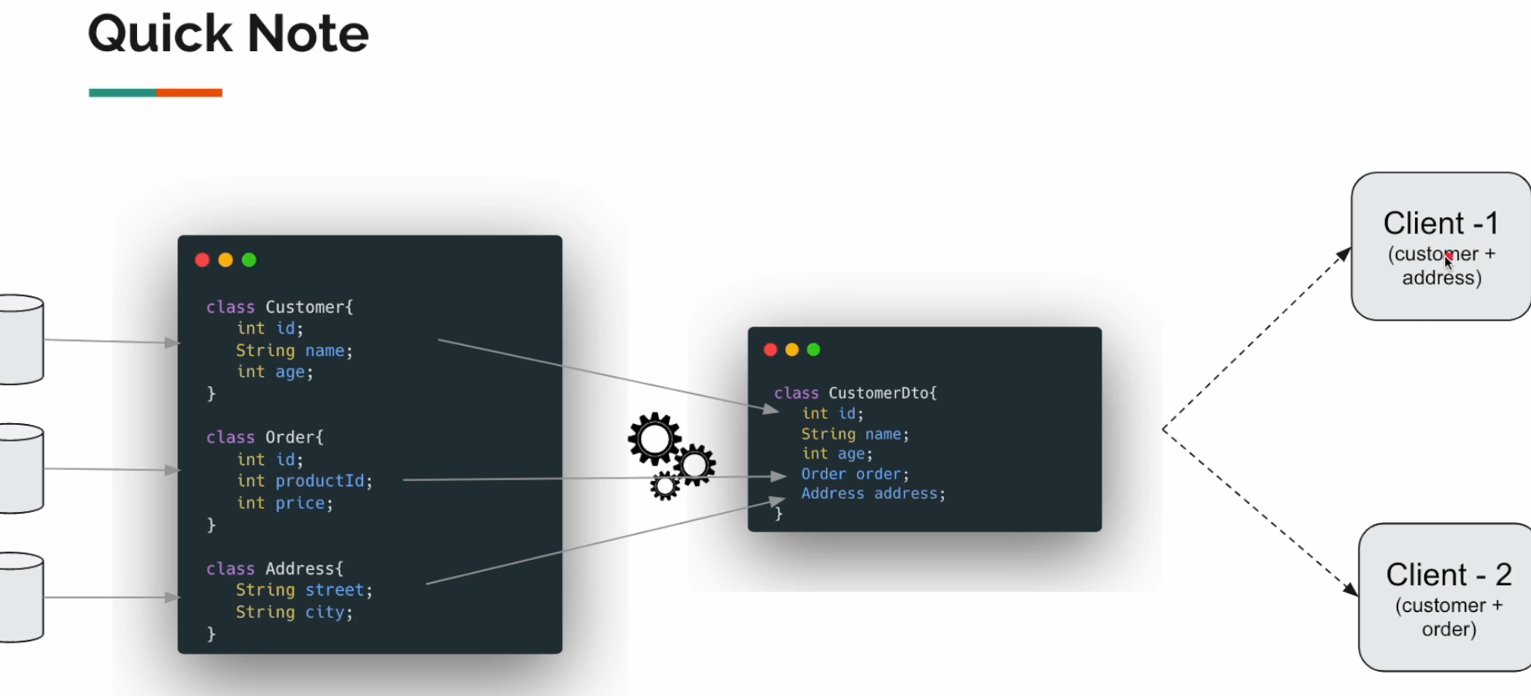

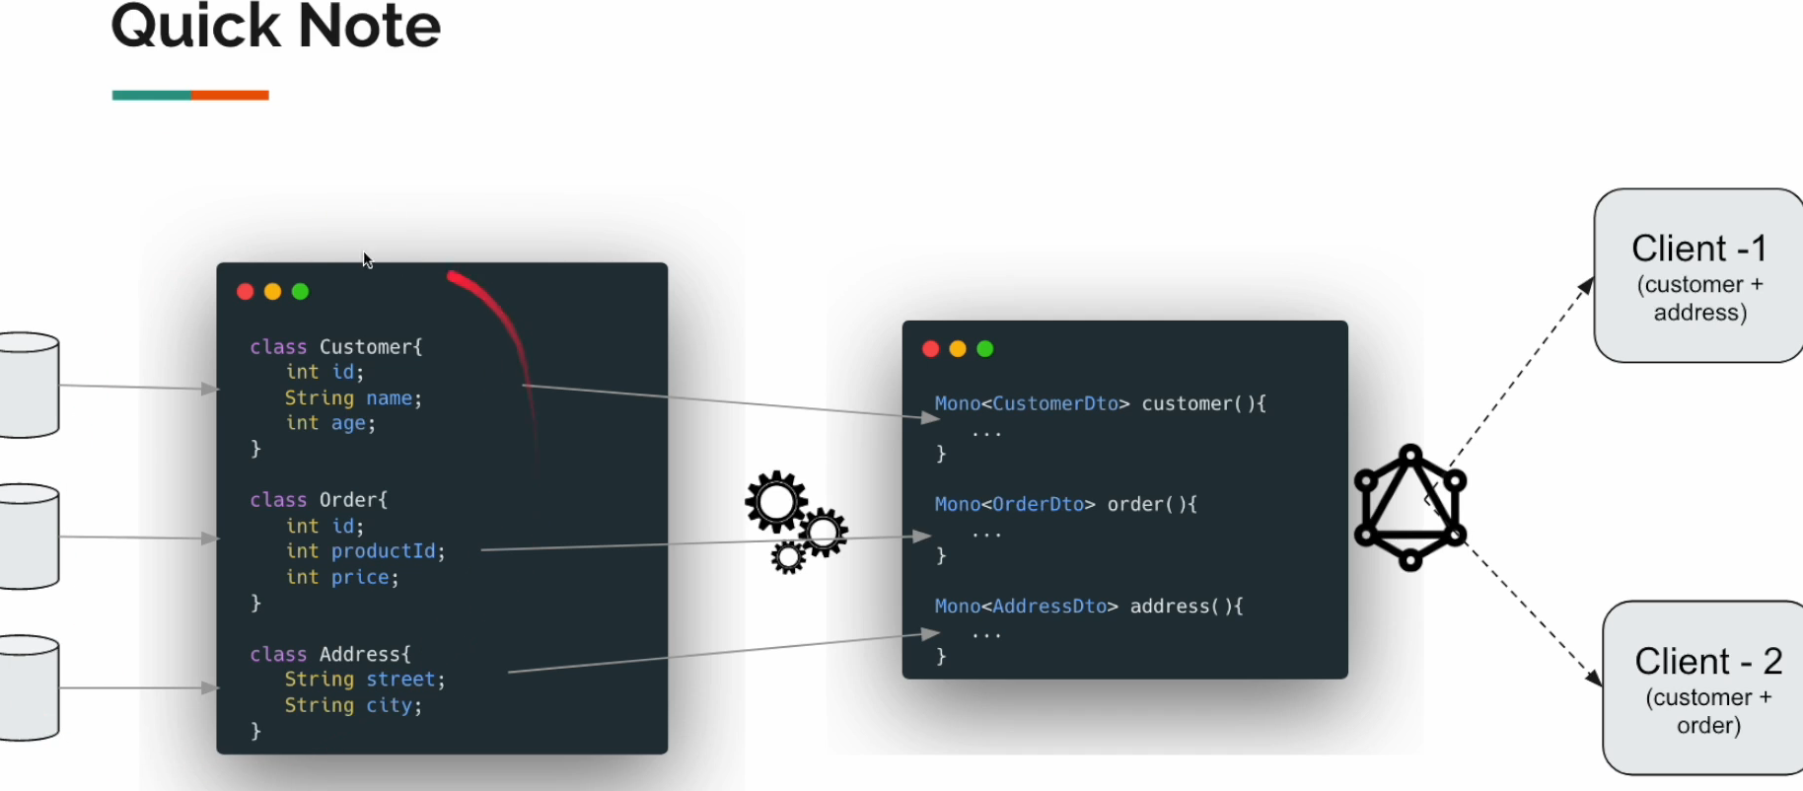

One Note:  
The Annotation “@Query” is actually :

*/\*\*  
 \* {@code @QueryMapping} is a <em>composed annotation</em> that acts as a  
 \* shortcut for {@link SchemaMapping @SchemaMapping} with  
 \* {@code typeName="Query"}.  
 \*  
 \* @author Rossen Stoyanchev  
 \* @since 1.0.0  
 \*/*@Target(ElementType.*METHOD*)  
@Retention(RetentionPolicy.*RUNTIME*)  
@Documented  
@SchemaMapping(typeName = "Query")  
public @interface QueryMapping {  
  
 */\*\*  
 \* Alias for {@link SchemaMapping#field()}.  
 \*/* @AliasFor(annotation = SchemaMapping.class, attribute = "field")  
 String name() default "";  
  
 */\*\*  
 \* Alias for {@link SchemaMapping#field()}.  
 \*/* @AliasFor(annotation = SchemaMapping.class, attribute = "field")  
 String value() default "";  
  
}

So we can now use instead of @Query:

@SchemaMapping(typeName = "Query")  
public Flux<Customer> customers(){  
 return this.service.allCustomers();  
}

Here above will work the same way as above. Here Query is Root object which means it does not have Parent.

type Query {  
  
 customers: [Customer]!  
}

So, For the Customer type we can specify like below and make it as Root object:

type Query {  
  
 customers: [Customer]!  
}  
  
type Customer{  
 id: Int,  
 name: String,  
 age: Int,  
 city: String,  
 orders: [CustomerOrder]!  
}  
  
type CustomerOrder{  
 id: ID!,  
 description: String  
}

@SchemaMapping(typeName = "Customer")  
public Flux<CustomerOrderDto> orders(Customer customer){  
 return this.orderService.ordersByCustomerName(customer.getName());  
}

So now, the GraphQl will take the control and will not call the orders API unnecessarily.

This annotation (**@SchemaMapping**) with **typeName = "Customer"** suggests that the **orders** method is somehow related to the GraphQL type named "Customer" in your schema. This annotation might be used to map the method to a specific field or operation within the "Customer" type.

Now this is our Controller and Service classes:

package com.graphql.praphqlplay.sec01.lec03;  
  
import com.graphql.praphqlplay.sec01.lec03.entity.Customer;  
import com.graphql.praphqlplay.sec01.lec03.entity.CustomerOrderDto;  
import com.graphql.praphqlplay.sec01.lec03.service.CustomerService;  
import com.graphql.praphqlplay.sec01.lec03.service.OrderService;  
import org.springframework.beans.factory.annotation.Autowired;  
import org.springframework.graphql.data.method.annotation.SchemaMapping;  
import org.springframework.stereotype.Controller;  
import reactor.core.publisher.Flux;  
  
@Controller  
public class CustomerController {  
  
 @Autowired  
 private CustomerService service;  
  
 @Autowired  
 private OrderService orderService;  
  
 @SchemaMapping(typeName = "Query") // This is the same as QueryMapping  
 public Flux<Customer> customers(){  
 return this.service.allCustomers();  
 }  
  
 @SchemaMapping(typeName = "Customer") // this is something like CustomerMapping  
 public Flux<CustomerOrderDto> orders(Customer customer){  
 return this.orderService.ordersByCustomerName(customer.getName());  
 }  
}

Service classes:

@Service  
public class CustomerService {  
 private final Flux<Customer> flux = Flux.*just*(  
 Customer.*create*(1, "Sam", 20, "Wollongong"),  
 Customer.*create*(2, "Mike", 25, "BlackTown"),  
 Customer.*create*(3, "Ota", 35, "Parramatta"),  
 Customer.*create*(4, "Jay-Jay", 18, "CBD")  
 );  
 public Flux<Customer> allCustomers(){  
 return flux;  
 }  
}

import com.graphql.praphqlplay.sec01.lec03.entity.CustomerOrderDto;  
import org.springframework.stereotype.Service;  
import reactor.core.publisher.Flux;  
  
import java.util.Collections;  
import java.util.List;  
import java.util.Map;  
import java.util.UUID;  
  
@Service  
public class OrderService {  
  
 private final Map<String, List<CustomerOrderDto>> map = Map.*of*(  
 "Sam", List.*of*(  
 CustomerOrderDto.*create*(UUID.*randomUUID*(), "sam-product-1"),  
 CustomerOrderDto.*create*(UUID.*randomUUID*(), "sam-product-2")  
 ),  
 "Mike", List.*of*(  
 CustomerOrderDto.*create*(UUID.*randomUUID*(), "mikle-product-1"),  
 CustomerOrderDto.*create*(UUID.*randomUUID*(), "mike-product-2"),  
 CustomerOrderDto.*create*(UUID.*randomUUID*(), "mike-product-3")  
 )  
 );  
 public Flux<CustomerOrderDto> ordersByCustomerName(String name){  
  
 //Returns the value to which the specified key is mapped, or defaultValue  
 // if this map contains no mapping for the key  
 return Flux.*fromIterable*(map.getOrDefault(name, Collections.*emptyList*()));  
 }  
}

the Dto classes are the same as above:

@Data  
@NoArgsConstructor  
@AllArgsConstructor(staticName = "create")  
public class CustomerOrderDto {  
  
 private UUID id;  
 private String description;  
}

If you have created new schema.graphqls, then make sure you have to refer it in application.properties:

#graphql schema file location and it is default property  
spring.graphql.schema.locations=classpath:graphql/sec01/lec03  
#endpoint: like localhost:8080/graphql  
spring.graphql.path=/graphql  
  
  
#graphiql - user interface - playground  
spring.graphql.graphiql.enabled=true  
#endpoint  
spring.graphql.graphiql.path=/graphiql

And on Main class also refer to the package:

@SpringBootApplication(scanBasePackages = "com.graphql.praphqlplay.sec01.lec03")  
public class GraphqlPlayApplication {  
  
 public static void main(String[] args) {  
 SpringApplication.*run*(GraphqlPlayApplication.class, args);  
 }  
  
}

Now we can call our playground:

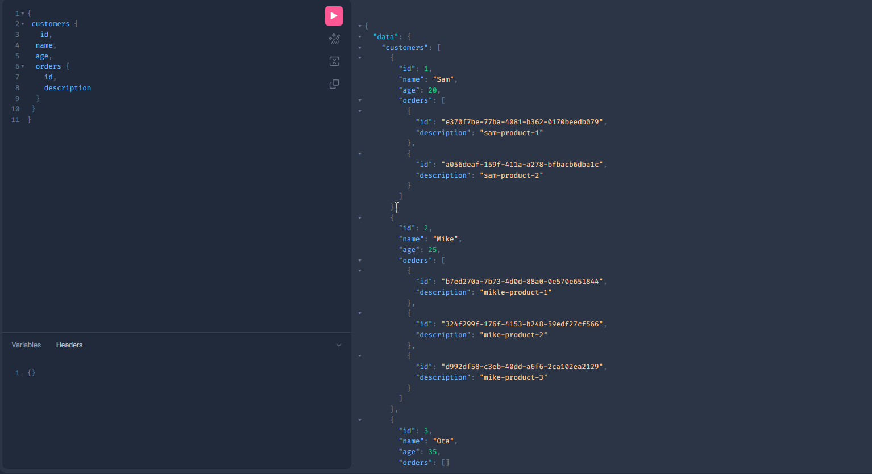

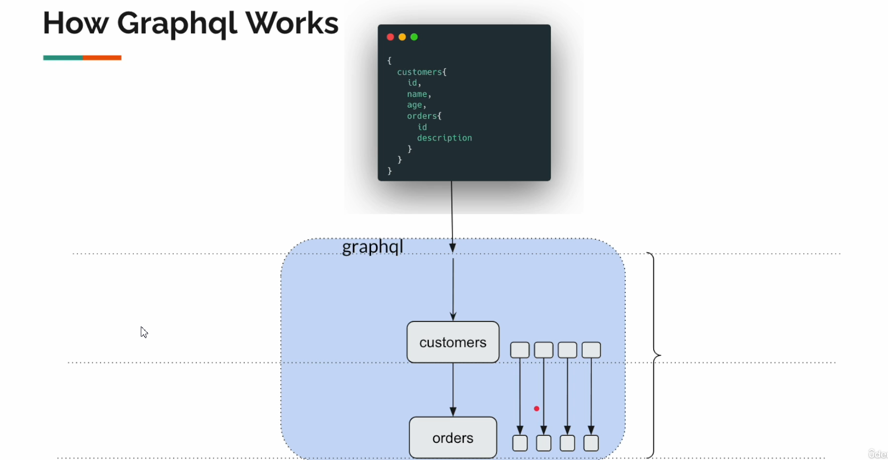

Hey, in our assignment, what if we want to take only limited amount of child object, say fetch only 1 order per customer. So, we do not need all the orders for a customer, just only one:

We need to change our schema.gr

type Query {  
  
 customers: [Customer]!  
}  
  
type Customer{  
 id: Int,  
 name: String,  
 age: Int,  
 city: String,  
 orders(limit: Int!): [CustomerOrder!]!  
}  
  
type CustomerOrder{  
 id: ID!,  
 description: String!  
}

Now in Controller:

@SchemaMapping(typeName = "Customer") // this is something like CustomerMapping  
public Flux<CustomerOrderDto> orders(Customer customer, @Argument Integer limit){  
 return this.orderService.ordersByCustomerName(customer.getName())  
 .take(limit);  
}

That’s is all:

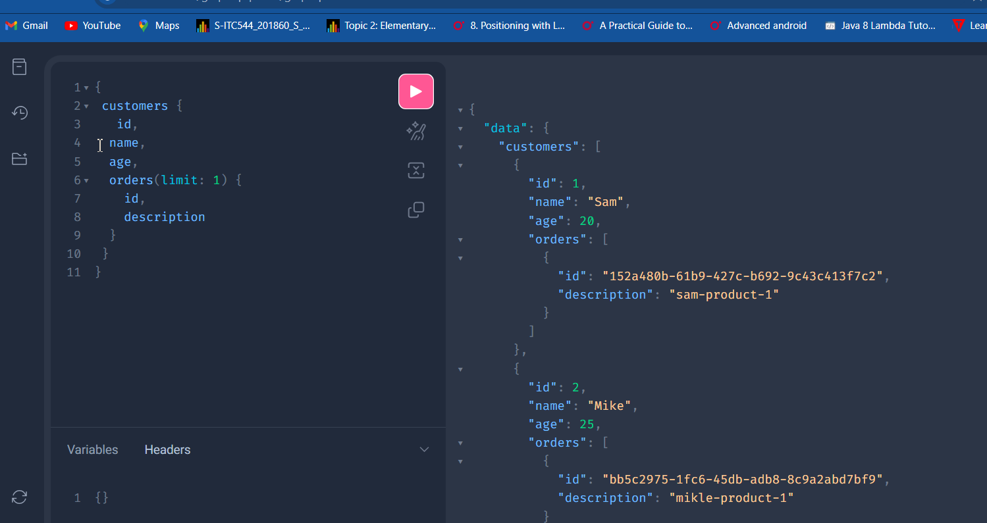

**N+1 Problem with @BatchMapping**

This problem is as mentioned above, for example if the customer has 4 orders, then it should call orders API 4 times.

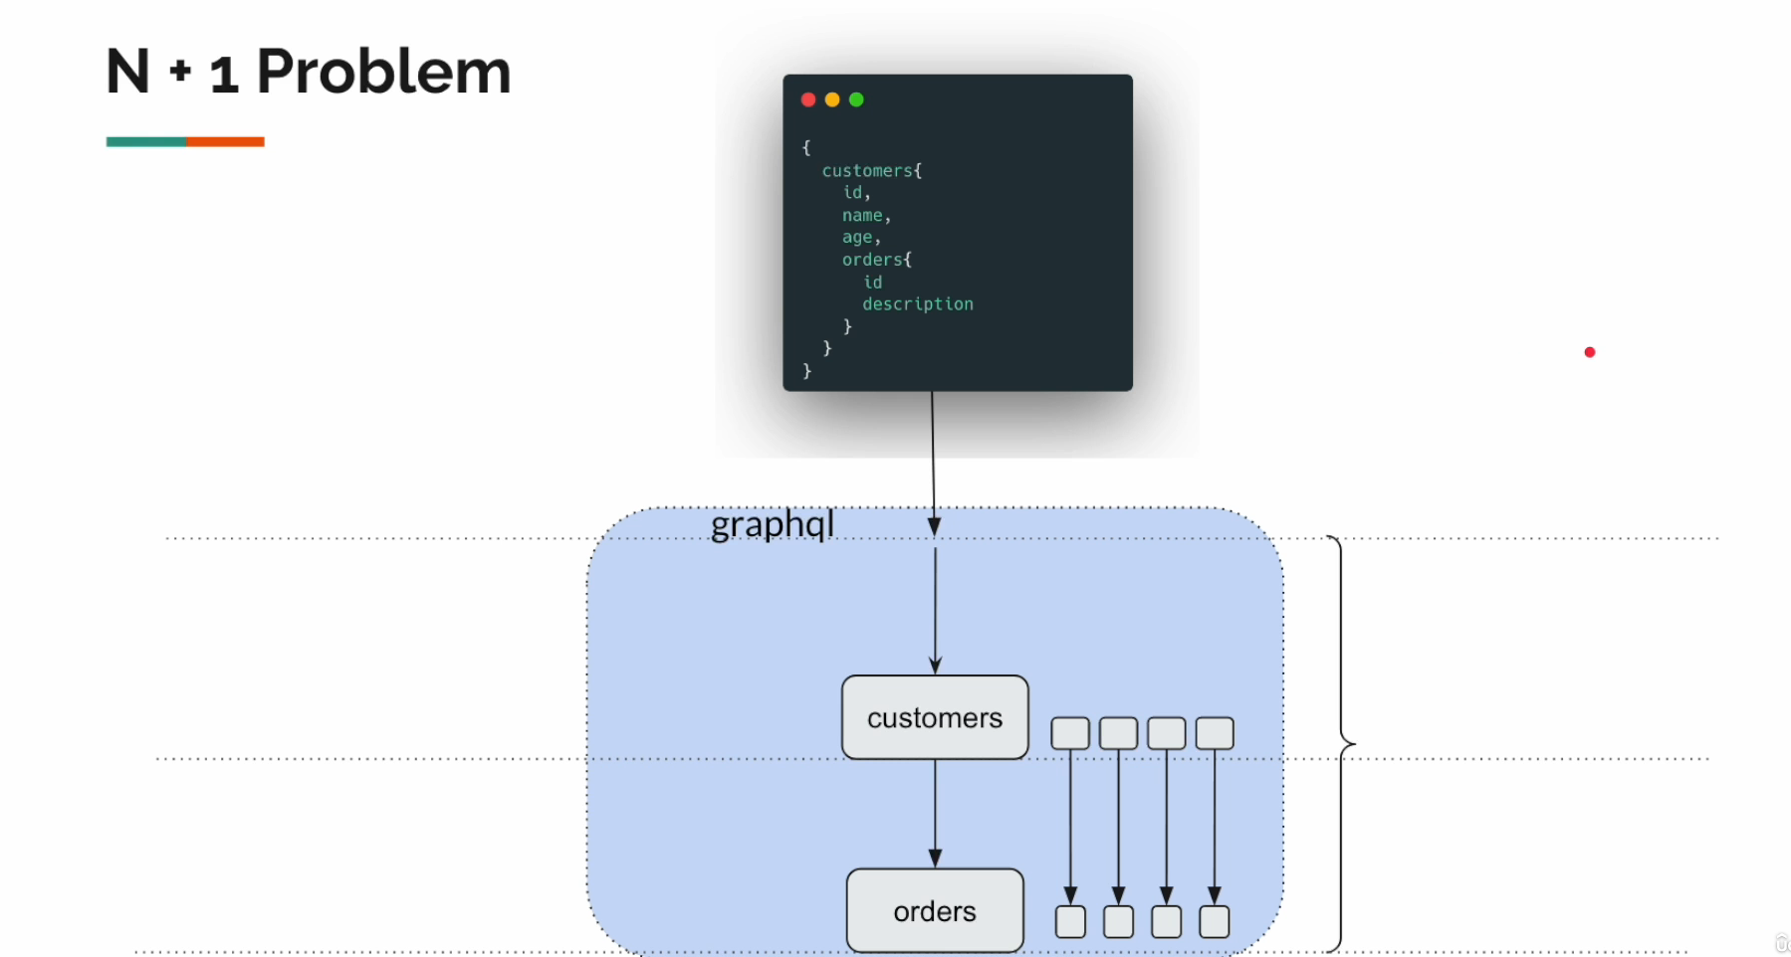

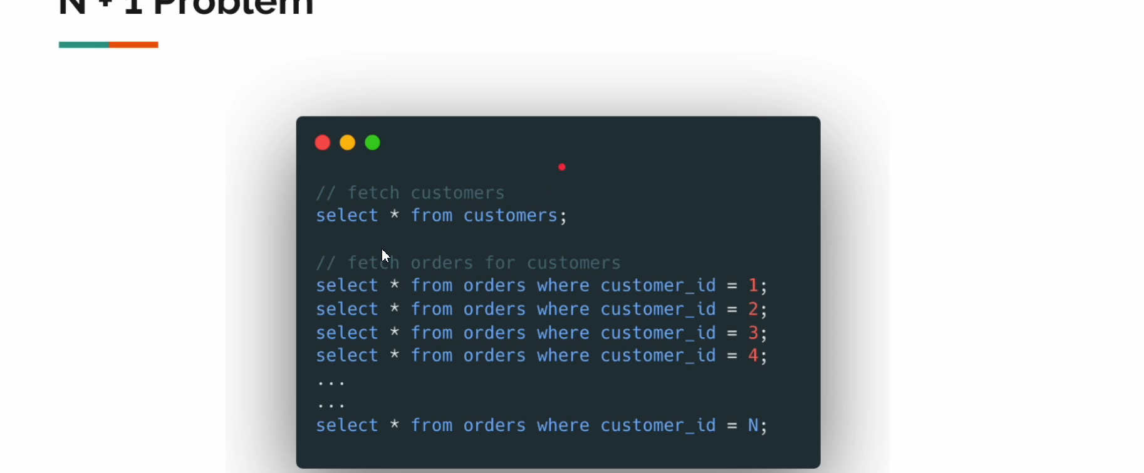

In SQL, ideal would be like:

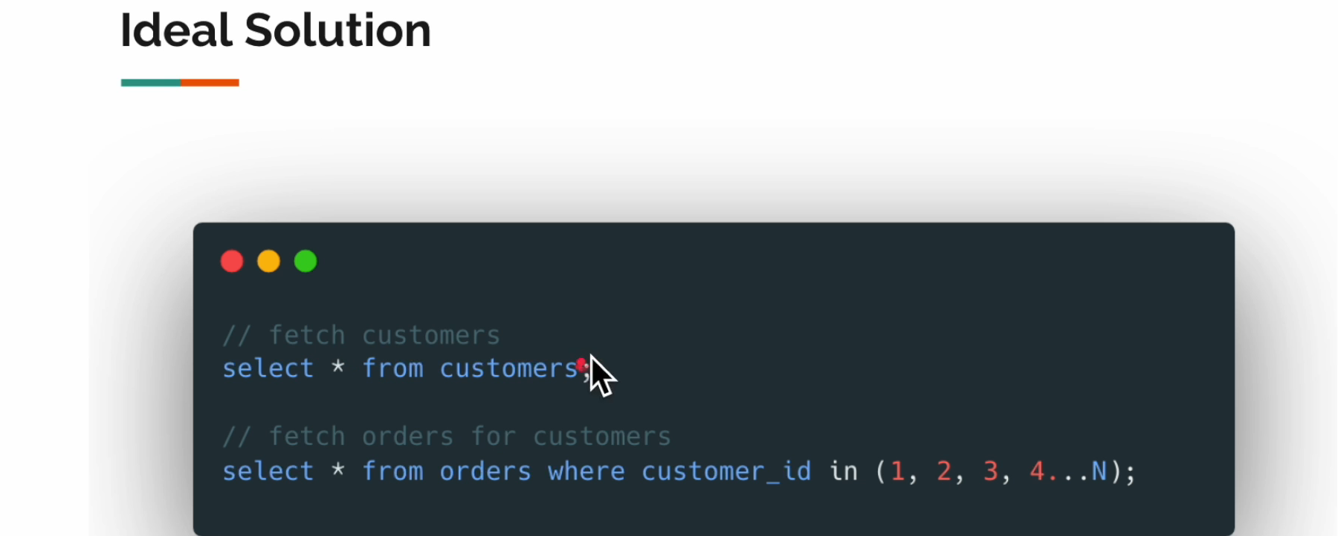

In GraphQL we can fix this:

Our schema:

type Query {  
 customers: [Customer!]!  
}  
  
type Customer{  
 id: Int,  
 name: String,  
 age: Int,  
 city: String,  
 orders: [CustomerOrders!]!  
}  
  
type CustomerOrders{  
 id: ID!,  
 description: String!  
}

and our Service:

package com.graphql.praphqlplay.sec01.lec04.service;  
  
import com.graphql.praphqlplay.sec01.lec04.entity.Customer;  
import org.springframework.stereotype.Service;  
import reactor.core.publisher.Flux;  
  
@Service  
public class CustomerService {  
 private final Flux<Customer> flux = Flux.*just*(  
 Customer.*create*(1, "Sam", 20, "Wollongong"),  
 Customer.*create*(2, "Mike", 25, "BlackTown"),  
 Customer.*create*(3, "Ota", 35, "Parramatta"),  
 Customer.*create*(4, "Jay-Jay", 18, "CBD")  
 );  
 public Flux<Customer> allCustomers(){  
 return flux;  
 }  
}

package com.graphql.praphqlplay.sec01.lec04.service;  
  
import com.graphql.praphqlplay.sec01.lec04.entity.CustomerOrderDto;  
import org.springframework.stereotype.Service;  
import reactor.core.publisher.Flux;  
  
import java.util.Collections;  
import java.util.List;  
import java.util.Map;  
import java.util.UUID;  
  
@Service  
public class OrderService {  
  
 private final Map<String, List<CustomerOrderDto>> map = Map.*of*(  
 "Sam", List.*of*(  
 CustomerOrderDto.*create*(UUID.*randomUUID*(), "sam-product-1"),  
 CustomerOrderDto.*create*(UUID.*randomUUID*(), "sam-product-2")  
 ),  
 "Mike", List.*of*(  
 CustomerOrderDto.*create*(UUID.*randomUUID*(), "mikle-product-1"),  
 CustomerOrderDto.*create*(UUID.*randomUUID*(), "mike-product-2"),  
 CustomerOrderDto.*create*(UUID.*randomUUID*(), "mike-product-3")  
 )  
 );  
 public Flux<CustomerOrderDto> ordersByCustomerName(String name){  
  
 //Returns the value to which the specified key is mapped, or defaultValue  
 // if this map contains no mapping for the key  
 return Flux.*fromIterable*(map.getOrDefault(name, Collections.*emptyList*()));  
 }  
  
 public Flux<List<CustomerOrderDto>> ordersByCustomerName(List<String> names){  
 return Flux.*fromIterable*(names)  
 .map(n -> map.getOrDefault(n, Collections.*emptyList*()));  
 }  
}

And our Controller: Here we will use **@BatchController**

import java.util.List;  
  
@Controller  
public class CustomerController {  
  
 @Autowired  
 private CustomerService service;  
  
 @Autowired  
 private OrderService orderService;  
  
 @SchemaMapping(typeName = "Query") // This is the same as QueryMapping  
 public Flux<Customer> customers(){  
 return this.service.allCustomers();  
 }  
  
 //N+1 problem solution  
 @BatchMapping(typeName = "Customer")  
 public Flux<List<CustomerOrderDto>> orders(List<Customer> list){  
  
 System.*out*.println("Orders method invoked for" + list);  
 return this.orderService.ordersByCustomerName(list.stream().map(Customer::getName).toList());  
 }  
}

This Batch will sort the problem with N+1.

So now we can check how many times API orders will be called in BackEnd:

This is our result in playground

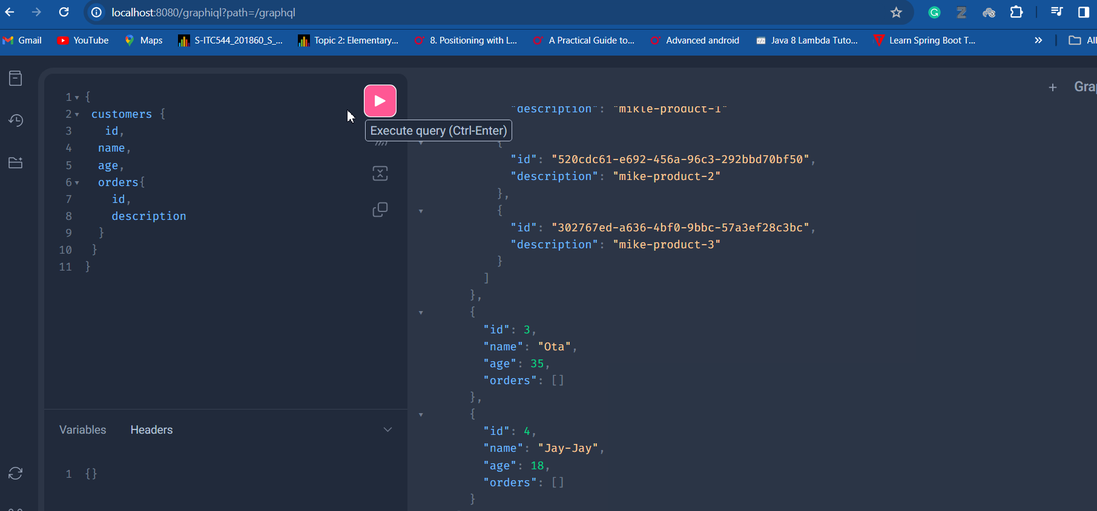

And if we check logs in Intellij: it is called once. And that is it.



**N+1 Size Mismatch**

If you use this way return: where the names are 4 but the result returns only those who has Orders:

public Flux<List<CustomerOrderDto>> ordersByCustomerName(List<String> names){  
 return Flux.*fromIterable*(names)  
 .flatMap(this::fetchOrders);  
 }  
  
 //some source  
 public Mono<List<CustomerOrderDto>> fetchOrders(String name){  
 return Mono.*justOrEmpty*(map.get(name));  
 }  
}

we will get error logs in Intellij:

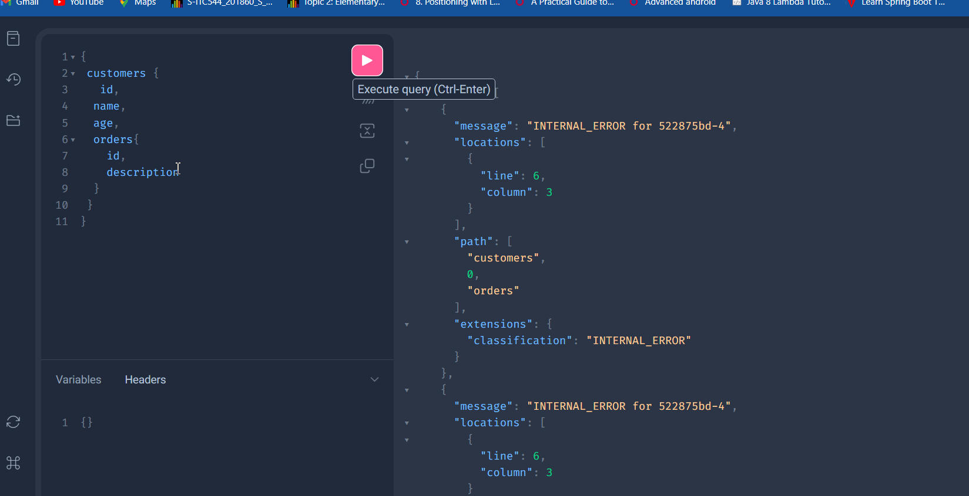

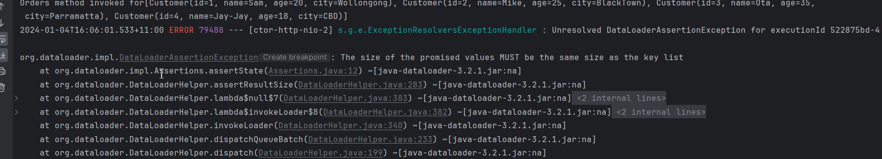

So, the expected result here must be the same size of items as given, but result was only 2 .

We can fix it by doing this:

public Flux<List<CustomerOrderDto>> ordersByCustomerName(List<String> names){  
 return Flux.*fromIterable*(names)  
 .flatMap(n -> this.fetchOrders(n).defaultIfEmpty(Collections.*emptyList*()));  
 }  
  
 //some source  
 public Mono<List<CustomerOrderDto>> fetchOrders(String name){  
 return Mono.*justOrEmpty*(map.get(name));  
 }  
}

**N+1 Order mismatch issue**

Look this:

public Flux<List<CustomerOrderDto>> ordersByCustomerName(List<String> names){  
 return Flux.*fromIterable*(names)  
 .flatMap(n -> this.fetchOrders(n).defaultIfEmpty(Collections.*emptyList*()));  
}  
  
//some source  
public Mono<List<CustomerOrderDto>> fetchOrders(String name){  
 return Mono.*justOrEmpty*(map.get(name))  
 .delayElement(Duration.*ofMillis*(ThreadLocalRandom.*current*().nextInt(0,500)));  
}

As you see we are using FlatMap and it is works in parallel, means it will not wait for the response but will subscribe to parallel:

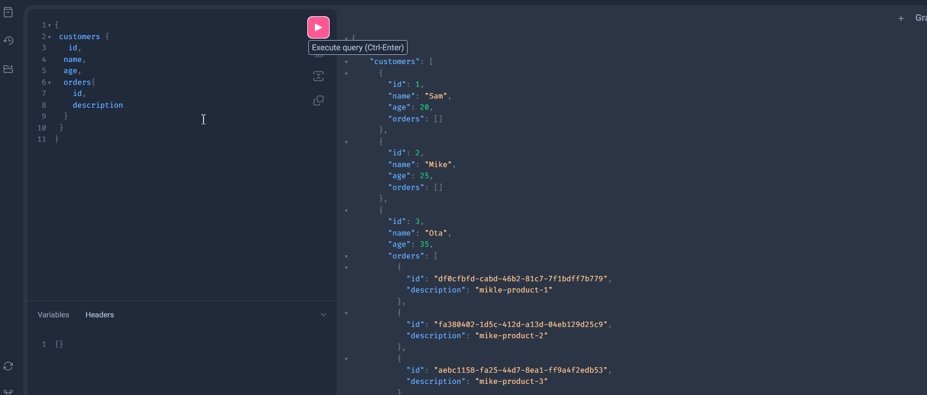

As you see there should be orders for sam and Mike, but here orders goes to Ota. This is because delay.

So we can easily fix it with **flatMapSequential()**

S

public Flux<List<CustomerOrderDto>> ordersByCustomerName(List<String> names){  
 return Flux.*fromIterable*(names)  
 .flatMapSequential(n -> this.fetchOrders(n).defaultIfEmpty(Collections.*emptyList*()));  
}  
  
//some source  
public Mono<List<CustomerOrderDto>> fetchOrders(String name){  
 return Mono.*justOrEmpty*(map.get(name))  
 .delayElement(Duration.*ofMillis*(ThreadLocalRandom.*current*().nextInt(0,500)));  
}

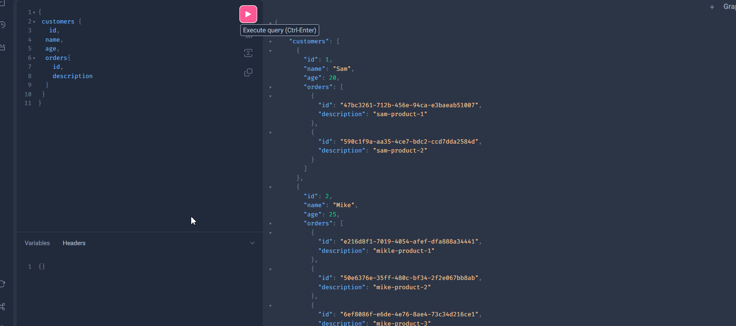

**Another way of Solution with Map**

Sd

//N+1 problem solution  
@BatchMapping(typeName = "Customer")  
public Mono<Map<Customer, List<CustomerOrderDto>>> orders(List<Customer> list){  
  
 System.*out*.println("Orders method invoked for" + list);  
 return this.orderService.fetchOrdersAsMap(list);  
}

public Mono<Map<Customer, List<CustomerOrderDto>>> fetchOrdersAsMap(List<Customer> customers){  
 return Flux.*fromIterable*(customers)  
 .map(c -> Tuples.*of*(c, map.getOrDefault(c.getName(), Collections.*emptyList*())))  
 .collectMap(  
 Tuple2::getT1,  
 Tuple2::getT2  
 );  
}

Let's break down the code step by step:

1. **Flux.fromIterable(customers)**: Converts the input list of **customers** into a reactive stream (**Flux**). A **Flux** is a sequence of elements that can be processed asynchronously.
2. **.map(c -> Tuples.of(c, map.getOrDefault(c.getName(), Collections.emptyList())))**: For each customer (**c**) in the stream, it creates a tuple (**Tuples.of(c, ...)**). The tuple consists of the customer (**c**) and a list of **CustomerOrderDto**. The list is obtained from a map (**map**) using the customer's name as the key. If the customer's name is not found in the map, it defaults to an empty list.

It seems that the **map** used in this line is not defined in the provided code snippet. Make sure it is declared and initialized appropriately elsewhere in your code.

1. **.collectMap(Tuple2::getT1, Tuple2::getT2)**: Collects the tuples into a **Map**. The key extractor (**Tuple2::getT1**) specifies that the customer (**c**) should be used as the key, and the value extractor (**Tuple2::getT2**) specifies that the list of **CustomerOrderDto** should be used as the corresponding value.
2. **Mono<Map<Customer, List<CustomerOrderDto>>>**: Wraps the resulting **Map** in a **Mono**. A **Mono** represents a single-value asynchronous computation, and in this case, it represents the asynchronous completion of the map creation.

In summary, the method takes a list of customers, retrieves corresponding lists of order DTOs for each customer, and returns a reactive **Mono** containing a map where customers are keys and lists of order DTOs are values.

Data Resolver:

Look here is interesting:

We have added one more API endpoind named age() which returns String of 100;

//N+1 problem solution  
@BatchMapping(typeName = "Customer")  
public Mono<Map<Customer, List<CustomerOrderDto>>> orders(List<Customer> list){  
  
 System.*out*.println("Orders method invoked for" + list);  
 return this.orderService.fetchOrdersAsMap(list);  
}  
  
@SchemaMapping(typeName = "Customer")  
public Mono<String> age(){  
 return Mono.*just*("101");  
}

So if you check schema.graphqls:

type Query {  
 customers: [Customer!]!  
}  
  
type Customer{  
 id: Int,  
 name: String,  
 age: Int,  
 city: String,  
 orders: [CustomerOrders!]!  
}  
  
type CustomerOrders{  
 id: ID!,  
 description: String!  
}

we can see there is a field in the Customer type that is corresponds to our method called age().

And the result is:

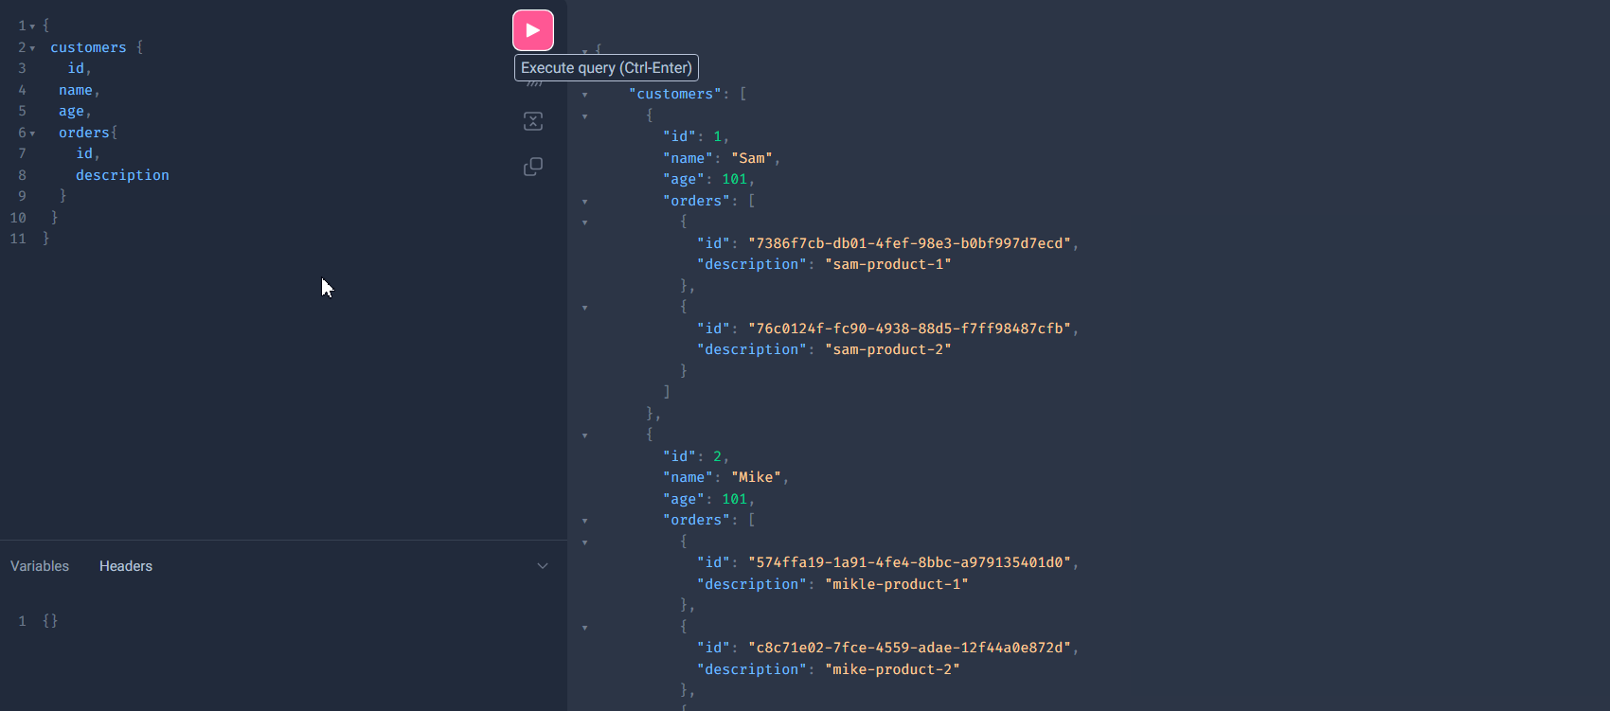

Wow here age was replaced by our method() result, because the name was corresponding and that is why it has overridden in Customers age field (it supposed to be Integer, but our method overrides it as well):

**Fetching from multiple Controllers:**

We can now separate the controllers and schemas:

Here are our schemas:

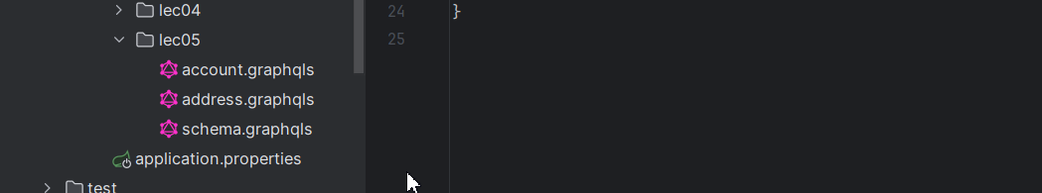

type Query {  
 customers: [Customer!]  
}  
  
type Customer{  
 id: Int,  
 name: String,  
 age: Int  
 address: Address,  
 account: Account  
}

type Address {  
 street: String  
 city: String  
}

type Account {  
 id: ID,  
 amount: Int,  
 accountType: AccountType  
}  
  
enum AccountType{  
 *CHECKING*,  
 *SAVING*}

and Here are our separated Controllers:

@Controller  
public class CustomerController {  
  
 @Autowired  
 private CustomerService service;  
  
 @QueryMapping  
 public Flux<Customer> customers(){  
 return this.service.allCustomers();  
 }  
}

@Controller  
public class AddressController {  
  
 @SchemaMapping(typeName = "Customer")  
 public Mono<Address> address(Customer customer){  
 return Mono.*just*(  
 Address.*create*(customer.getName() + " street", customer.getCity() + " city" ));  
 }  
}

@Controller  
public class AccountController {  
  
 @SchemaMapping(typeName = "Customer")  
 public Mono<Account> account (Customer customer){  
 var type = ThreadLocalRandom.*current*().nextBoolean()? "CHECKING": "SAVING";  
 return Mono.*just*(  
 Account.*create*(UUID.*randomUUID*(),  
 ThreadLocalRandom.*current*().nextInt(1, 1000),  
 type)  
 );  
 }  
}

And now we can query in Playground:

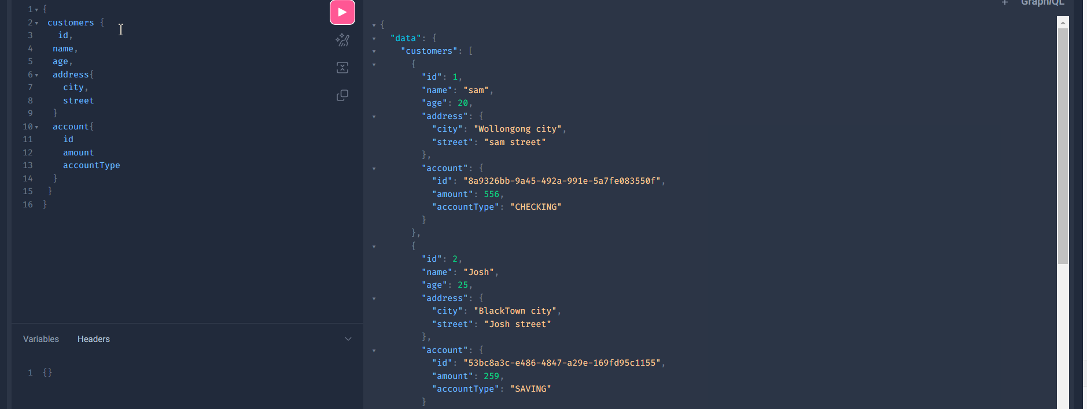

**Structuring GraphQL queries**

We can change the display name of the field with alias name:

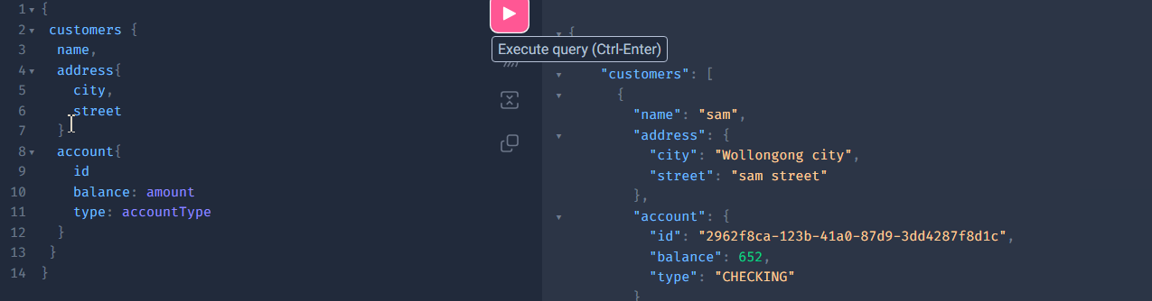

Executing The same API with Different Arguments:

Here below we executed the method that selects customer by id

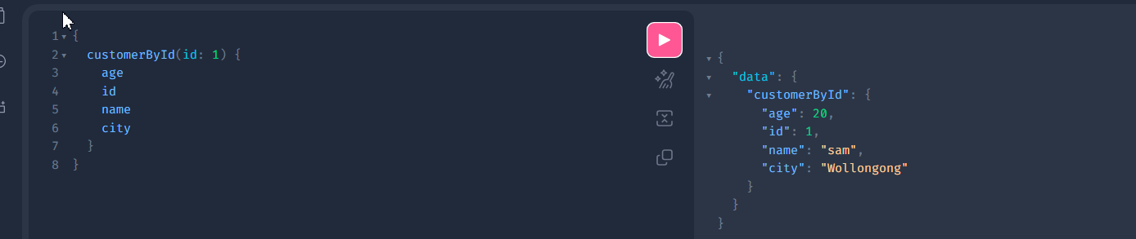

However, under single query we can call 2 customers using field alias:

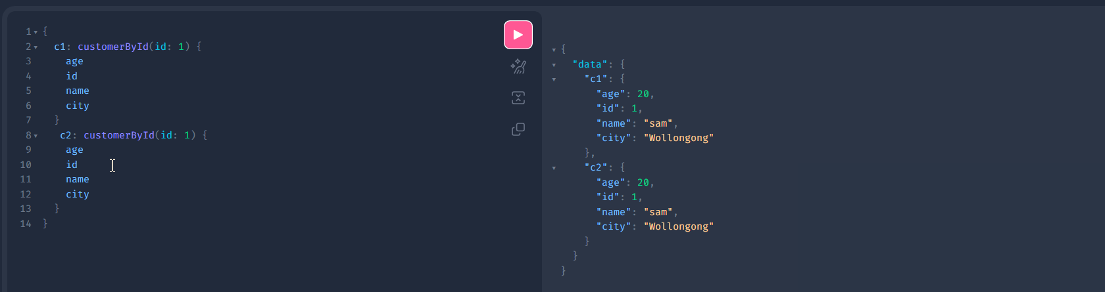

Another example:

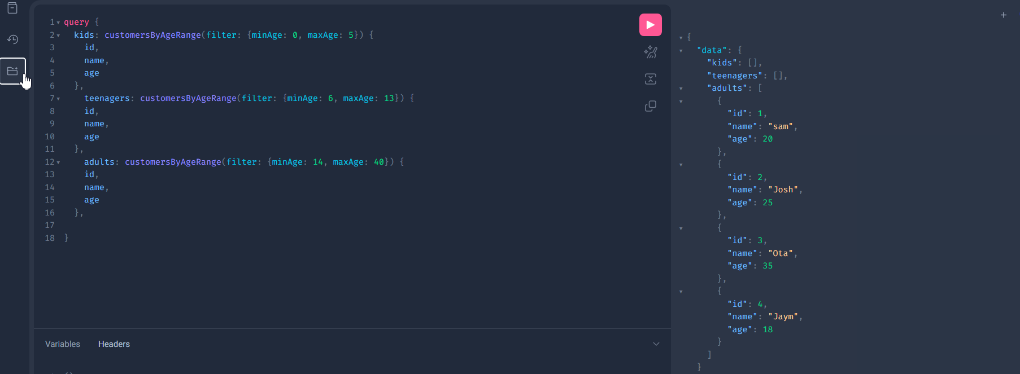

**@Freagmens**

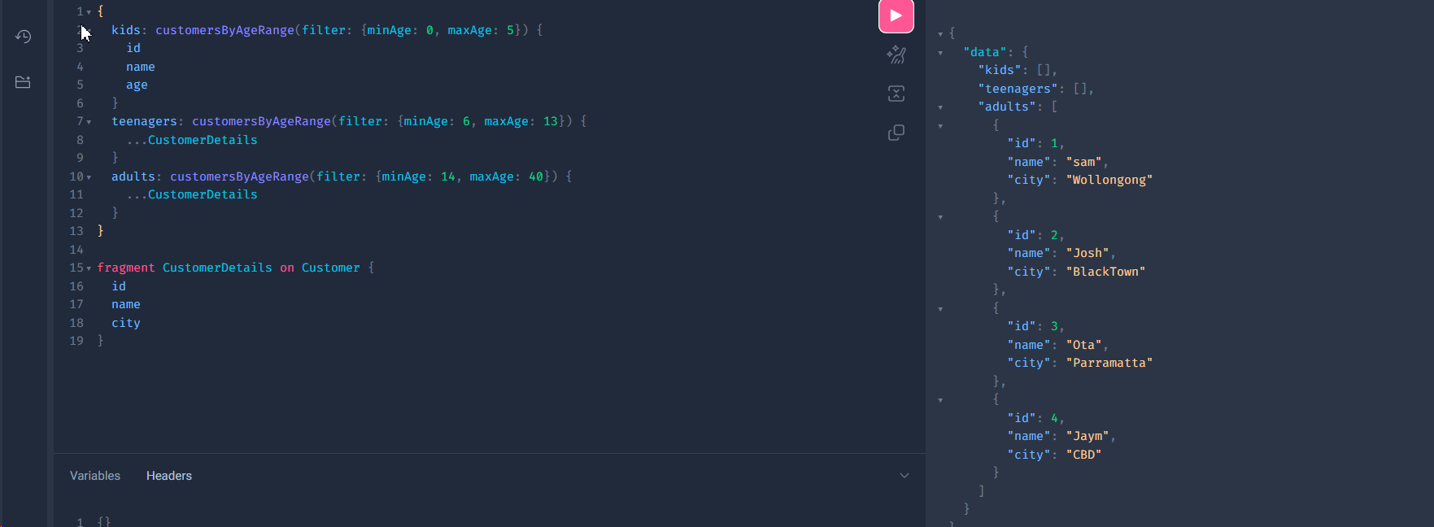

Some times, if you do not want enter all the fields in the list, we can create fragment and use that fragment in the queries.

**Operation name**

We can give names to the each query.

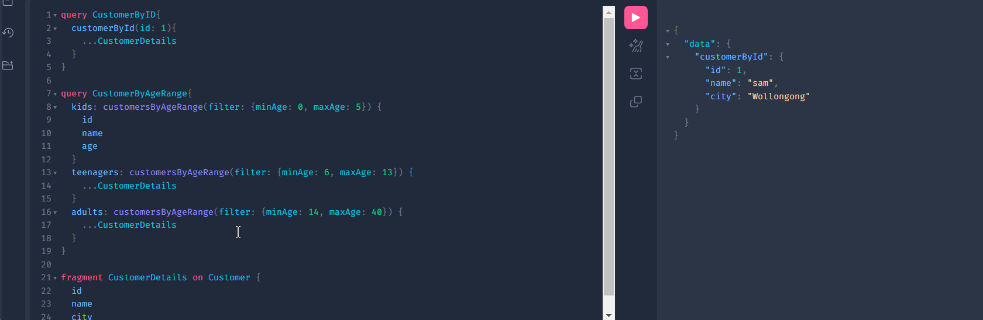

**Variables:**

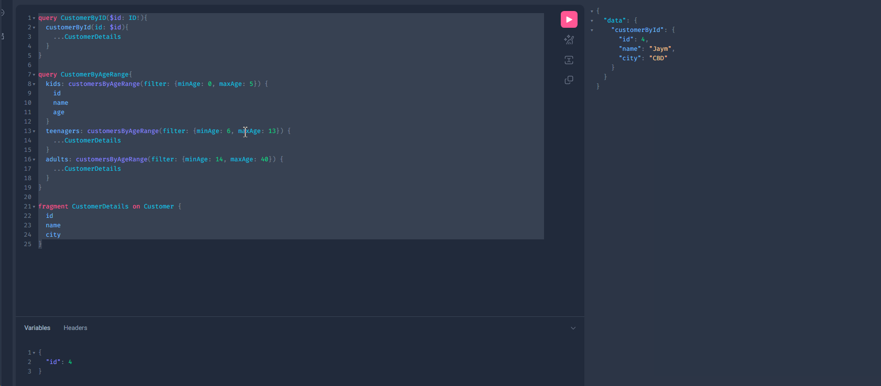

**Assignment:**

We optimized our query CustomerByAgeRange: we created variables for kids, teens and adults

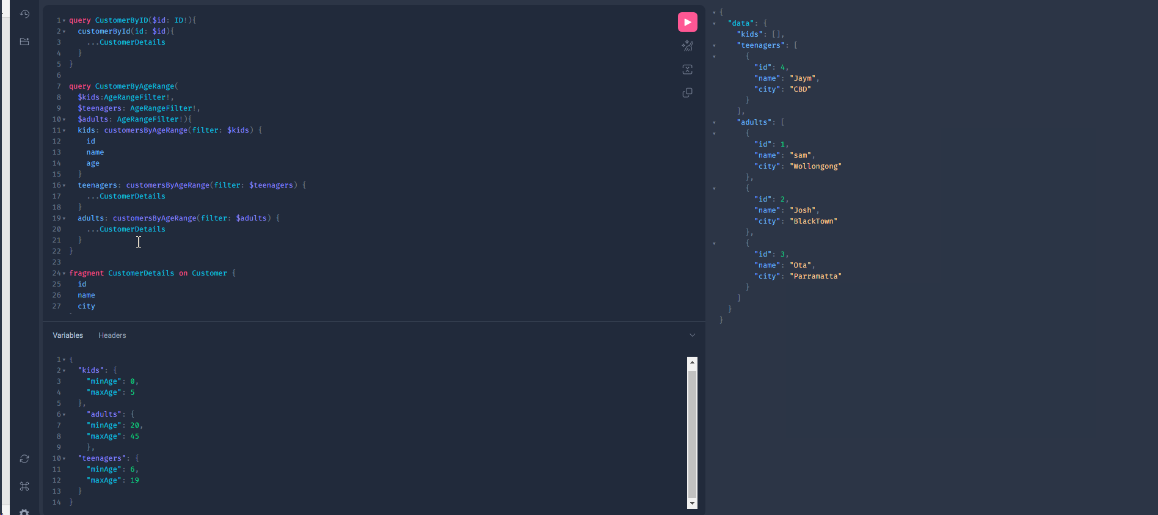

**Directives - @Skip/@Include**

Skip or include, we can use in query for certain condition to be true or false:

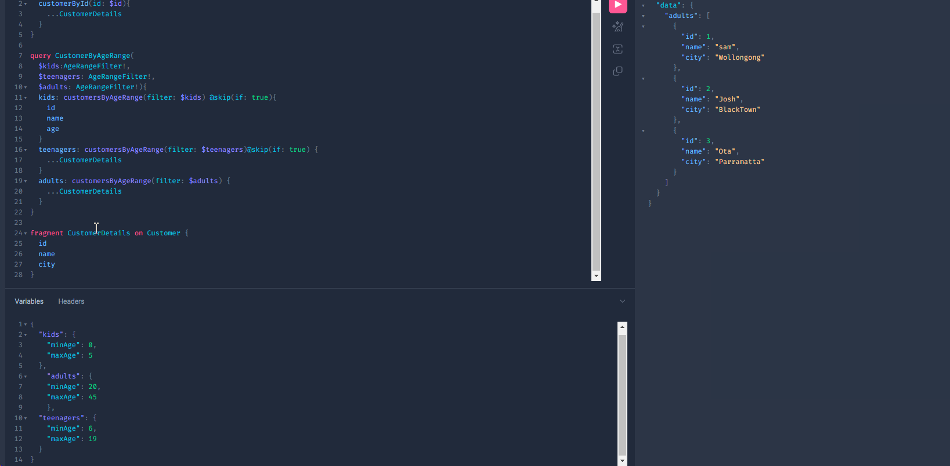

For skip: if the condition is true, it will skip fetching or executing that query and vice versa.

For Include: it is vise versa of Skip.

Here below we also optimized our code as well with variables and @include directives:

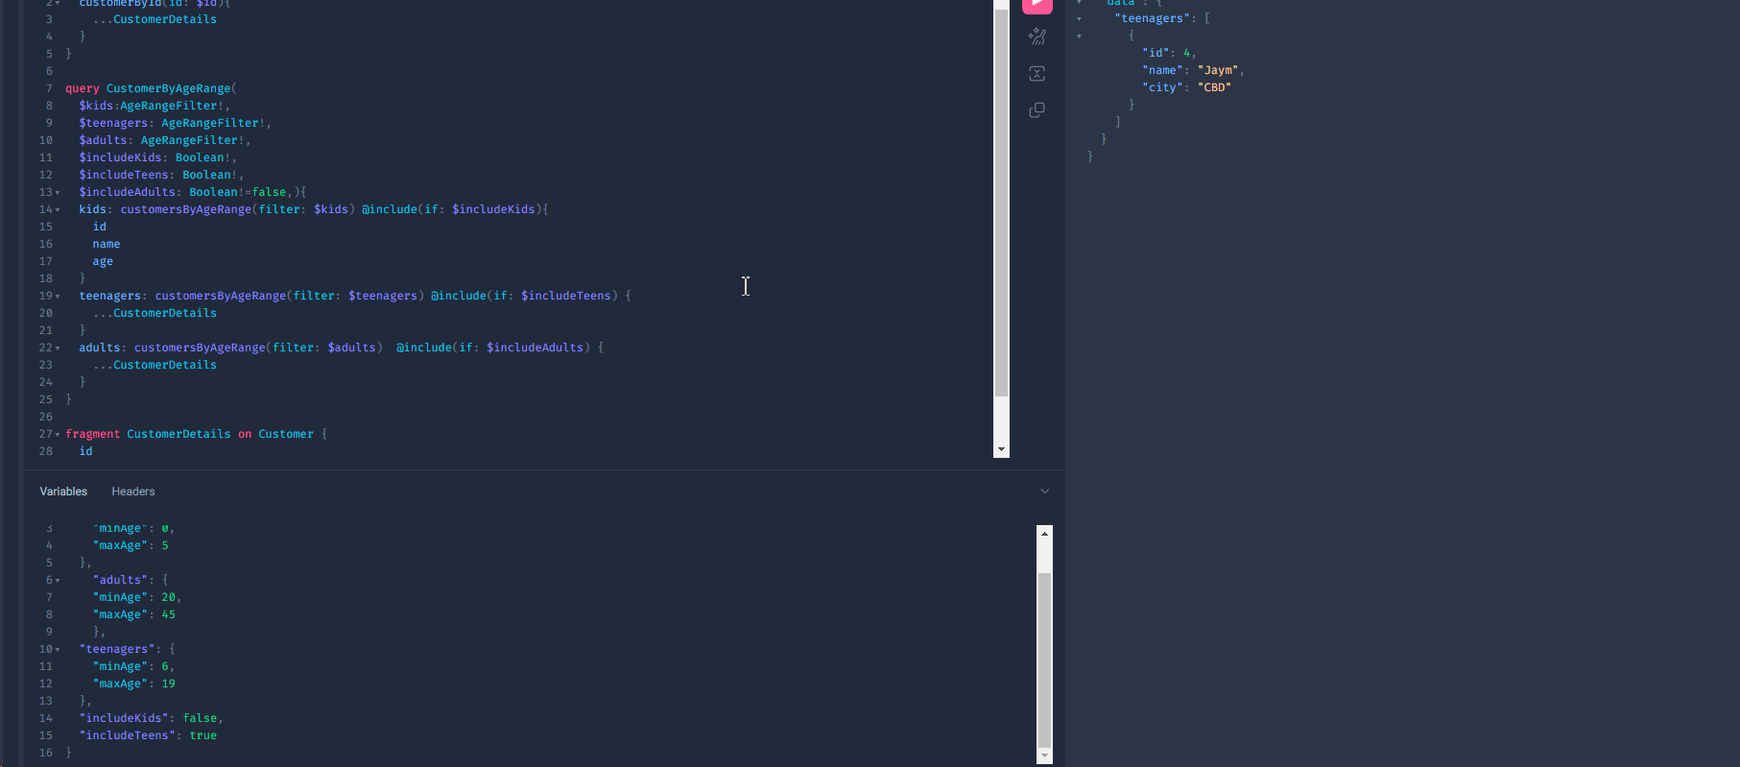

We can also @Depricate our API queries:

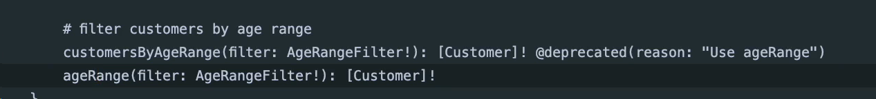

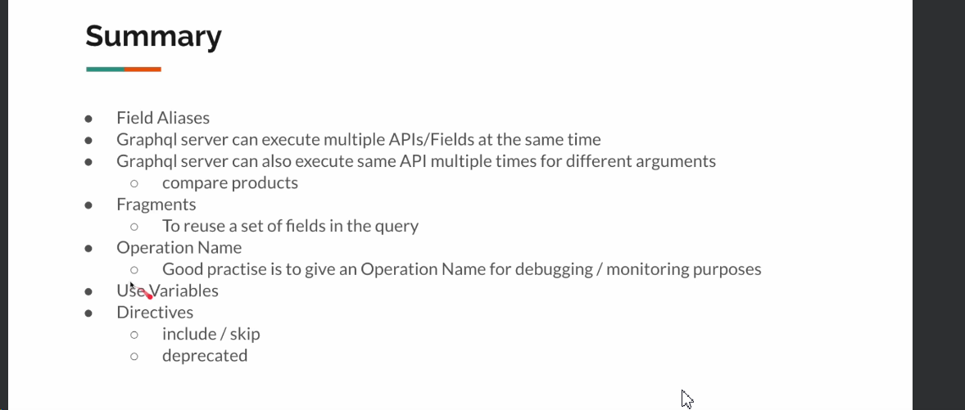

**Advanced GraphQL:**

Fetching Selection set.

If we change our controllers: to add DataFetchingFieldSelectionSet, then we can print them how graphql is managing with schema and API.

@Controller  
public class CustomerController {  
  
 @Autowired  
 private CustomerService service;  
  
 @QueryMapping  
 public Flux<Customer> customers(DataFetchingFieldSelectionSet selectionSet){  
 System.*out*.println("customer: " + selectionSet.getFields());  
 return this.service.allCustomers();  
 }  
}

@Controller  
public class AddressController {  
  
 @SchemaMapping(typeName = "Customer")  
 public Mono<Address> address(Customer customer, DataFetchingFieldSelectionSet selectionSet){  
 System.*out*.println("address: " + selectionSet.getFields());  
 return Mono.*just*(  
 Address.*create*(customer.getName() + " street", customer.getCity() + " city" ));  
 }  
}

@Controller  
public class AccountController {  
  
 @SchemaMapping(typeName = "Customer")  
 public Mono<Account> account (Customer customer, DataFetchingFieldSelectionSet selectionSet){  
 System.*out*.println("account: " + selectionSet.getFields());  
 var type = ThreadLocalRandom.*current*().nextBoolean()? "CHECKING": "SAVING";  
 return Mono.*just*(  
 Account.*create*(UUID.*randomUUID*(),  
 ThreadLocalRandom.*current*().nextInt(1, 1000),  
 type)  
 );  
 }  
}

Now if we send this query: 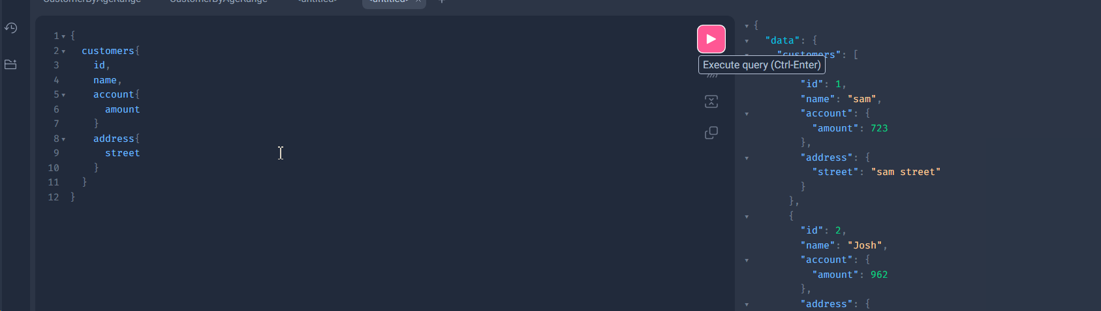

The log will print this:

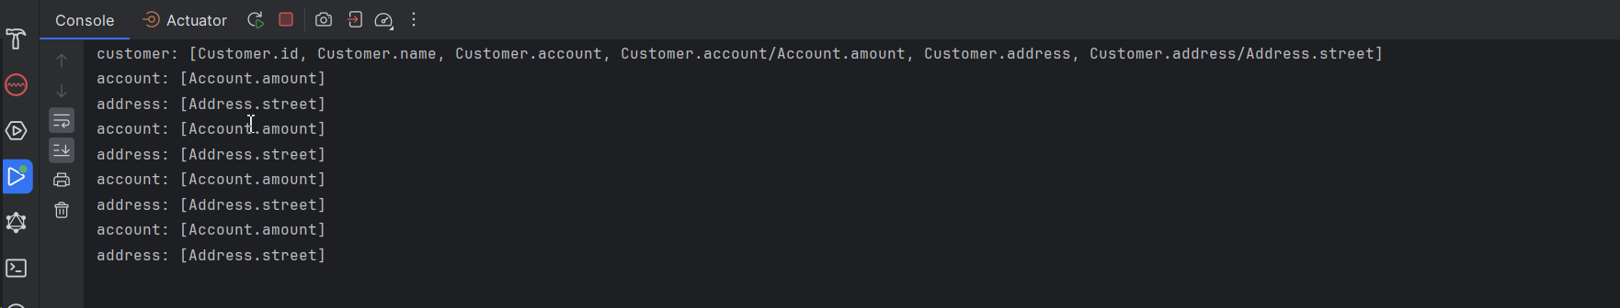

**Data fetching environment**

Printing Data fetching environment:

By Using this feature, we can get entire document.:

@Controller  
public class CustomerController {  
  
 @Autowired  
 private CustomerService service;  
  
 @QueryMapping  
 public Flux<Customer> customers(DataFetchingEnvironment environment){  
 System.*out*.println("customer: environment: -> " + environment.getDocument());  
 return this.service.allCustomers();  
 }  
}

@Controller  
public class AddressController {  
  
 @SchemaMapping(typeName = "Customer")  
 public Mono<Address> address(Customer customer, DataFetchingEnvironment environment){  
 System.*out*.println("address: " + environment.getDocument());  
 return Mono.*just*(  
 Address.*create*(customer.getName() + " street", customer.getCity() + " city" ));  
 }  
}

If you run this:

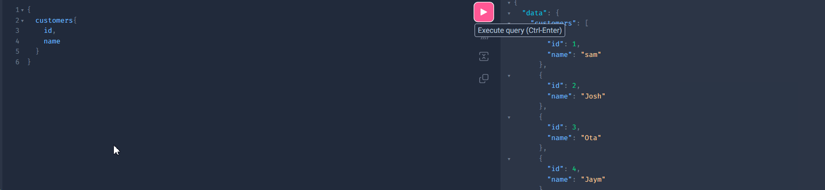

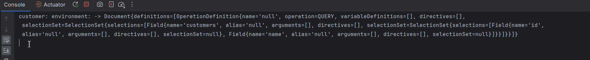

As you can see from the logs we are seeing the entire documentation of our graphql.

If you need to add query names and know which query is executed, you have to add another field of environment: getOperationDefinition:

@Controller  
public class CustomerController {  
  
 @Autowired  
 private CustomerService service;  
  
 @QueryMapping  
 public Flux<Customer> customers(DataFetchingEnvironment environment){  
 System.*out*.println("customer: environment: -> " + environment.getDocument());  
 System.*out*.println(environment.getOperationDefinition());  
 return this.service.allCustomers();  
 }  
}

If you run the 1st query:

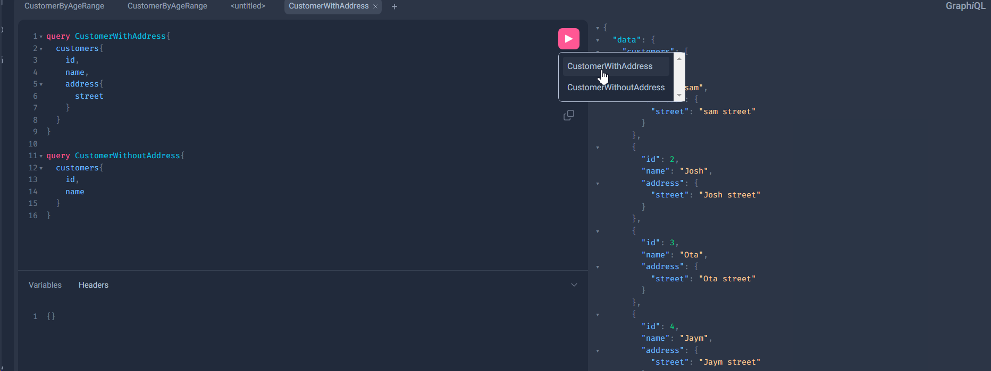

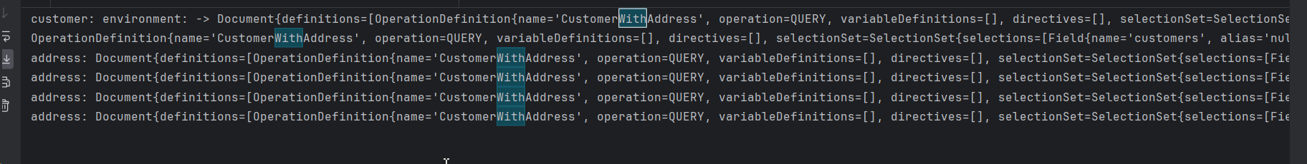

Now let us check our project for Sequential execution problem and compare it with REST:

1st we will change it in our service classes: each service class we implemented the delay of 1 second

@Service  
public class CustomerService {  
 private final Flux<Customer> flux = Flux.*just*(  
 Customer.*create*(1, "Sam", 20, "Wollongong"),  
 Customer.*create*(2, "Mike", 25, "BlackTown"),  
 Customer.*create*(3, "Ota", 35, "Parramatta"),  
 Customer.*create*(4, "Jay-Jay", 18, "CBD")  
 );  
 public Flux<Customer> allCustomers(){  
 return flux  
 .delayElements(Duration.*ofSeconds*(1))  
 .doOnNext(c -> print("customer " + c.getName()));  
 }  
  
 private void print(String msg){  
 System.*out*.println(LocalDateTime.*now*() + " : " + msg);  
 }  
}

@Service  
public class OrderService {  
  
 private final Map<String, List<CustomerOrderDto>> map = Map.*of*(  
 "Sam", List.*of*(  
 CustomerOrderDto.*create*(UUID.*randomUUID*(), "sam-product-1"),  
 CustomerOrderDto.*create*(UUID.*randomUUID*(), "sam-product-2")  
 )  
// "Mike", List.of(  
// CustomerOrderDto.create(UUID.randomUUID(), "mikle-product-1"),  
// CustomerOrderDto.create(UUID.randomUUID(), "mike-product-2"),  
// CustomerOrderDto.create(UUID.randomUUID(), "mike-product-3")  
// )  
 );  
 public Flux<CustomerOrderDto> ordersByCustomerName(String name){  
  
 //Returns the value to which the specified key is mapped, or defaultValue  
 // if this map contains no mapping for the key  
 return Flux.*fromIterable*(map.getOrDefault(name, Collections.*emptyList*()))

.delayElements(Duration.*ofSeconds*(1))

.doOnNext(o -> print("emitting order for: " + name));  
 }  
  
 private void print(String msg){  
 System.*out*.println(LocalDateTime.*now*() + " : " + msg);  
 }  
}

This is our controller:

@Controller  
public class CustomerController {  
  
 @Autowired  
 private CustomerService service;  
  
 @Autowired  
 private OrderService orderService;  
  
 @SchemaMapping(typeName = "Query") // This is the same as QueryMapping  
 public Flux<Customer> customers(){  
 return this.service.allCustomers();  
 }  
  
 @SchemaMapping(typeName = "Customer") // this is something like CustomerMapping  
 public Flux<CustomerOrderDto> orders(Customer customer){  
 return this.orderService.ordersByCustomerName(customer.getName());  
 }  
}

And schema:

type Query {  
  
 customers: [Customer]!  
}  
  
type Customer{  
 id: Int,  
 name: String,  
 age: Int,  
 city: String,  
 orders: [CustomerOrder!]!  
}  
  
type CustomerOrder{  
 id: ID!,  
 description: String!  
}

if we run it: it willtake us 6 seconds to be executed

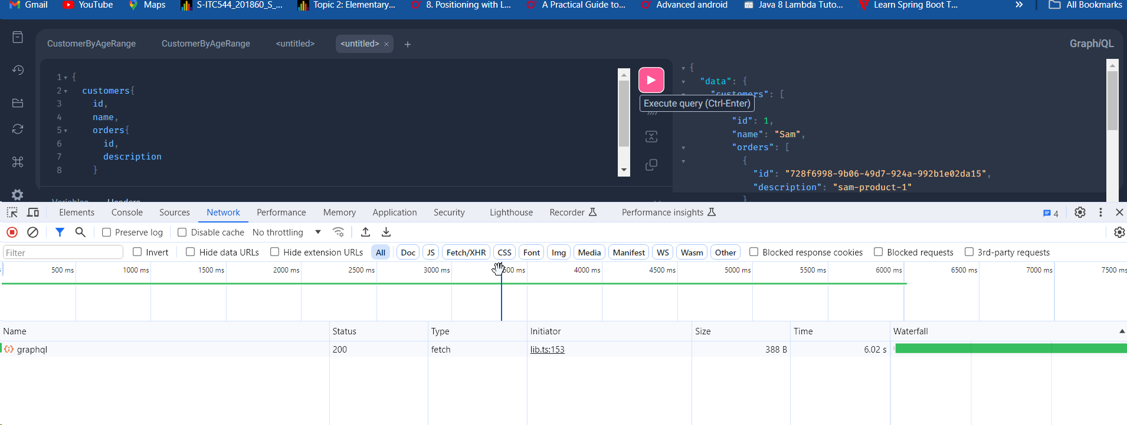

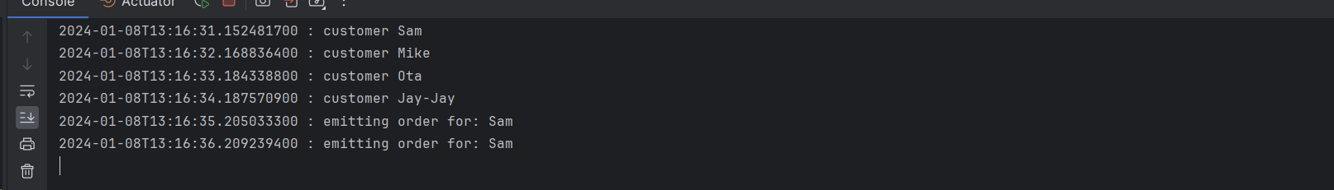

Now let us create REST api and check how long it will take to execute it:

@RestController  
public class CustomerREstController {  
  
 @Autowired  
 private CustomerService customerService;  
  
 @Autowired  
 private OrderService orderService;  
  
 @GetMapping("customers")  
 public Flux<CustomerWithOrder> customerOrders() {  
 return this.customerService.allCustomers()  
 .flatMap(c ->  
 this.orderService.ordersByCustomerName(c.getName())  
 .collectList()  
 .map(l -> CustomerWithOrder.*create*(c.getId(), c.getName(), c.getAge(), c.getCity(), l))  
 );  
 }  
  
 @Data  
 @AllArgsConstructor(staticName = "create")  
 @NoArgsConstructor  
 private static class CustomerWithOrder {  
 private Integer id;  
 private String name;  
 private Integer age;  
 private String city;  
 private List<CustomerOrderDto> orders;  
 }  
  
}

Here in this REST controller we are calling the same service classes and the execution takes 4 seconds which is less that GraphQL:

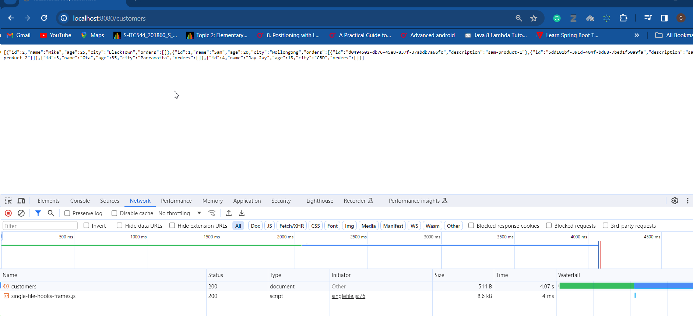

However if you check the logs:

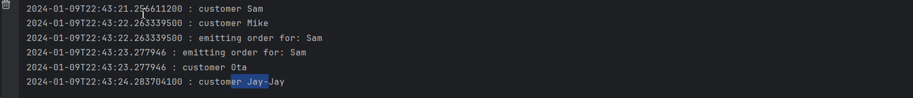

The Customers and orders coming in parallel, not like GraphQL(1st Customers will be collected then Orders)

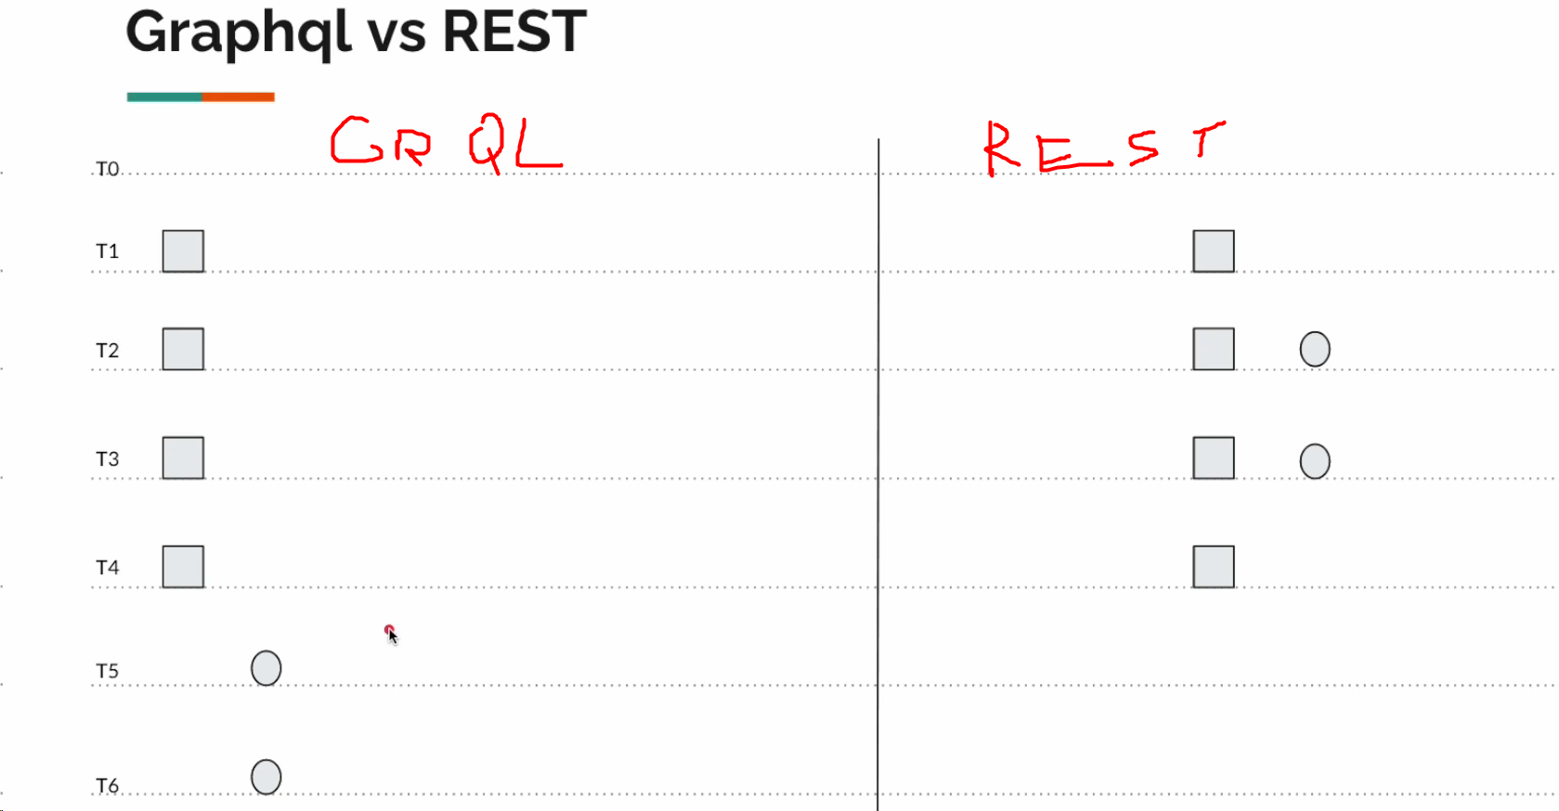

Orders

Orders

Now we can fix our GraphQL as well: (How to fetch the whole data Customer + orders in 4 seconds as REST)

We gonna change our Controller class and create new Fetcher class:

Controller:

@Controller  
public class CustomerController {  
  
 @Autowired  
 private CustomerOrderDataFetcher dataFetcher;  
  
 @SchemaMapping(typeName = "Query") // This is the same as QueryMapping  
 public Flux<CustomerWithOrder> customers(DataFetchingFieldSelectionSet selectionSet){  
 return this.dataFetcher.customerOrders(selectionSet);  
 }

}

And DataFetcher – as Service:

@Service  
public class CustomerOrderDataFetcher {  
 @Autowired  
 private CustomerService customerService;  
  
 @Autowired  
 private OrderService orderService;  
  
 public Flux<CustomerWithOrder> customerOrders(DataFetchingFieldSelectionSet selectionSet) {  
  
 var includeOrders = selectionSet.contains("orders");  
  
 System.*out*.println(includeOrders);  
  
 return this.customerService.allCustomers()  
 .map(c -> CustomerWithOrder.*create*(c.getId(), c.getName(), c.getAge(), c.getCity(), Collections.*emptyList*()))  
 .transform(this.updateOrderTransformer(includeOrders));  
 }  
  
 private UnaryOperator<Flux<CustomerWithOrder>> updateOrderTransformer(boolean includeOrders){  
 return includeOrders ? f -> f.flatMap(this::fetchOrders) : f -> f;  
 }  
  
 private Mono<CustomerWithOrder> fetchOrders(CustomerWithOrder customerWithOrder){  
 return this.orderService.ordersByCustomerName(customerWithOrder.getName())  
 .collectList()  
 .doOnNext(customerWithOrder::setOrders)  
 .thenReturn(customerWithOrder);  
 }  
}

We have also crete Dto class as a response:

@Data  
@AllArgsConstructor(staticName = "create")  
@NoArgsConstructor  
public class CustomerWithOrder {  
 private Integer id;  
 private String name;  
 private Integer age;  
 private String city;  
 private List<CustomerOrderDto> orders;  
}

As you can see we are now using DataFetchingFieldSelectionSet parameters in Controller above:

And no if I run our GraphiQL it will take 4 seconds as RESTful:

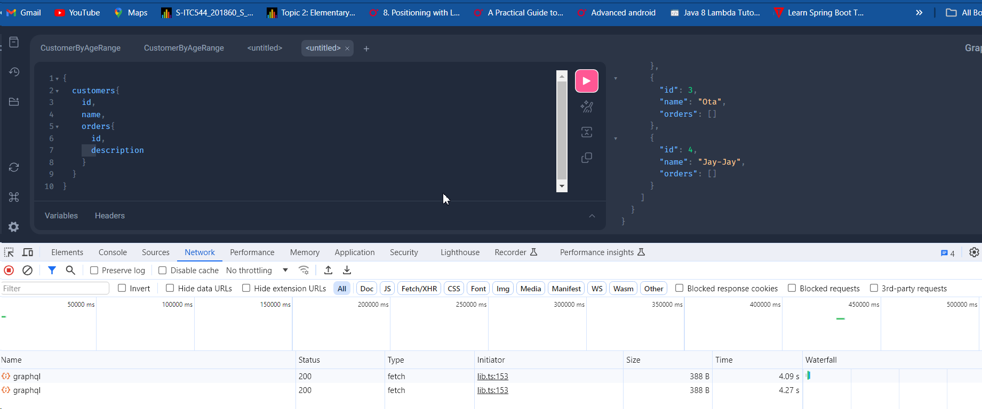

Now our logs show:

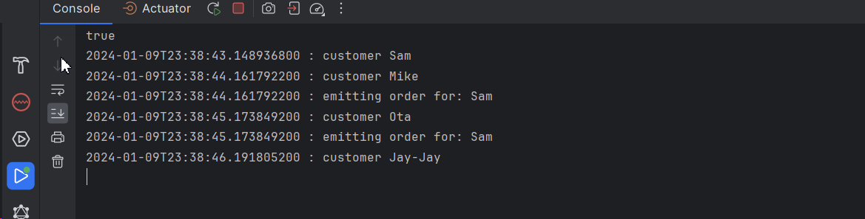

But if you wonder and want to print the orders in order(For example above, the Customer Sam printed the Mike and after it Sam’s order is printing, so this is kind a disordered) u can use **flatMapSequential** instead of **flatMap()**

@Service  
public class CustomerOrderDataFetcher {  
 @Autowired  
 private CustomerService customerService;  
  
 @Autowired  
 private OrderService orderService;  
  
 public Flux<CustomerWithOrder> customerOrders(DataFetchingFieldSelectionSet selectionSet) {  
  
 var includeOrders = selectionSet.contains("orders");  
  
 System.*out*.println(includeOrders);  
  
 return this.customerService.allCustomers()  
 .map(c -> CustomerWithOrder.*create*(c.getId(), c.getName(), c.getAge(), c.getCity(), Collections.*emptyList*()))  
 .transform(this.updateOrderTransformer(includeOrders));  
 }  
  
 private UnaryOperator<Flux<CustomerWithOrder>> updateOrderTransformer(boolean includeOrders){

return includeOrders ? f -> f.flatMapSequential(this::fetchOrders) : f -> f;  
 }  
  
 private Mono<CustomerWithOrder> fetchOrders(CustomerWithOrder customerWithOrder){  
 return this.orderService.ordersByCustomerName(customerWithOrder.getName())  
 .collectList()  
 .doOnNext(customerWithOrder::setOrders)  
 .thenReturn(customerWithOrder);  
 }  
}

Now result will be secuential:

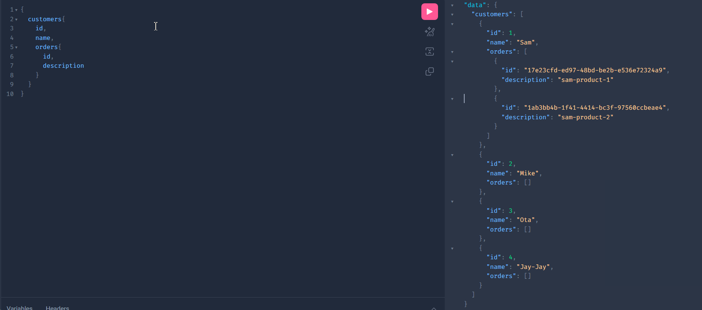

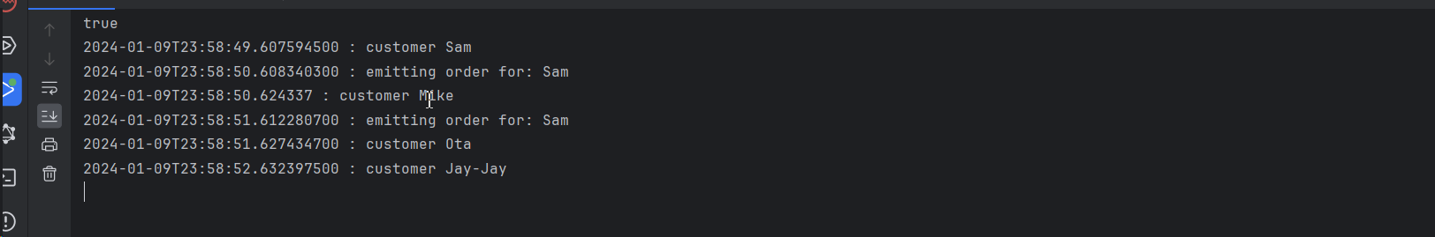

**Runtime wiring Bean**

So far, the GraphQL is calling the API’s and it wires it automatically, Say if we have 5 API’s under the same method name, Graphql will found the appropriate API to the call and it wires it by itself.

However, we can wire it by our chose as well.

We have integrated interface for DataFetcher:

@PublicSpi  
public interface DataFetcher<T> {  
 T get(DataFetchingEnvironment environment) throws Exception;  
}

In our service (CustomerOrderDataFetcher) class we will change the implementation. We need to implement the interface w mentioned above:

package com.graphql.praphqlplay.lec07.service;  
  
import com.graphql.praphqlplay.lec07.entity.CustomerWithOrder;  
import graphql.schema.DataFetcher;  
import graphql.schema.DataFetchingEnvironment;  
import org.springframework.beans.factory.annotation.Autowired;  
import org.springframework.stereotype.Service;  
import reactor.core.publisher.Flux;  
import reactor.core.publisher.Mono;  
  
import java.util.Collections;  
import java.util.function.UnaryOperator;  
  
@Service  
public class CustomerOrderDataFetcher implements DataFetcher<Flux<CustomerWithOrder>> {  
  
 @Autowired  
 private CustomerService customerService;  
  
 @Autowired  
 private OrderService orderService;  
  
 @Override  
 public Flux<CustomerWithOrder> get(DataFetchingEnvironment environment) throws Exception {  
 var includeOrders = environment.getSelectionSet().contains("orders");  
  
 System.*out*.println(includeOrders);  
  
 return this.customerService.allCustomers()  
 .map(c -> CustomerWithOrder.*create*(c.getId(), c.getName(), c.getAge(), c.getCity(), Collections.*emptyList*()))  
 .transform(this.updateOrderTransformer(includeOrders));  
 }  
  
 private UnaryOperator<Flux<CustomerWithOrder>> updateOrderTransformer(boolean includeOrders){  
 return includeOrders ? f -> f.flatMapSequential(this::fetchOrders) : f -> f;  
 }  
  
 private Mono<CustomerWithOrder> fetchOrders(CustomerWithOrder customerWithOrder){  
 return this.orderService.ordersByCustomerName(customerWithOrder.getName())  
 .collectList()  
 .doOnNext(customerWithOrder::setOrders)  
 .thenReturn(customerWithOrder);  
 }  
}

The rest classes are the same except we created new Config.class:

In this configuration class, we referencing to the bean that must wire. (This job was done automatically before by the GraphQl.)

import com.graphql.praphqlplay.lec07.service.CustomerOrderDataFetcher;  
import org.springframework.beans.factory.annotation.Autowired;  
import org.springframework.context.annotation.Bean;  
import org.springframework.context.annotation.Configuration;  
import org.springframework.graphql.execution.RuntimeWiringConfigurer;  
  
@Configuration  
public class DataFetcherWiringConfig {  
  
 @Autowired  
 private CustomerOrderDataFetcher dataFetcher;  
  
 @Bean  
 public RuntimeWiringConfigurer configurer(){  
 //Here we are manually wiring the bean.  
 //Here we can wire the type in the schema  
 return c -> c.type("Query", b ->b.dataFetcher("customers", dataFetcher));  
 }  
}

For this, we do not need any Controllers: All the DTO s and Entity classes a the same as above. And Schema.graphqls as well.

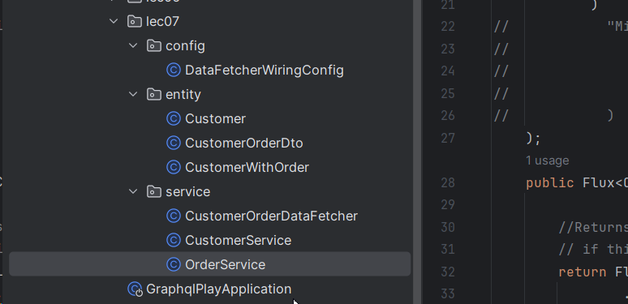

The result is the same:

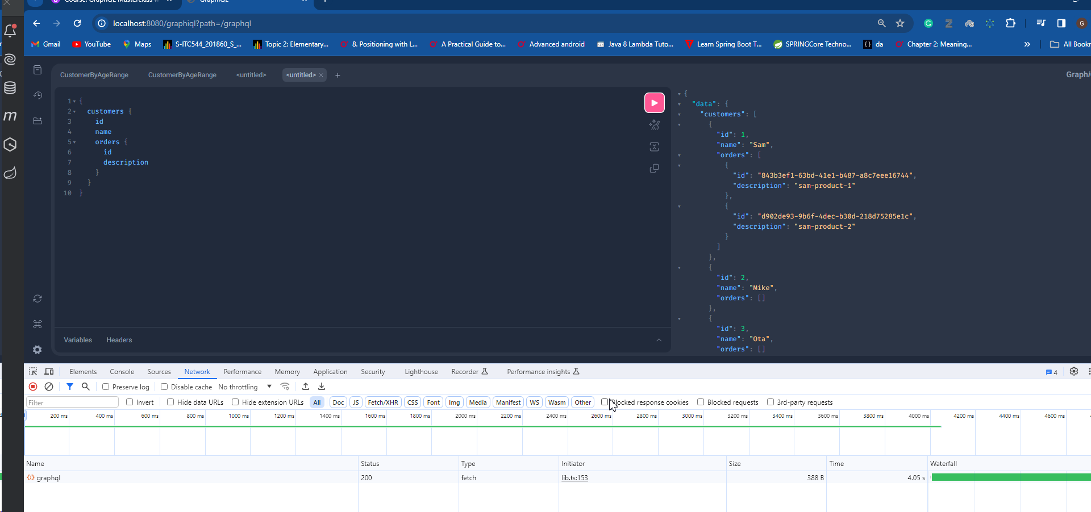

For DataFetcher Config class, we can use Map as well:

@Bean  
public RuntimeWiringConfigurer configurer(){  
 //Here we are manually wiring the bean.  
 //Here we can wire the type in the schema  
 return c -> c.type("Query", b -> b.dataFetchers(map()));  
}  
  
private Map<String, DataFetcher> map(){  
 return Map.*of*(  
 "customers", dfe -> "s",  
 "age", dfe -> 12,  
 "city", dfe -> "sydney"  
 );  
}

**Field globe pattern**

Let us create super sub level schema like this:

type Query {  
 level1: Level1  
}  
type Level1{  
  
 level2: Level2  
}  
type Level2{  
 level3: Level3  
}  
type Level3{  
 leven4: Level4  
}  
type Level4{  
 level5: Level5  
}  
type Level5{  
 id: ID  
}

And create one controller class:

import graphql.schema.DataFetchingFieldSelectionSet;  
import org.springframework.graphql.data.method.annotation.QueryMapping;  
import org.springframework.stereotype.Controller;  
  
@Controller  
public class FieldGlobePatternController {  
  
 @QueryMapping  
 public Object level1(DataFetchingFieldSelectionSet selectionSet){  
 System.*out*.println(selectionSet.contains("level2"));  
 System.*out*.println(selectionSet.contains("level3"));  
 return null;  
 }  
}

Here as you can see we are trying to print the Boolean value. So we know that level1 only contains level2 fiesd, therefore, the 2nd print will be printing false:

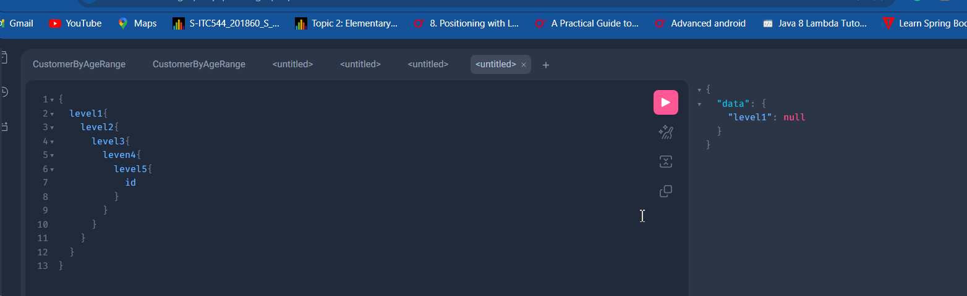

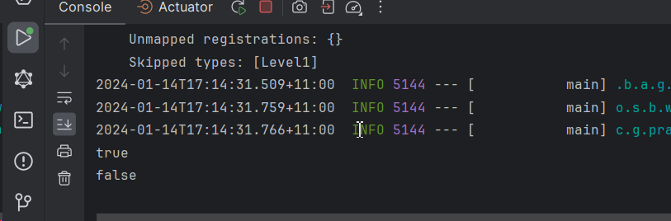

However we can fix it by doing this:

import graphql.schema.DataFetchingFieldSelectionSet;  
import org.springframework.graphql.data.method.annotation.QueryMapping;  
import org.springframework.stereotype.Controller;  
  
@Controller  
public class FieldGlobePatternController {  
  
 @QueryMapping  
 public Object level1(DataFetchingFieldSelectionSet selectionSet){  
 System.*out*.println(selectionSet.contains("level2"));  
 System.*out*.println(selectionSet.contains("level2/level3")); //true  
 System.*out*.println(selectionSet.contains("\*\*/level3")); //true  
 System.*out*.println(selectionSet.contains("level2/\*/level5")); //false

System.*out*.println(selectionSet.contains("level2/\*\*/level5")); //true

return null;  
 }  
}

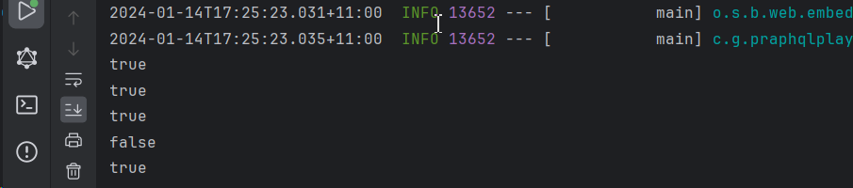

\_\_\_\_\_\_\_\_\_\_\_\_\_\_\_\_\_\_\_\_\_

**MAVEN DEPENDENCY for Particular types that Graphql lacks**

In the upcoming lectures we need some types that GraphqL can not provide itself, like Data, Time and so on.

1. <dependency>
2. <groupId>com.graphql-java</groupId>
3. <artifactId>graphql-java-extended-scalars</artifactId>
4. <version>18.1</version>
5. </dependency>

**SCALAR TYPES**

This is all the scalar that dependency has :

@PublicApi  
public class ExtendedScalars {  
 public static final GraphQLScalarType *DateTime*;  
 public static final GraphQLScalarType *Date*;  
 public static final GraphQLScalarType *Time*;  
 public static final GraphQLScalarType *LocalTime*;  
 public static final GraphQLScalarType *Object*;  
 public static final GraphQLScalarType *Json*;  
 public static final GraphQLScalarType *Url*;  
 public static final GraphQLScalarType *Locale*;  
 public static final GraphQLScalarType *Currency*;  
 public static final GraphQLScalarType *CountryCode*;  
 public static GraphQLScalarType *UUID*;  
 public static final GraphQLScalarType *PositiveInt*;  
 public static final GraphQLScalarType *NegativeInt*;  
 public static final GraphQLScalarType *NonPositiveInt*;  
 public static final GraphQLScalarType *NonNegativeInt*;  
 public static final GraphQLScalarType *PositiveFloat*;  
 public static final GraphQLScalarType *NegativeFloat*;  
 public static final GraphQLScalarType *NonPositiveFloat*;  
 public static final GraphQLScalarType *NonNegativeFloat*;  
 public static final GraphQLScalarType *GraphQLLong*;  
 public static final GraphQLScalarType *GraphQLShort*;  
 public static final GraphQLScalarType *GraphQLByte*;  
 public static final GraphQLScalarType *GraphQLBigDecimal*;  
 public static final GraphQLScalarType *GraphQLBigInteger*;  
 public static final GraphQLScalarType *GraphQLChar*;  
  
 public ExtendedScalars() {  
 }

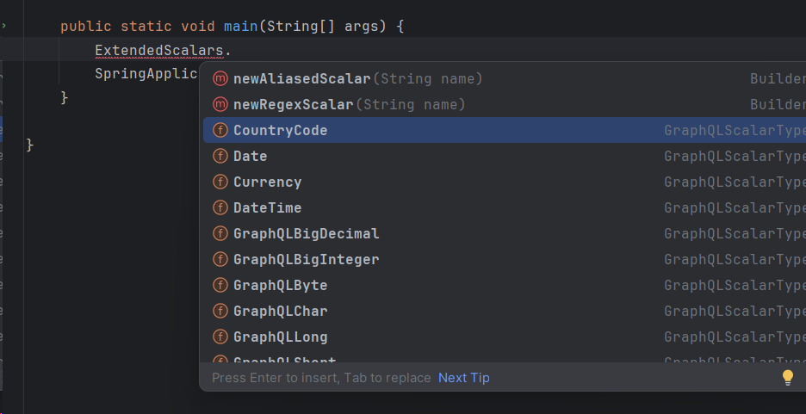

Here we created our schema.graphqls:

scalar Long  
scalar Short  
scalar Byte  
scalar BigDecimal  
scalar DateTime  
scalar LocalTime  
  
type Query{  
 get: allTypes  
}  
  
type allTypes {  
  
 id: ID,  
 height: Int,  
 temp: Float,  
 city: String,  
 isValid: Boolean,  
 distance: Long,  
 ageInYears: Byte,  
 ageMonth: Short,  
 bigDecimal: BigDecimal,  
 dateTime: DateTime,  
 localTime: LocalTime  
 car: Car  
}  
enum Car{  
 *BMW  
 MERCEDES*}

Now we have to register these scalar in our Config.class:

import graphql.scalars.ExtendedScalars;  
import org.springframework.context.annotation.Bean;  
import org.springframework.context.annotation.Configuration;  
import org.springframework.graphql.execution.RuntimeWiringConfigurer;  
  
@Configuration  
public class ScalarConfig {  
  
 //We have to here register all our scalar types we used in our schema  
 @Bean  
 public RuntimeWiringConfigurer configurer(){  
 return c -> c  
 .scalar(ExtendedScalars.*GraphQLLong*)  
 .scalar(ExtendedScalars.*GraphQLByte*)  
 .scalar(ExtendedScalars.*GraphQLShort*)  
 .scalar(ExtendedScalars.*GraphQLBigDecimal*)  
 .scalar(ExtendedScalars.*Date*)  
 .scalar(ExtendedScalars.*LocalTime*)  
 .scalar(ExtendedScalars.*DateTime*);  
 }  
}

And We can create our Dto:

import java.math.BigDecimal;  
import java.time.LocalDate;  
import java.time.LocalTime;  
import java.time.OffsetDateTime;  
import java.util.UUID;  
  
@Data  
@AllArgsConstructor  
@NoArgsConstructor  
public class AllTypes {  
 private UUID id;  
 private Integer height;  
 private Float temp;  
 private String city;  
 private Boolean isValid;  
 private Long distance;  
 private Byte ageIntYears;  
 private Short ageMonth;  
 private BigDecimal bigDecimal;  
 private LocalDate date; //Here we have to use LoalDate as scalar user LocalDate

private LocalTime time;  
 private OffsetDateTime dateTime;  
 private Car car;  
}

package com.graphql.praphqlplay.lec09.dto;  
  
public enum Car {  
 *BMW*,*MERCEDES*}

Now we need to create Controller class to return all the typos to demo the serialization to types:

package com.graphql.praphqlplay.lec09.dto;  
  
import org.springframework.graphql.data.method.annotation.QueryMapping;  
import org.springframework.stereotype.Controller;  
import reactor.core.publisher.Mono;  
  
import java.math.BigDecimal;  
import java.time.LocalDate;  
import java.time.LocalTime;  
import java.time.OffsetDateTime;  
import java.util.UUID;  
  
@Controller  
public class ScalarController {  
  
 private AllTypes allTypes = AllTypes.*create*(  
 UUID.*randomUUID*(),  
 10,  
 10.88f,  
 "Eastlakes",  
 false,  
 120000000L,  
 Byte.*valueOf*("12"),  
 Short.*valueOf*("11"),  
 BigDecimal.*valueOf*(123456789.123456789),  
 LocalDate.*now*(),  
 LocalTime.*now*(),  
 OffsetDateTime.*now*(),  
 Car.*MERCEDES* );  
  
 @QueryMapping  
 public Mono<AllTypes> get(){  
 return Mono.*just*(allTypes);  
 }  
}

Now open our playground and send the query:

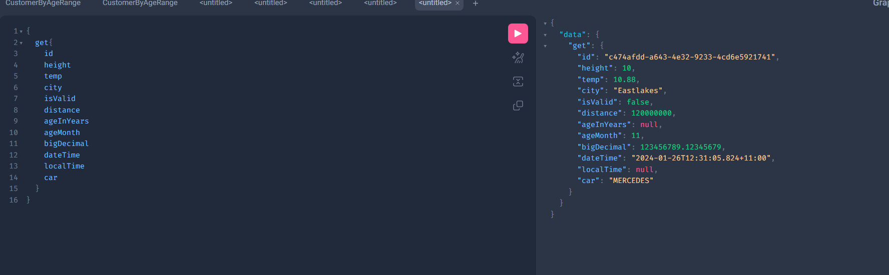

Object/JSON Scalar

Sometimes the types can be very comprehensive like our Product class:  
@Data  
@AllArgsConstructor(staticName = "create")  
@NoArgsConstructor  
public class Product {  
  
 private String name;  
 private Map<String, String> attributes;  
}

Here as you can see the type of Product has field like Map<> which in turn has key/value pair: So it is very difficult to establish this type in the schema:

So you can use Object type scalar: in the schema.graphqls

scalar Long  
scalar Short  
scalar Byte  
scalar BigDecimal  
scalar Date  
scalar DateTime  
scalar LocalTime

scalar Object  
  
type Query{  
 get: allTypes  
 products: [Product]  
}  
  
type allTypes {  
 id: ID,  
 height: Int,  
 temp: Float,  
 city: String,  
 isValid: Boolean,  
 distance: Long,  
 ageInYears: Byte,  
 ageMonth: Short,  
 bigDecimal: BigDecimal,  
 dateTime: DateTime,  
 localTime: LocalTime  
 car: Car  
}  
enum Car{  
 *BMW  
 MERCEDES*}  
  
type Product{  
 name: String  
 attributes: Object  
}

So now we can create new QueryMapping:

@QueryMapping  
public Flux<Product> products(){  
 return Flux.*just*(  
 Product.*create*("banana", Map.*of*(  
 "expiry date", "01/01/2025",  
 "color", "yellow"  
 )),  
 Product.*create*("mac", Map.*of*(  
 "cpu", "8",  
 "RAM", "64g"  
 ))  
 );  
}

And also need s to be added in the config as well:

@Configuration  
public class ScalarConfig {  
  
 //We have to here register all our scalar types we used in our schema  
 @Bean  
 public RuntimeWiringConfigurer configurer(){  
 return c -> c  
 .scalar(ExtendedScalars.*GraphQLLong*)  
 .scalar(ExtendedScalars.*GraphQLByte*)  
 .scalar(ExtendedScalars.*GraphQLShort*)  
 .scalar(ExtendedScalars.*GraphQLBigDecimal*)  
 .scalar(ExtendedScalars.*Date*)  
 .scalar(ExtendedScalars.*LocalTime*)  
 .scalar(ExtendedScalars.*DateTime*)  
 .scalar(ExtendedScalars.*Object*);  
 }  
}

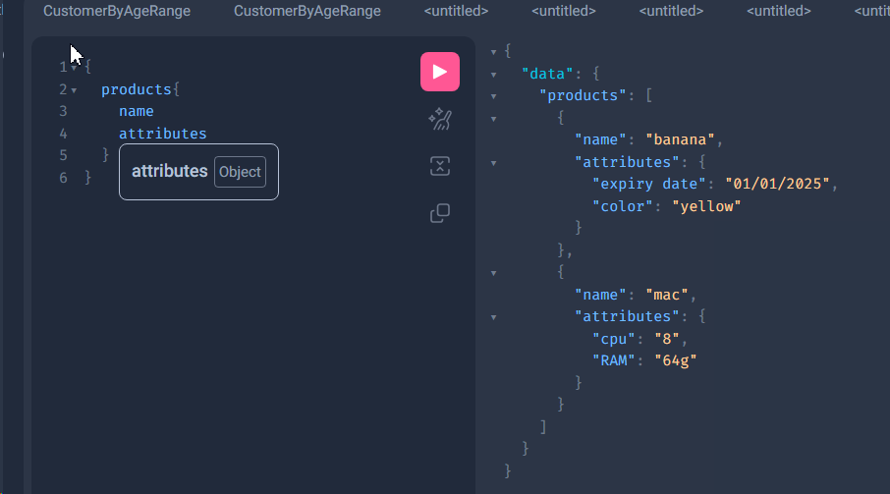

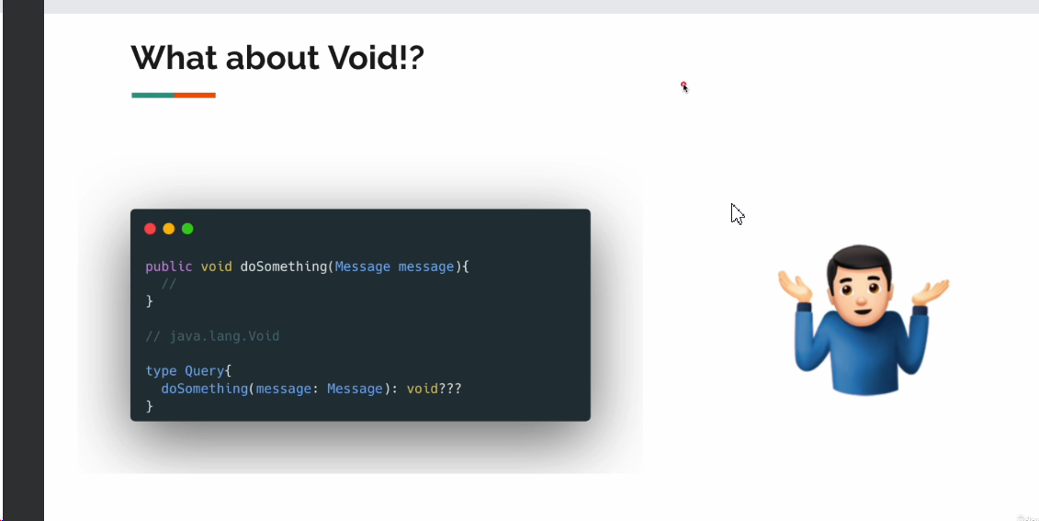

**Graphql Interface – SCHEMA design**

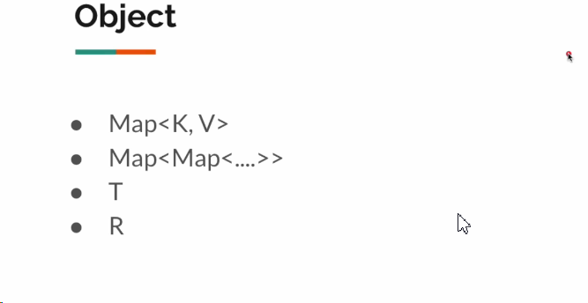

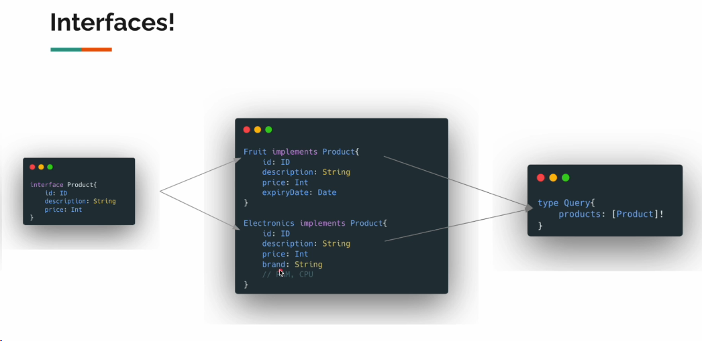

As we know, interface can be used for common fields as abstract classes, so Implementing classes can add their own fields as well: we will use lec10 for this:

Let us create types that implements (in GRAPHQL they are extends from interfaces)

type Query{  
 products: [Product]  
}  
  
interface Product{  
 id: ID  
 description: String  
 price: Int  
}  
  
type Fruit implements Product{  
 id: ID!  
 description: String  
 price: Int  
 expiryDate: String  
}  
  
type Electronics implements Product{  
 id: ID!  
 description: String  
 price: Int  
 brand: Brand  
}  
  
enum Brand{  
 *APPLE*, *SAMSUNG*}  
  
type Book implements Product{  
 id: ID!  
 description: String  
 price: Int  
 author: String  
}

as you see we have a query that has field of Interface of **PRODUCT**

Now create appropriate classes:

@Data  
@AllArgsConstructor(staticName = "create")  
@NoArgsConstructor  
public class Book {  
 private final UUID id = UUID.*randomUUID*();  
 private String description;  
 private Integer price;  
 private String author;  
  
}

@Data  
@AllArgsConstructor(staticName = "create")  
@NoArgsConstructor  
public class Electronics {  
  
 private final UUID id = UUID.*randomUUID*();  
 private String description;  
 private Integer price;  
 private String brand;  
}

@Data  
@AllArgsConstructor(staticName = "create")  
@NoArgsConstructor  
public class Fruit {  
  
 private final UUID id = UUID.*randomUUID*();  
 private String description;  
 private Integer price;  
 private LocalDate expiryDate;  
}

As you see we didn’t created any abstract class or interface in the DTO, But 3 fields are the same:

Now our Controller class:

@Controller  
public class ProductController {  
  
 @QueryMapping  
 public Flux<Object> products(){  
  
 return Flux.*just*(  
 Fruit.*create*("banana", 1, LocalDate.*now*().plusDays(3)),  
 Fruit.*create*("apple", 1, LocalDate.*now*().plusDays(15)),  
 Electronics.*create*("Dell", 600, "APPLE"),  
 Electronics.*create*("APPLE", 590, "SAMSUNG"),  
 Book.*create*("Java", 40, "Matlab")  
 );  
 }  
}

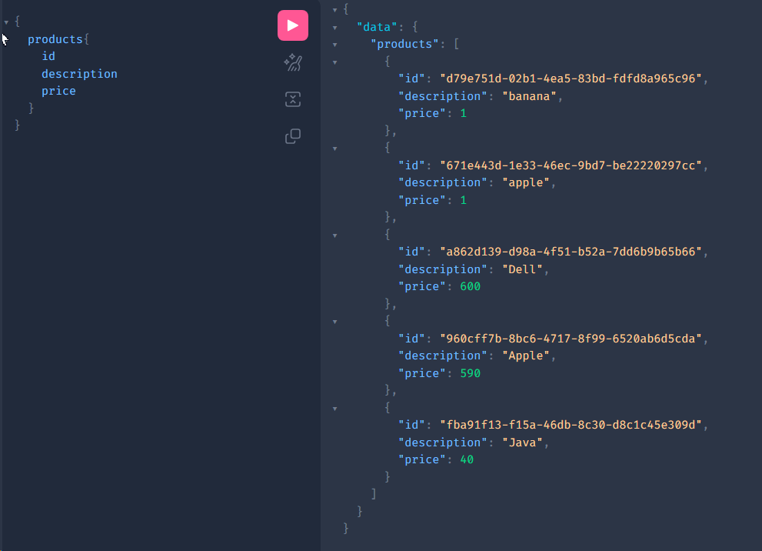

But where is the 4th fields. For example for Boor author, Electronics- brand and so on:

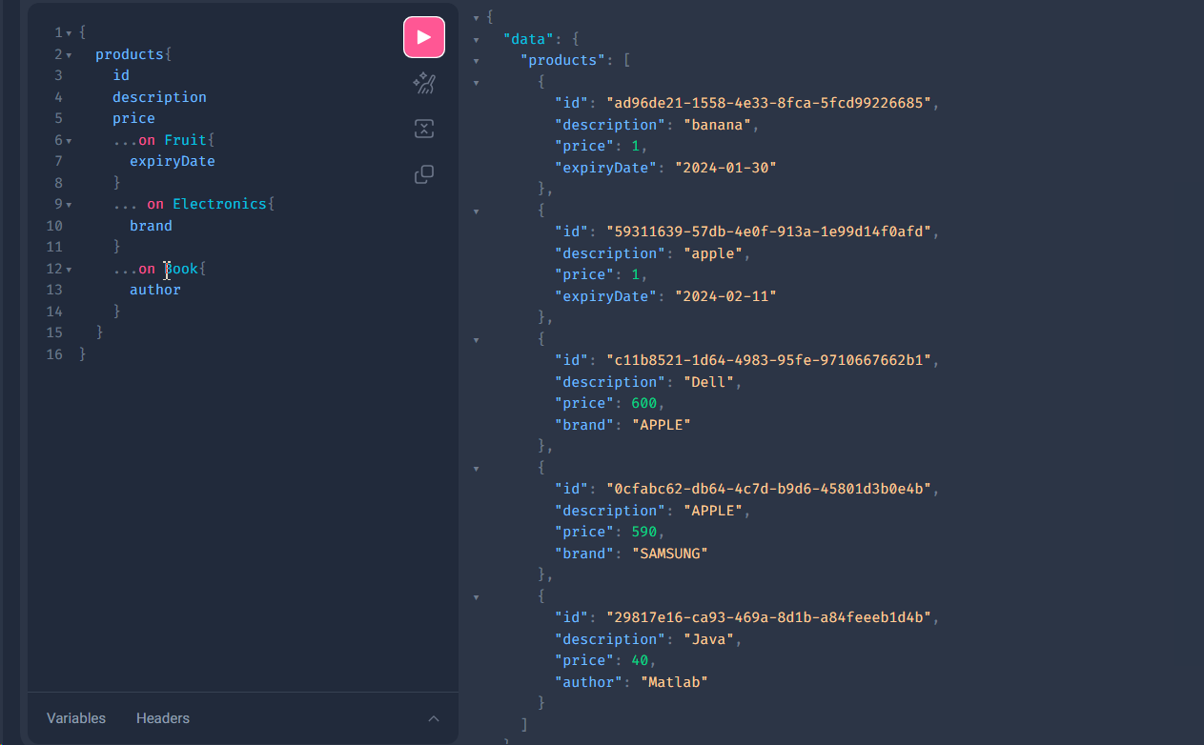

So in the above query we are saying or asking if the Type is Book then please provide us author field as well, if Fruit then expiry date and so on.

We can also see of each object belongs to the type by adding \_\_type field in the query:

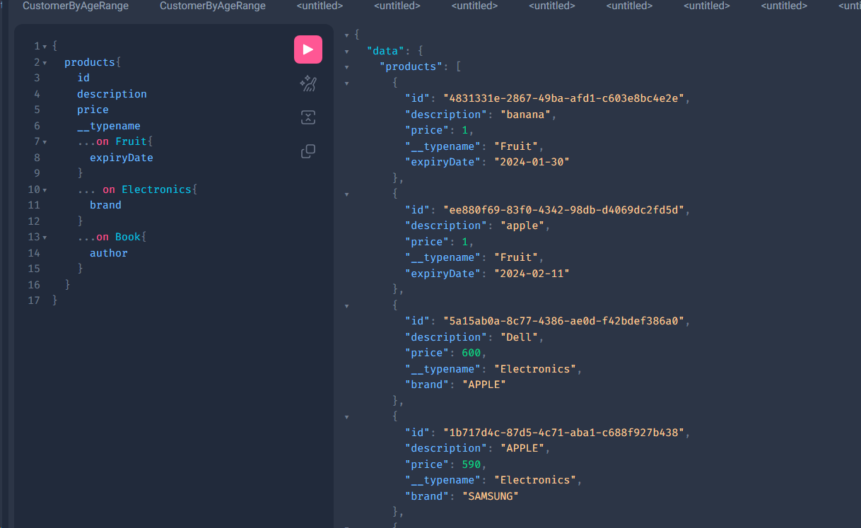

Here we have a question, HOW graphQl know the which Type implements Product or instance of particular type?

So all the Class name must match exactly with the Schema, So Imagine If we change some of the Classes say Book to Books

Then it will throw an error and exception:

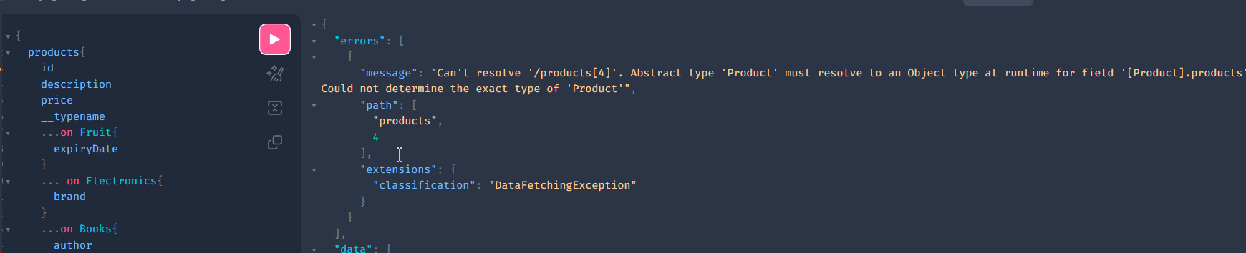

So here it says Product does not match the class.

So we can resolve this: Here below we changed Our Fruit class name to FruitDto.class

Now we need to create Config class that will map it with resolver:

@Data  
@AllArgsConstructor(staticName = "create")  
@NoArgsConstructor  
public class FruitDto {  
  
 private final UUID id = UUID.*randomUUID*();  
 private String description;  
 private Integer price;  
 private LocalDate expiryDate;  
}

Here Below is our Resolver Config:

import com.graphql.praphqlplay.lec10.dto.FruitDto;  
import graphql.schema.TypeResolver;  
import org.springframework.context.annotation.Bean;  
import org.springframework.context.annotation.Configuration;  
import org.springframework.graphql.execution.ClassNameTypeResolver;  
import org.springframework.graphql.execution.RuntimeWiringConfigurer;  
  
@Configuration  
public class TypeResolverConfig {  
  
 @Bean  
 public RuntimeWiringConfigurer configurer(TypeResolver resolver){  
 return c -> c.type("Product", b -> b.typeResolver(resolver));  
 }  
  
 @Bean  
 public TypeResolver typeResolver(){  
 ClassNameTypeResolver resolver = new ClassNameTypeResolver();  
 resolver.addMapping(FruitDto.class, "Fruit");  
 return resolver;  
 }  
}

So there is no issue at all now:

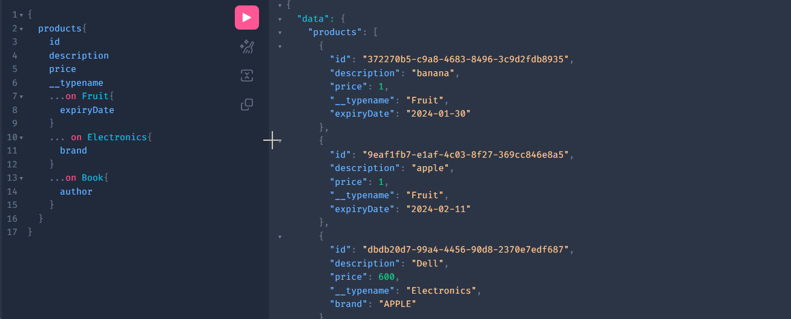

Real life use case of **Interface**

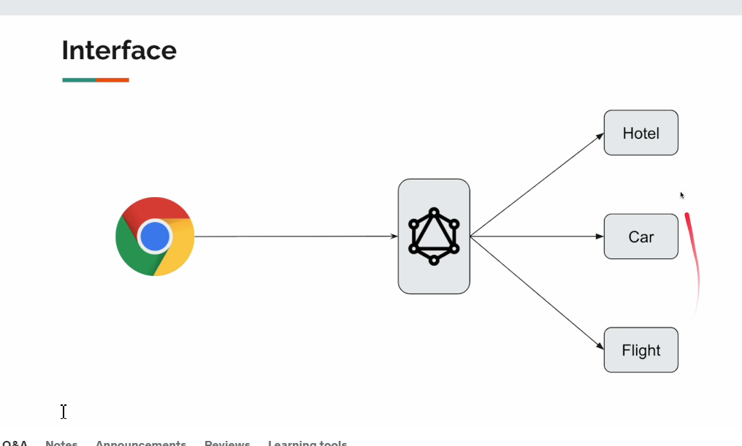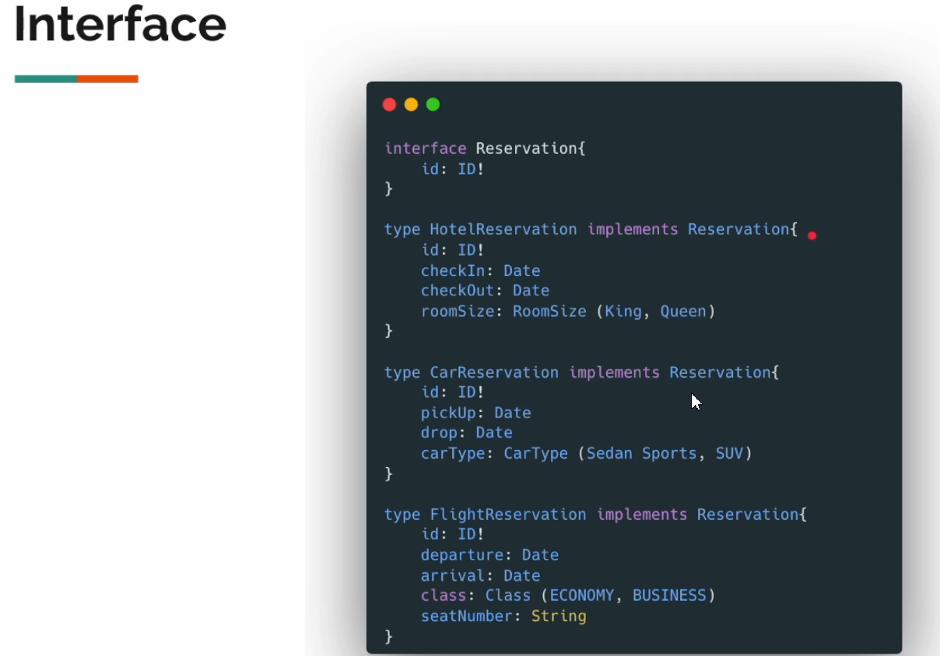

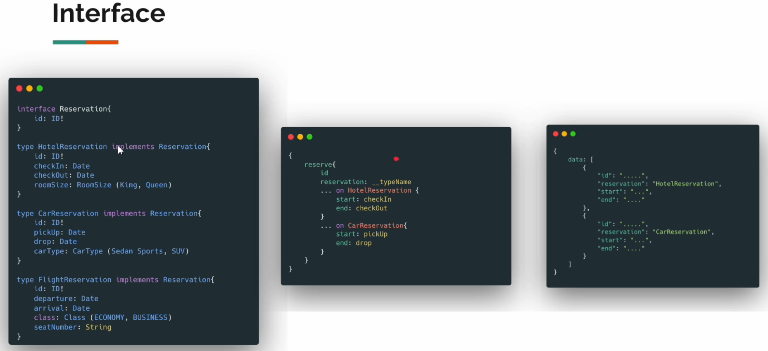

**GRaphQL- UNION**

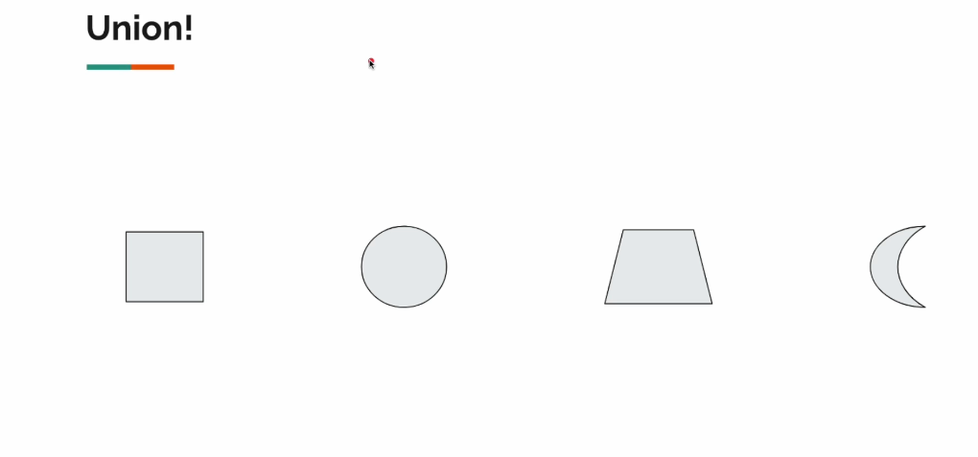

If you search on the internet, example apple: it gives you everything from apple phones, to apple fruit or even apple logo. So it means the search is not specific.

So, result could be one of the figures. This is the UNION comes to picture.

**UNION schema design**

return Mono.fromSupplier(()-> new ArrayList<>(list)) .doOnNext(Collections::shuffle) .flatMapIterable(Function.identity()) .take(ThreadLocalRandom.current().nextInt(0, list.size())); }

ChatGPT

**ChatGPT**

This code appears to be written in Java and uses the Reactor library, which is commonly used for reactive programming. Let's break down what each part of the code does:

1. **Mono.fromSupplier(() -> new ArrayList<>(list))**: This creates a Mono, which is a reactive type representing a single value or no value. It uses a supplier function to generate the value asynchronously. In this case, it creates a new ArrayList containing all elements from the **list** provided as an input.
2. **.doOnNext(Collections::shuffle)**: This is a side-effect operation applied to each item emitted by the previous Mono. It shuffles the elements of the ArrayList using **Collections.shuffle()**.
3. **.flatMapIterable(Function.identity())**: This operator is used to transform each emitted item into an Iterable, and then flattens these iterables into a single sequence. **Function.identity()** here serves as a mapping function that returns the input unchanged.
4. **.take(ThreadLocalRandom.current().nextInt(0, list.size()))**: This operator takes the specified number of elements from the sequence. In this case, it takes a random number of elements between 0 (inclusive) and the size of the original list (exclusive), using **ThreadLocalRandom** to generate a random number.

Overall, this code takes a list, shuffles its elements asynchronously, then flattens the shuffled list, and finally takes a random number of elements from it. The result is a reactive stream (Mono) containing the randomly selected elements.



**You**

Can you give an example to .flatMapIterable(Function.identity())

ChatGPT

**ChatGPT**

Certainly! Let's consider a simple example to demonstrate the use of **.flatMapIterable(Function.identity())**. Suppose we have a list of lists, and we want to flatten this structure into a single list.

public class Main {  
 public static void main(String[] args) {  
 List<List<Integer>> listOfLists = new ArrayList<>();  
 listOfLists.add(Arrays.asList(1, 2, 3));  
 listOfLists.add(Arrays.asList(4, 5));  
 listOfLists.add(Arrays.asList(6, 7, 8));  
  
 listOfLists.stream()  
 .flatMap(list -> list.stream())  
 .forEach(System.*out*::println);  
 }  
}

In this example:

* We have a list of lists called **listOfLists**.
* We use the **flatMap** operation to transform each list within **listOfLists** into a stream of its elements.
* Then, we use **forEach** to print each element.

The output will be:

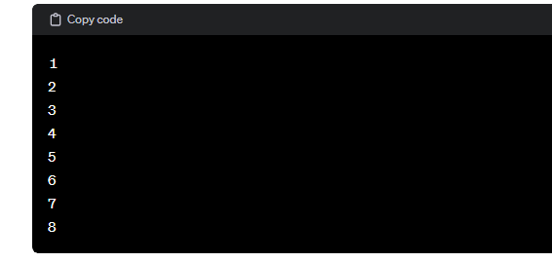

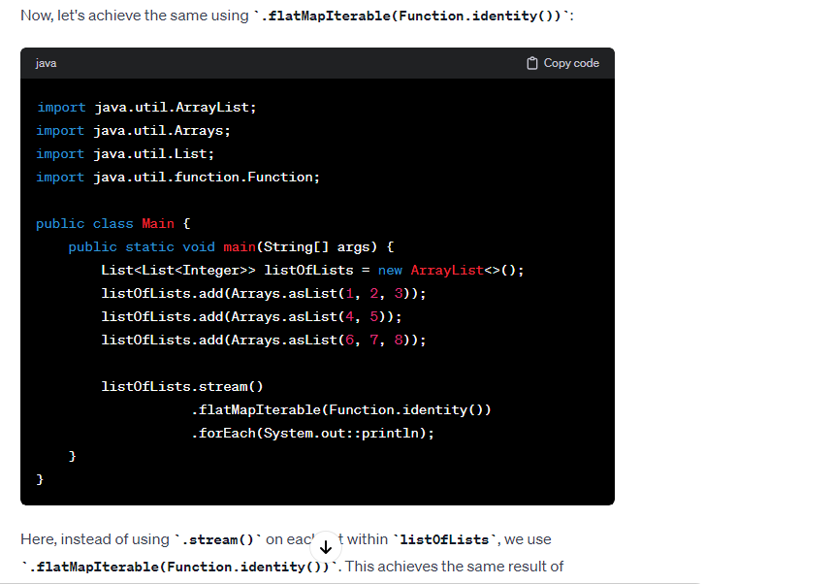

Now we will add some type in the schema.graphqls:

type Query{  
 search: [Result]  
}  
#Here the result could be one of these types  
union Result = Fruit | Electronics | Book  
  
type Fruit {  
 description: String  
 expiryDate: String  
}  
  
type Electronics {  
 id: ID!  
 description: String  
 price: Int  
 brand: Brand  
}  
  
enum Brand{  
 *APPLE*, *SAMSUNG*}  
  
type Book {  
 title: String  
 author: String  
}

An our DTO classes:

@Data  
@AllArgsConstructor(staticName = "create")  
@NoArgsConstructor  
public class Book {  
 private String title;  
 private String author;  
}

@Data  
@AllArgsConstructor(staticName = "create")  
@NoArgsConstructor  
public class Electronics {  
 private final UUID id = UUID.*randomUUID*();  
 private String description;  
 private Integer price;  
 private String brand;  
}

@Data  
@AllArgsConstructor(staticName = "create")  
@NoArgsConstructor  
public class FruitDto {  
 private String description;  
 private LocalDate expiryDate;  
}

Since we have difference between FruitDto.class and type Fruit type (schema), we need our Config resolver.

@Configuration  
public class TypeResolverConfig {  
  
 @Bean  
 public RuntimeWiringConfigurer configurer(TypeResolver resolver){  
 return c -> c.type("Result", b -> b.typeResolver(resolver));  
 }  
  
 @Bean  
 public TypeResolver typeResolver(){  
 ClassNameTypeResolver resolver = new ClassNameTypeResolver();  
 resolver.addMapping(FruitDto.class, "Fruit");  
 return resolver;  
 }  
}

And our controller:  
  
@Controller  
public class SearchEngineController {  
  
 List<Object> list = List.*of*(  
 FruitDto.*create*("banana", LocalDate.*now*().plusDays(3)),  
 FruitDto.*create*("apple", LocalDate.*now*().plusDays(15)),  
 Electronics.*create*("Dell", 600, "APPLE"),  
 Electronics.*create*("APPLE", 590, "SAMSUNG"),  
 Book.*create*("Java","Matlab")  
 );  
  
 @QueryMapping  
 public Flux<Object> search(){  
 return Mono.*fromSupplier*(()-> new ArrayList<>(list))  
 .doOnNext(Collections::*shuffle*)

// this will flatten our map similar to flatMap  
 .flatMapIterable(Function.*identity*())  
 //take random number of elements  
 .take(ThreadLocalRandom.*current*().nextInt(0, list.size()));  
 }  
}

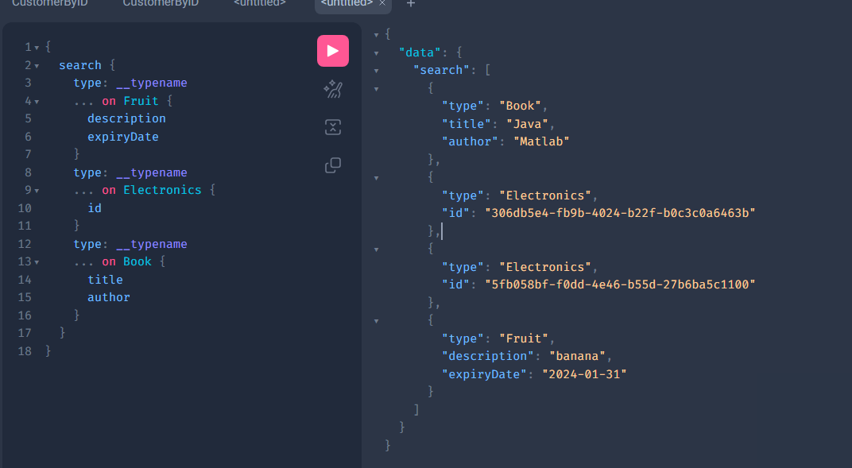

**OPERATION\_CACHING**

Before giving the response, the GraphQl server spend time to resolve the type and appropriate methods and so on .

So, we can cache it save the time.

Let us enable debugging and check what is happening in the GRAPHQL logs:

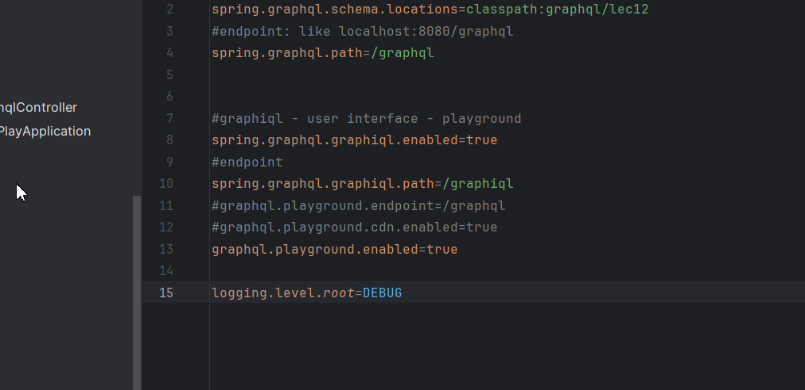

Call the sayHello method and you will see:

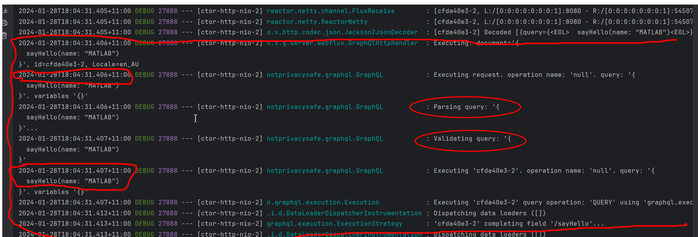

As you see, it spends some time between Executing the query till Validating.

So, Parsing and Validation is happening in each and every query request, We can somehow cache this.

It will save us time. This will be helpful if this is repeating over and over again.

Lets improve this:

Here is new configuration:

@Configuration  
@Sl4j

public class OperationCachingConfig {  
   
 /\*  
 \* request body  
 \* exe doc  
 \* parse (needs caching)  
 \* validation (needs caching)  
 \* exe doc  
 \*  
 \*/  
  
 @Bean  
 public GraphQlSourceBuilderCustomizer sourceBuilderCustomizer(PreparsedDocumentProvider provider){  
  
 //This GraphQlSourceBuilderCustomizer is functional interface  
// return (GraphQlSource.SchemaResourceBuilder builder1) -> builder1.configureGraphQl(provide -> provide.preparsedDocumentProvider(provider));  
  
 return c -> c.configureGraphQl(builder -> builder.preparsedDocumentProvider(provider));  
 }  
  
 @Bean  
 public PreparsedDocumentProvider provider(){  
  
 return new PreparsedDocumentProvider() {  
 Map<String, PreparsedDocumentEntry> map =new HashMap<>();  
 @Override  
 public PreparsedDocumentEntry getDocument(ExecutionInput executionInput, Function<ExecutionInput, PreparsedDocumentEntry> parseAndValidateFunction) {  
 *log*.info("Calling preparsed document");  
  
 String query = executionInput.getQuery();  
  
 if(map.containsKey(executionInput.getQuery())){  
 *log*.info("Found in the cache {}", query);  
 return map.get(executionInput.getQuery());  
 }  
 *log*.info("Not cached ... caching it {}", query);  
 PreparsedDocumentEntry preparsedDocumentEntry = parseAndValidateFunction.apply(executionInput);  
 map.put(executionInput.getQuery(), preparsedDocumentEntry);  
 return preparsedDocumentEntry;  
 }  
 };  
 }  
}

So if we call the same query more that one time it will get it from cache:

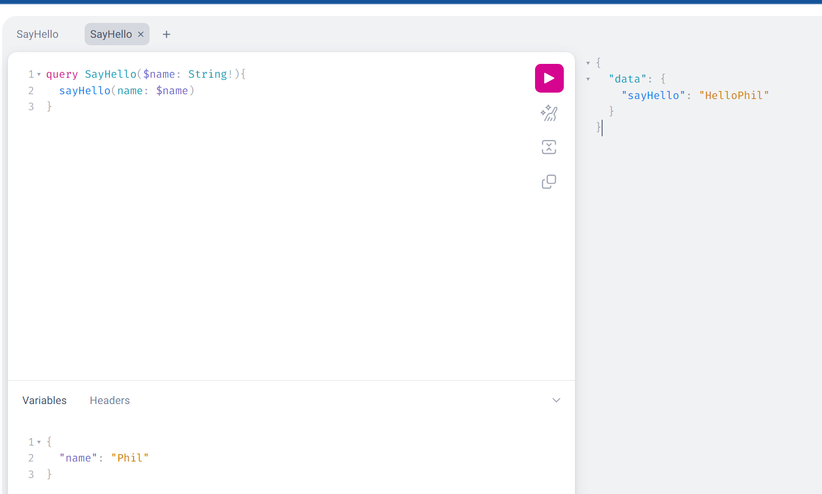

1st time calling:  
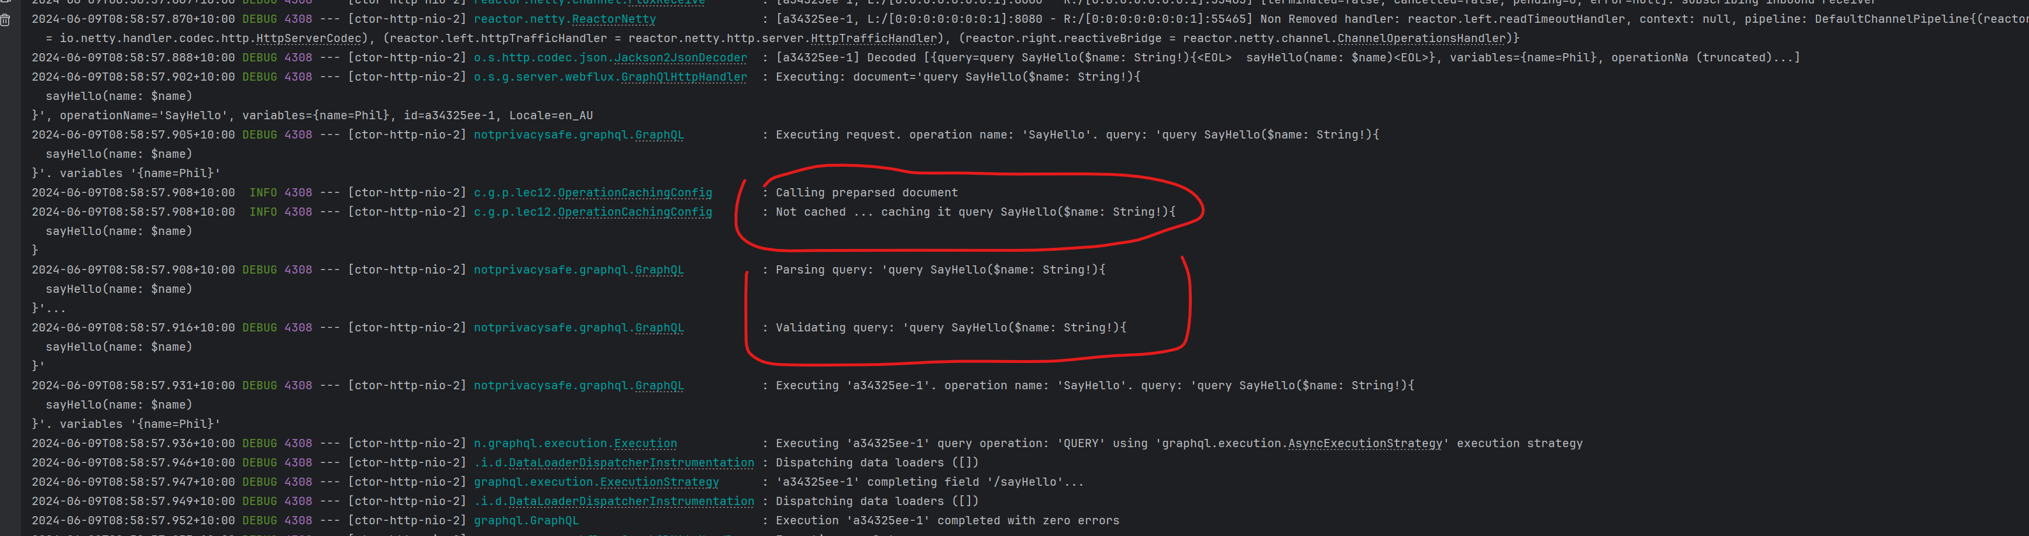

2nd time caching:  
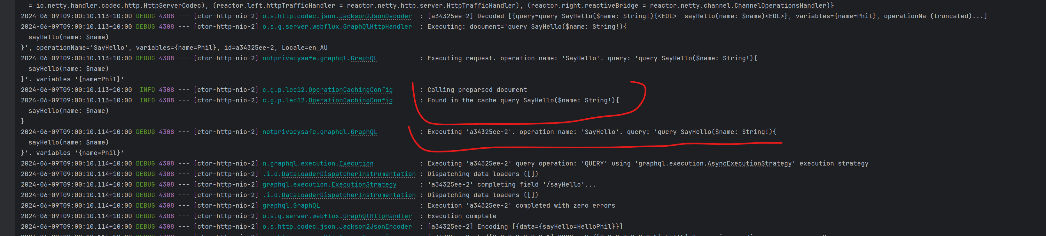

This is improved version:

package com.graphql.praphqlplay.lec12;  
  
import graphql.ExecutionInput;  
import graphql.execution.preparsed.PreparsedDocumentEntry;  
import graphql.execution.preparsed.PreparsedDocumentProvider;  
import lombok.extern.slf4j.Slf4j;  
import org.springframework.boot.autoconfigure.graphql.GraphQlSourceBuilderCustomizer;  
import org.springframework.context.annotation.Bean;  
import org.springframework.context.annotation.Configuration;  
  
import java.util.HashMap;  
import java.util.Map;  
import java.util.function.Function;  
  
@Configuration  
@Slf4j  
public class OperationCachingConfig {  
  
 /\*  
 \* request body  
 \* exe doc  
 \* parse (needs caching)  
 \* validation (needs caching)  
 \* exe doc  
 \*

\* suggestion:  
\* use: variables along with operation name  
\* use caffeine cache: https://github.com/ben-manes/caffenie

\*/  
  
 @Bean  
 public GraphQlSourceBuilderCustomizer sourceBuilderCustomizer(PreparsedDocumentProvider provider){   
  
 return c -> c.configureGraphQl(builder -> builder.preparsedDocumentProvider(provider));  
 }  
  
 @Bean  
 public PreparsedDocumentProvider provider(){  
  
 Map<String, PreparsedDocumentEntry> map =new HashMap<>();  
  
 return new PreparsedDocumentProvider() {  
  
 @Override  
 public PreparsedDocumentEntry getDocument(ExecutionInput executionInput, Function<ExecutionInput, PreparsedDocumentEntry> parseAndValidateFunction) {  
 *log*.info("Calling preparsed document");  
  
 //Better improved version  
 return map.computeIfAbsent(executionInput.getQuery(), key -> {  
 *log*.info("Query not found in cache............");  
 var r = parseAndValidateFunction.apply(executionInput);  
 *log*.info("Caching this query: {}", r);  
 return r;  
 });  
 }  
 };  
 }  
}

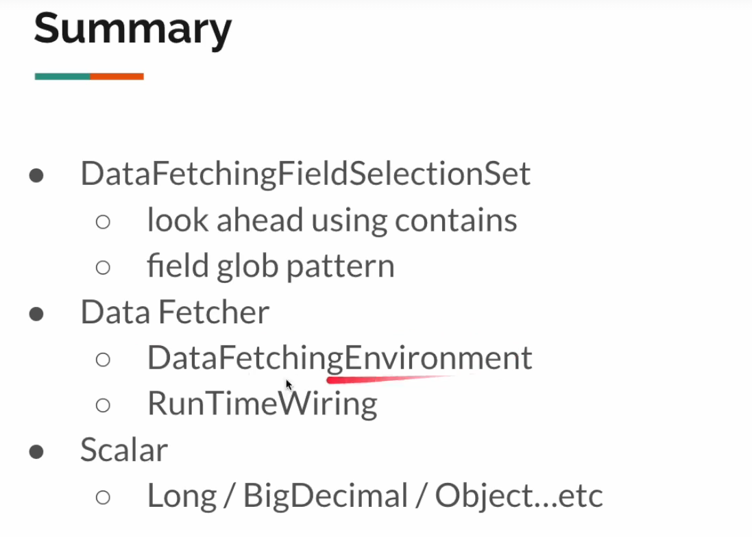

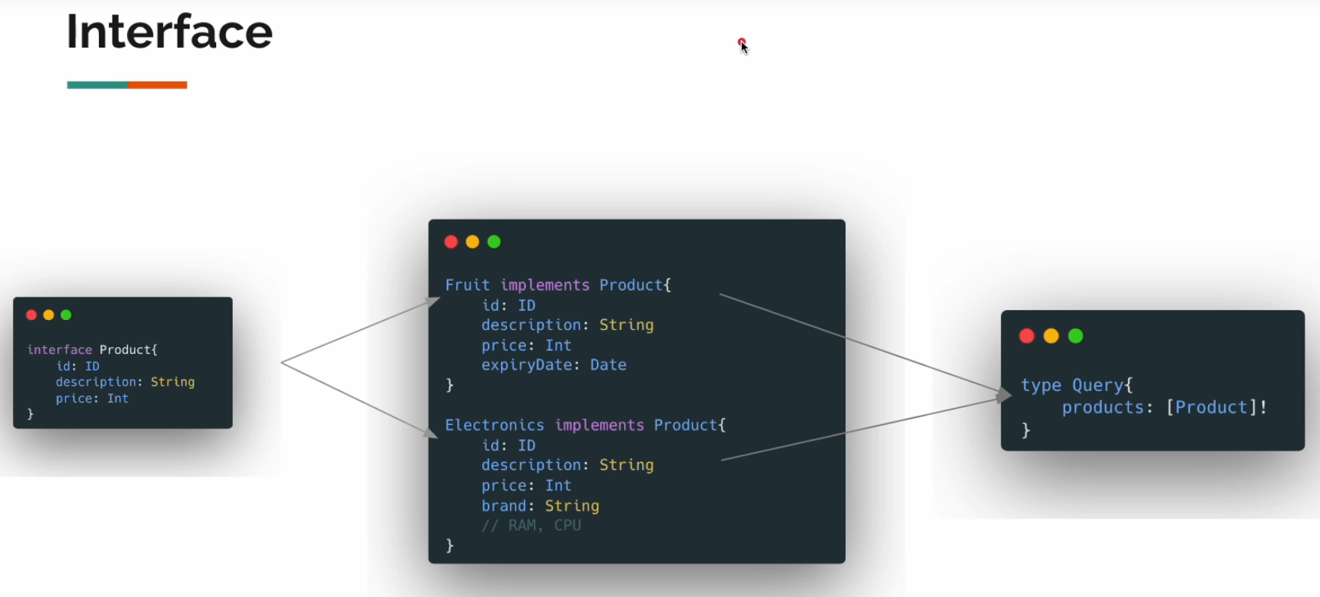

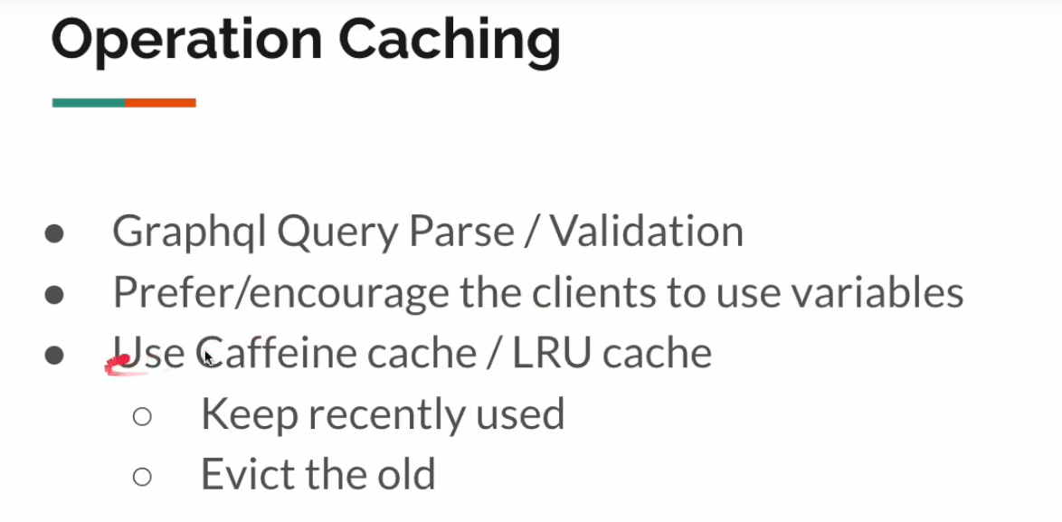

**MUTATION**

**Add these dependencies:**<dependency>  
 <groupId>org.springframework.boot</groupId>  
 <artifactId>spring-boot-starter-data-r2dbc</artifactId>  
</dependency>  
  
<dependency>  
 <groupId>com.h2database</groupId>  
 <artifactId>h2</artifactId>  
 <scope>runtime</scope>  
</dependency>  
<dependency>  
 <groupId>io.r2dbc</groupId>  
 <artifactId>r2dbc-h2</artifactId>  
 <scope>runtime</scope>  
</dependency>

Changes are under the directory lec13: now let us create new **schema.graphqls**

type Query{  
 customers: [Customer]!  
 customerById(id: ID!): Customer  
}  
  
type Mutation{  
 createCustomer(customer: CustomerInput!): Customer  
 updateCustomer(id: ID!, customer: CustomerInput): Customer  
 deleteCustomer(id: ID!): DeleteResponse!  
}  
  
type Customer{  
 id: ID!  
 name: String  
 age: Int  
 city: String  
}  
  
input CustomerInput{  
 name: String  
 age: Int  
 city: String  
}  
type DeleteResponse{  
 id: ID!  
 status: Status  
}  
  
enum Status{  
 *SUCCESS  
 FAILURE*}

Create DTO and entity classes:

import lombok.AllArgsConstructor;  
import lombok.Data;  
import lombok.NoArgsConstructor;  
import org.springframework.data.annotation.Id;  
  
@Data  
@AllArgsConstructor(staticName = "create")  
@NoArgsConstructor  
public class Customer {  
  
 @Id  
 private Integer id;  
 private String name;  
 private Integer age;  
 private String city;  
}

import lombok.Data;  
  
@Data  
public class CustomerDto {  
 private Integer id;  
 private String name;  
 private Integer age;  
 private String city;  
}

import lombok.AllArgsConstructor;  
import lombok.Data;  
import lombok.NoArgsConstructor;  
  
@Data  
@NoArgsConstructor  
@AllArgsConstructor(staticName = "create")  
public class DeleteResponseDto {  
 private Integer id;  
 private Status status;  
}

package com.graphql.praphqlplay.lec13.dto;  
  
public enum Status {  
 *SUCCESS*,  
 *FAILURE*}

Then repository:

import com.graphql.praphqlplay.lec13.entity.Customer;  
import org.springframework.data.repository.reactive.ReactiveCrudRepository;  
import org.springframework.stereotype.Repository;  
  
@Repository  
public interface CustomerRepository extends ReactiveCrudRepository<Customer, Integer> {  
  
}

And converting Util:

import com.graphql.praphqlplay.lec13.dto.CustomerDto;  
import com.graphql.praphqlplay.lec13.entity.Customer;  
import org.springframework.beans.BeanUtils;  
  
public class EntityDtoUtil {  
  
 public static Customer toEntity(CustomerDto dto){  
 Customer customer = new Customer();  
 BeanUtils.*copyProperties*(dto, customer);  
 return customer;  
 }  
 public static Customer toEntity(Integer id, CustomerDto dto){  
 Customer customer = new Customer();  
 BeanUtils.*copyProperties*(dto, customer);  
 customer.setId(id);  
 return customer;  
 }  
 public static CustomerDto toDto(Customer customer){  
 CustomerDto dto = new CustomerDto();  
 BeanUtils.*copyProperties*(customer, dto);  
 return dto;  
 }  
}

Service class:  
import com.graphql.praphqlplay.lec13.dto.CustomerDto;  
import com.graphql.praphqlplay.lec13.dto.DeleteResponseDto;  
import com.graphql.praphqlplay.lec13.dto.Status;  
import com.graphql.praphqlplay.lec13.repository.CustomerRepository;  
import com.graphql.praphqlplay.lec13.util.EntityDtoUtil;  
import org.springframework.beans.factory.annotation.Autowired;  
import org.springframework.stereotype.Service;  
import reactor.core.publisher.Flux;  
import reactor.core.publisher.Mono;  
  
@Service  
public class CustomerService {  
  
 @Autowired  
 private CustomerRepository repository;  
  
 public Flux<CustomerDto> allCustomers(){  
 return this.repository.findAll()  
 .map(EntityDtoUtil::*toDto*);  
 }  
  
 public Mono<CustomerDto> findById(Integer id){  
 return this.repository.findById(id)  
 .map(EntityDtoUtil::*toDto*);  
 }  
 public Mono<CustomerDto> createCustomer(CustomerDto dto){  
 return Mono.*just*(dto)  
 .map(EntityDtoUtil::*toEntity*)  
 .flatMap(this.repository::save)  
 .map(EntityDtoUtil::*toDto*);  
 }  
 public Mono<CustomerDto> updateCustomer(Integer id, CustomerDto dto){  
  
 return this.repository.findById(id)  
 .map(c -> EntityDtoUtil.*toEntity*(id, dto))  
 .flatMap(this.repository::save)  
 .map(EntityDtoUtil::*toDto*);  
 }  
  
 public Mono<DeleteResponseDto> deleteCustomer(Integer id){  
 return this.repository.deleteById(id)  
 .thenReturn(DeleteResponseDto.*create*(id, Status.*FAILURE*))  
 .onErrorReturn(DeleteResponseDto.*create*(id, Status.*FAILURE*));  
 }  
}

Controller class:  
import com.graphql.praphqlplay.lec13.dto.CustomerDto;  
import com.graphql.praphqlplay.lec13.dto.DeleteResponseDto;  
import com.graphql.praphqlplay.lec13.service.CustomerService;  
import org.springframework.beans.factory.annotation.Autowired;  
import org.springframework.graphql.data.method.annotation.Argument;  
import org.springframework.graphql.data.method.annotation.MutationMapping;  
import org.springframework.graphql.data.method.annotation.QueryMapping;  
import org.springframework.stereotype.Controller;  
import reactor.core.publisher.Flux;  
import reactor.core.publisher.Mono;  
  
@Controller  
public class CustomerController {  
  
 @Autowired  
 private CustomerService service;  
  
 @QueryMapping  
 public Flux<CustomerDto> customers(){  
 return this.service.allCustomers();  
 }  
  
 @QueryMapping  
 public Mono<CustomerDto> customerById(@Argument Integer id){  
 return this.service.findById(id);  
 }  
  
 @MutationMapping  
 public Mono<CustomerDto> createCustomer(@Argument CustomerDto customer){  
 return this.service.createCustomer(customer);  
 }  
  
 @MutationMapping  
 public Mono<CustomerDto> updateCustomer(@Argument Integer id, @Argument("customer") CustomerDto dto){  
 return this.service.updateCustomer(id, dto);  
 }  
  
 @MutationMapping  
 public Mono<DeleteResponseDto> deleteCustomer(@Argument Integer id){  
 return this.service.deleteCustomer(id);  
 }  
}

Now let us create ***data.sql*** script under resources folder:

DROP TABLE IF EXISTS customer;  
  
CREATE TABLE customer(  
 id INT PRIMARY KEY AUTO\_INCREMENT NOT NULL,  
 name VARCHAR(50),  
 age INT,  
 city VARCHAR(50)  
);  
  
insert into customer(name, age, city)  
values  
 ('sam', 10, 'Namangan'),  
 ('Ota', 10, 'Namangan'),  
 ('Jay', 12, 'Fergana'),  
 ('Shax', 11, 'Samarkand');

Now start graphql;  
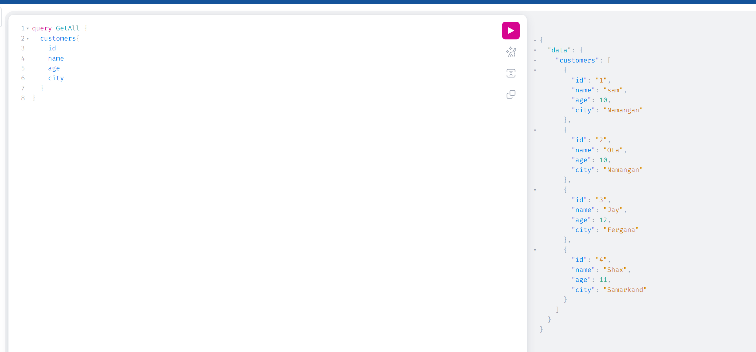

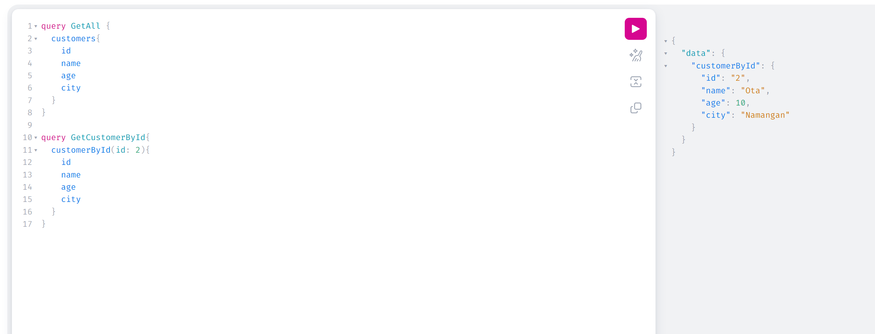

Create customer:  
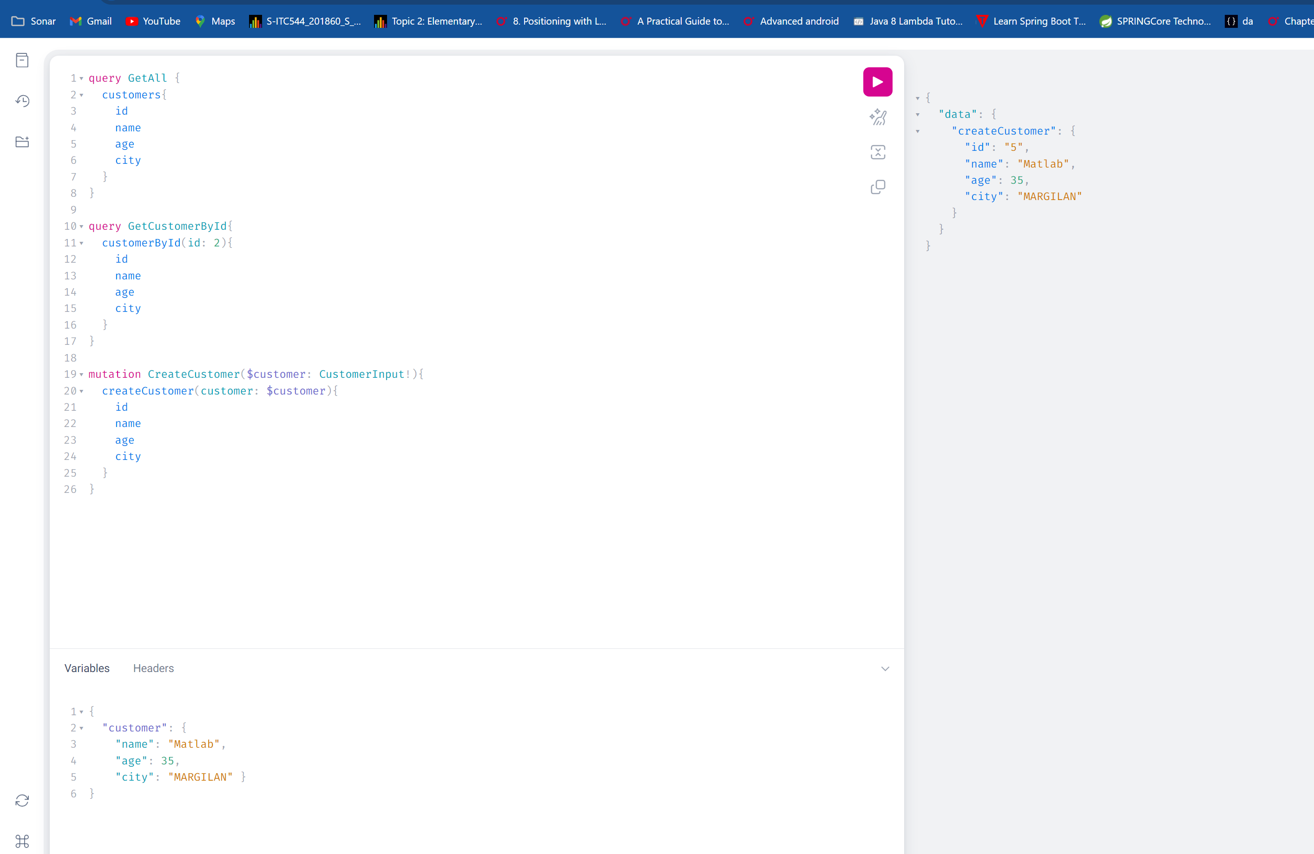

Update

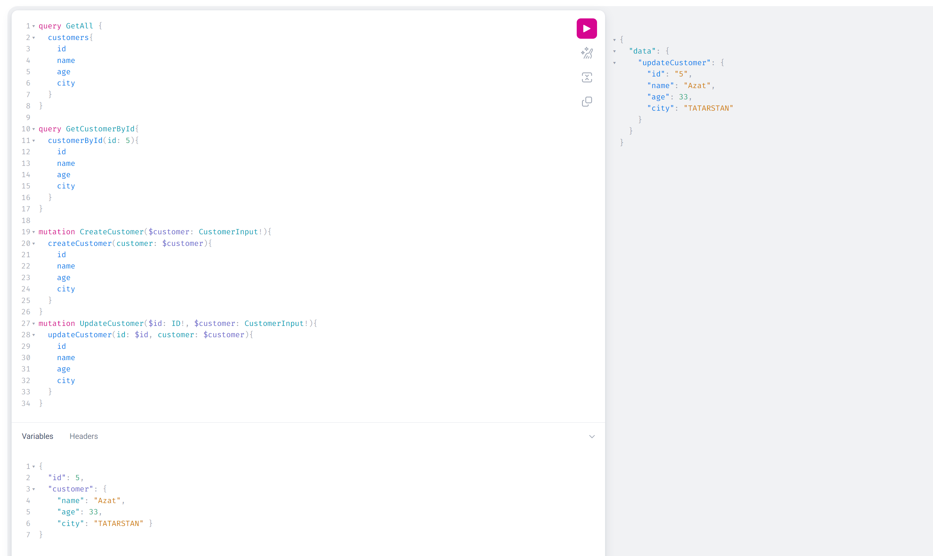

**Multiple mutation**

In calling multiple mutation api’s, the call will be sequentially:

[Meaning, If I call 2 API in one mutation, it will complete 1](#QUERY" \t "_self)[st](#QUERY" \t "_self) [then jumps to 2](#QUERY" \t "_self)[nd](#QUERY" \t "_self)[.](#QUERY" \t "_self)

If for example, I create new customer (id is 6) and I call the update the newly created customer in one call then this will be updated. (if you remember, in QUERY all the calls are parallel, but in mutation they are sequentially)

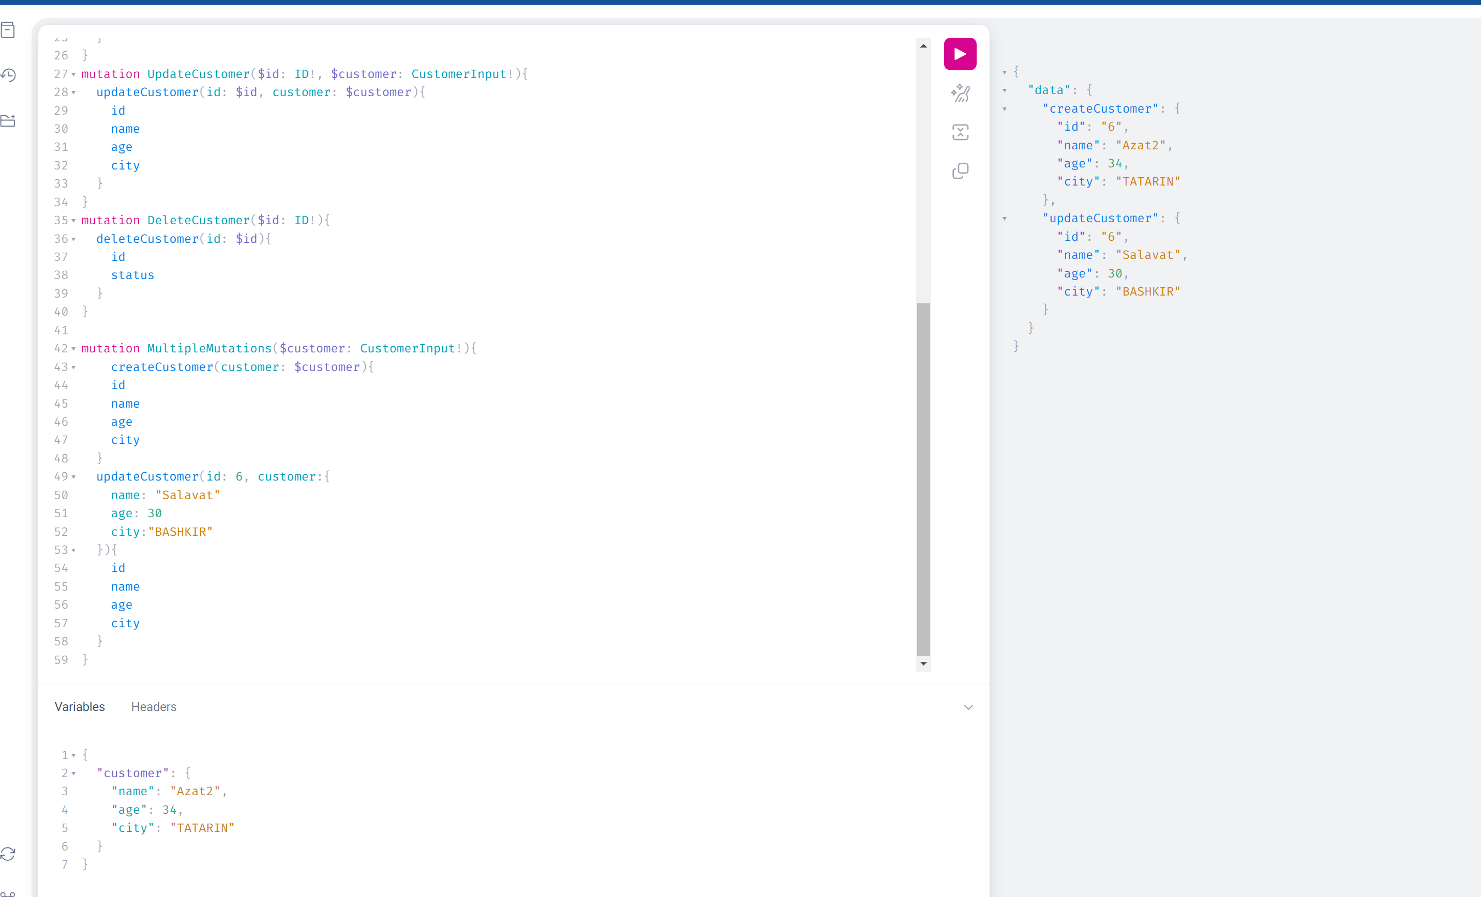

NOTICE: There cannot be mixed in a single request mutation + query: Whether all query or all mutation.

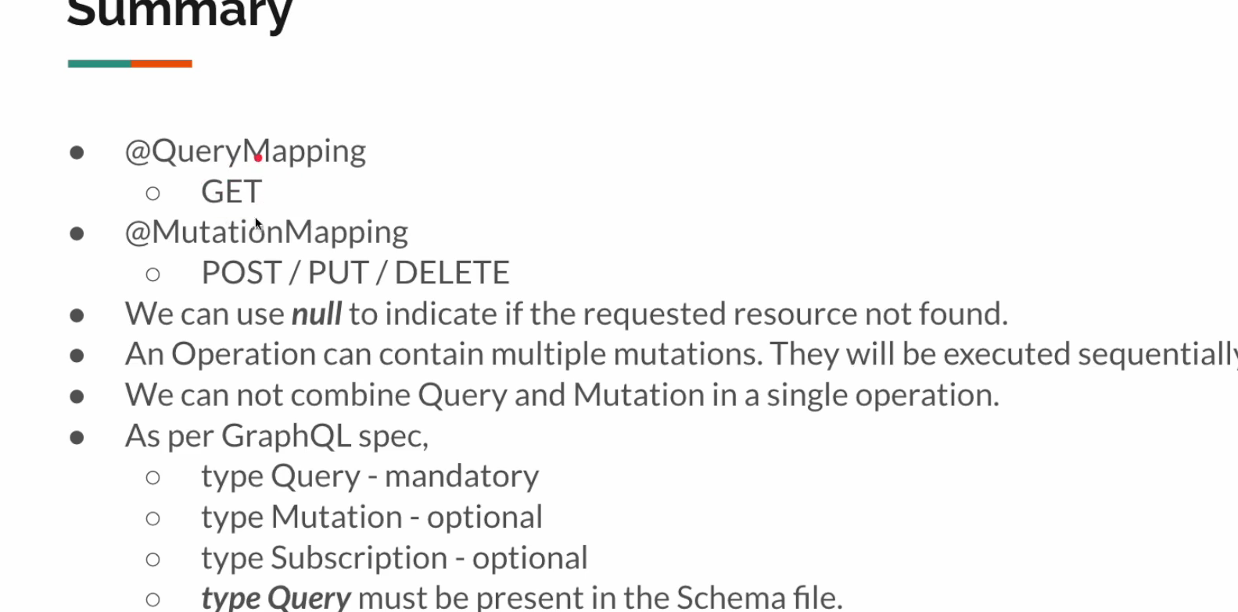

**SUBSCRIPTION TYPE**

Now created new package lec14 and copy paste from lec13 and also create subscription graphqls file for subscription events.

type Subscription{  
 customerEvent: CustomerEvent  
}  
  
type CustomerEvent{  
 id: ID!  
 action: Action!  
}  
  
enum Action{  
 *CREATED  
 DELETED  
 UPDATED*}

then create enum for dto of subscription:

public enum Action {  
 *CREATED*,  
 *UPDATED*,  
 *DELETED*}

CustomerEvent class: for event body (this will contain our event)

@Data  
@NoArgsConstructor  
@AllArgsConstructor(staticName = "create")  
public class CustomerEvent {  
  
 private Integer id;  
 private Action action;  
}

We will change our Customer service little bit so when the create, update or delete customer is happened, it will publish event.

import com.graphql.praphqlplay.lec14.dto.\*;  
import com.graphql.praphqlplay.lec14.repository.CustomerRepository;  
import com.graphql.praphqlplay.lec14.util.EntityDtoUtil;  
import org.springframework.beans.factory.annotation.Autowired;  
import org.springframework.stereotype.Service;  
import reactor.core.publisher.Flux;  
import reactor.core.publisher.Mono;  
  
@Service  
public class CustomerService {  
  
 @Autowired  
 private CustomerRepository repository;  
  
 @Autowired  
 private CustomerEventService customerEventService;  
  
 public Flux<CustomerDto> allCustomers(){  
 return this.repository.findAll()  
 .map(EntityDtoUtil::*toDto*);  
 }  
  
 public Mono<CustomerDto> findById(Integer id){  
 return this.repository.findById(id)  
 .map(EntityDtoUtil::*toDto*);  
 }  
 public Mono<CustomerDto> createCustomer(CustomerDto dto){  
 return Mono.*just*(dto)  
 .map(EntityDtoUtil::*toEntity*)  
 .flatMap(this.repository::save)  
 .map(EntityDtoUtil::*toDto*)  
 .doOnNext(c -> this.customerEventService.emitEvent(CustomerEvent.*create*(c.getId(), Action.*CREATED*)));  
 }  
 public Mono<CustomerDto> updateCustomer(Integer id, CustomerDto dto){  
  
 return this.repository.findById(id)  
 .map(c -> EntityDtoUtil.*toEntity*(id, dto))  
 .flatMap(this.repository::save)  
 .map(EntityDtoUtil::*toDto*)  
 .doOnNext(c -> this.customerEventService.emitEvent(CustomerEvent.*create*(c.getId(), Action.*UPDATED*)));  
 }  
  
 public Mono<DeleteResponseDto> deleteCustomer(Integer id){  
 return this.repository.deleteById(id)  
 .doOnSuccess(c -> this.customerEventService.emitEvent(CustomerEvent.*create*(id, Action.*DELETED*)))  
 .thenReturn(DeleteResponseDto.*create*(id, Status.*SUCCESS*))  
 .onErrorReturn(DeleteResponseDto.*create*(id, Status.*FAILURE*));  
 }  
}

Now our Controller:

@Controller  
public class CustomerEventController {  
  
 @Autowired  
 private CustomerEventService customerEventService;  
  
 @SubscriptionMapping  
 public Flux<CustomerEvent> customerEvent(){  
 return this.customerEventService.subscribe();  
 }  
}

import org.springframework.boot.SpringApplication;  
import org.springframework.boot.autoconfigure.SpringBootApplication;  
import org.springframework.data.r2dbc.repository.config.EnableR2dbcRepositories;  
  
@SpringBootApplication(scanBasePackages = "com.graphql.praphqlplay. lec14")  
@EnableR2dbcRepositories(basePackages = "com.graphql.praphqlplay.${lec}")  
public class GraphqlPlayApplication {  
  
 public static void main(String[] args) {  
 SpringApplication.*run*(GraphqlPlayApplication.class, args);  
 }  
}

And finally CustomerEventService:

import com.graphql.praphqlplay.lec14.dto.CustomerEvent;  
import org.springframework.stereotype.Service;  
import reactor.core.publisher.Flux;  
import reactor.core.publisher.Sinks;  
  
@Service  
public class CustomerEventService {  
  
 private final Sinks.Many<CustomerEvent> sink = Sinks.*many*().multicast().onBackpressureBuffer();  
 private final Flux<CustomerEvent> flux = sink.asFlux().cache(0); //no caching  
  
 public void emitEvent(CustomerEvent event){  
 this.sink.tryEmitNext(event);  
 }  
  
 public Flux<CustomerEvent> subscribe(){  
 return this.flux;  
 }  
}

This part above emits event:

**Sinks and Flux Initialization**

java

Copy code

private final Sinks.Many<CustomerEvent> sink = Sinks.many().multicast().onBackpressureBuffer();

private final Flux<CustomerEvent> flux = sink.asFlux();

Here, two important objects from the Reactor project are being created:

* Sinks.Many<CustomerEvent> sink: This is a reactive sink that can handle multiple subscribers. Sinks.many().multicast().onBackpressureBuffer() creates a multicast sink with an unbounded buffer to handle backpressure, which means that if the downstream cannot keep up with the events being emitted, they will be buffered.
* Flux<CustomerEvent> flux: This is a Flux that will emit events to its subscribers. The sink.asFlux() method converts the sink into a Flux, so any events emitted to the sink will be available to the subscribers of this Flux.

**4. emitEvent Method**

java

Copy code

public void emitEvent(CustomerEvent event){

this.sink.tryEmitNext(event);

}

* This method is used to emit a new event.
* this.sink.tryEmitNext(event) tries to emit the given CustomerEvent to the sink. If successful, the event will be sent to all subscribers of the Flux. The tryEmitNext method will return an emission result indicating success or failure, but it is not handled here.

**5. subscribe Method**

java

Copy code

public Flux<CustomerEvent> subscribe(){

return this.flux;

}

* This method returns the Flux that represents the stream of CustomerEvent events.
* When a consumer subscribes to this Flux, it will receive any events emitted via the emitEvent method.

**Summary**

* The CustomerEventService class is a Spring service component designed to handle reactive event streaming using Project Reactor.
* It initializes a multicast sink (Sinks.Many) with backpressure buffering and a corresponding Flux.
* The emitEvent method allows emitting new events to the sink.
* The subscribe method returns the Flux for consumers to subscribe to and receive events.

By using this approach, you can handle event-driven architectures in a reactive manner, where multiple components can listen to and process events asynchronously.

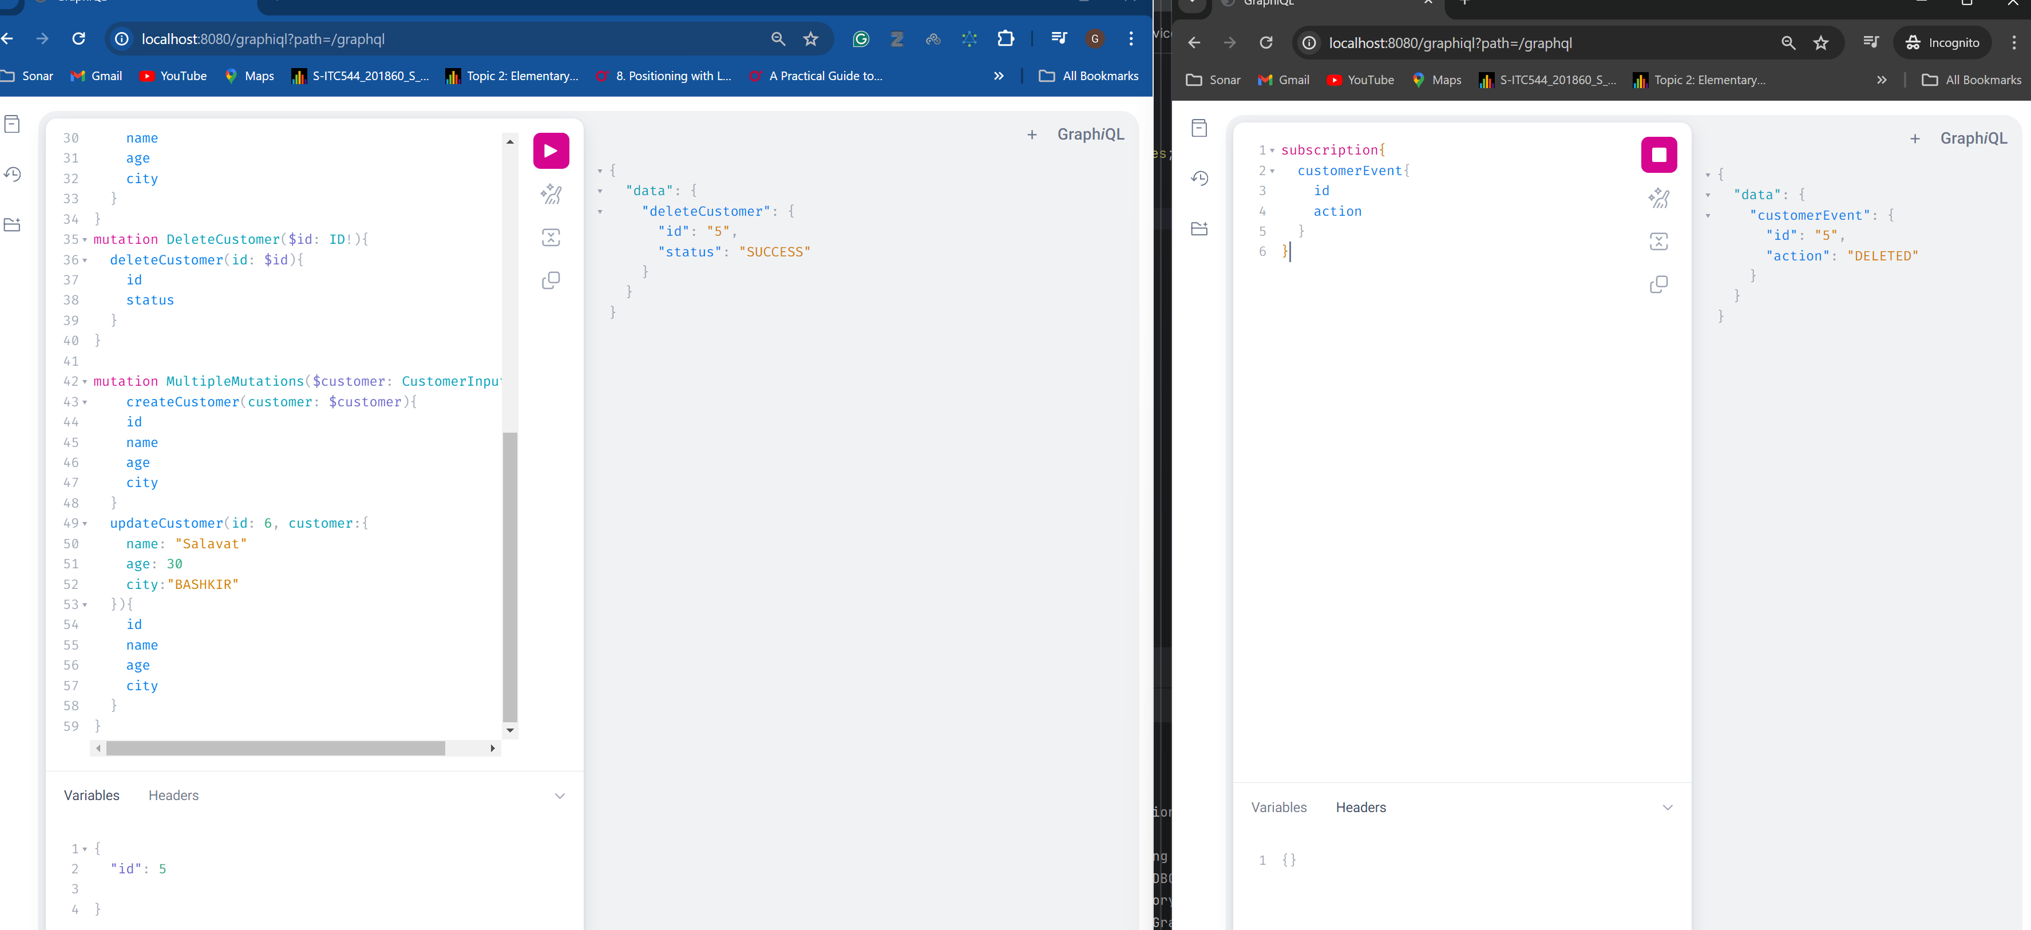

--------------------------------

**Error Handling**

**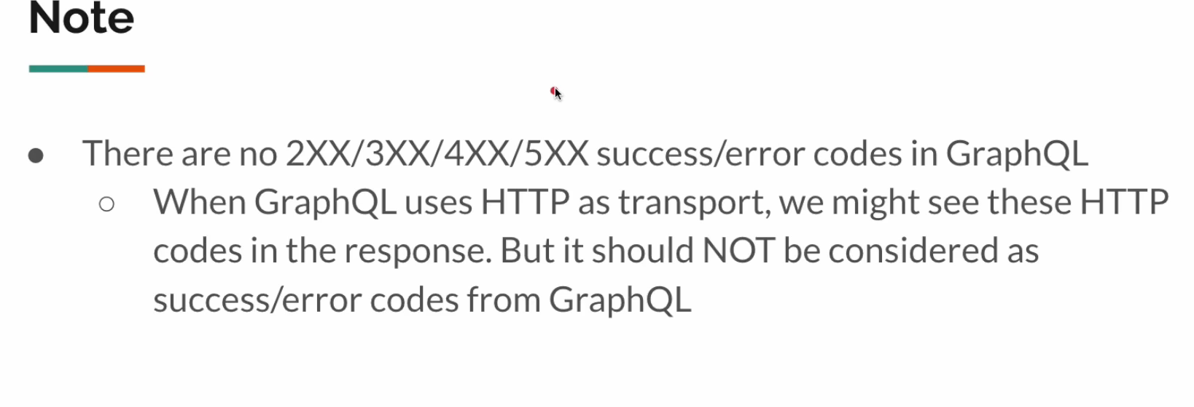**

**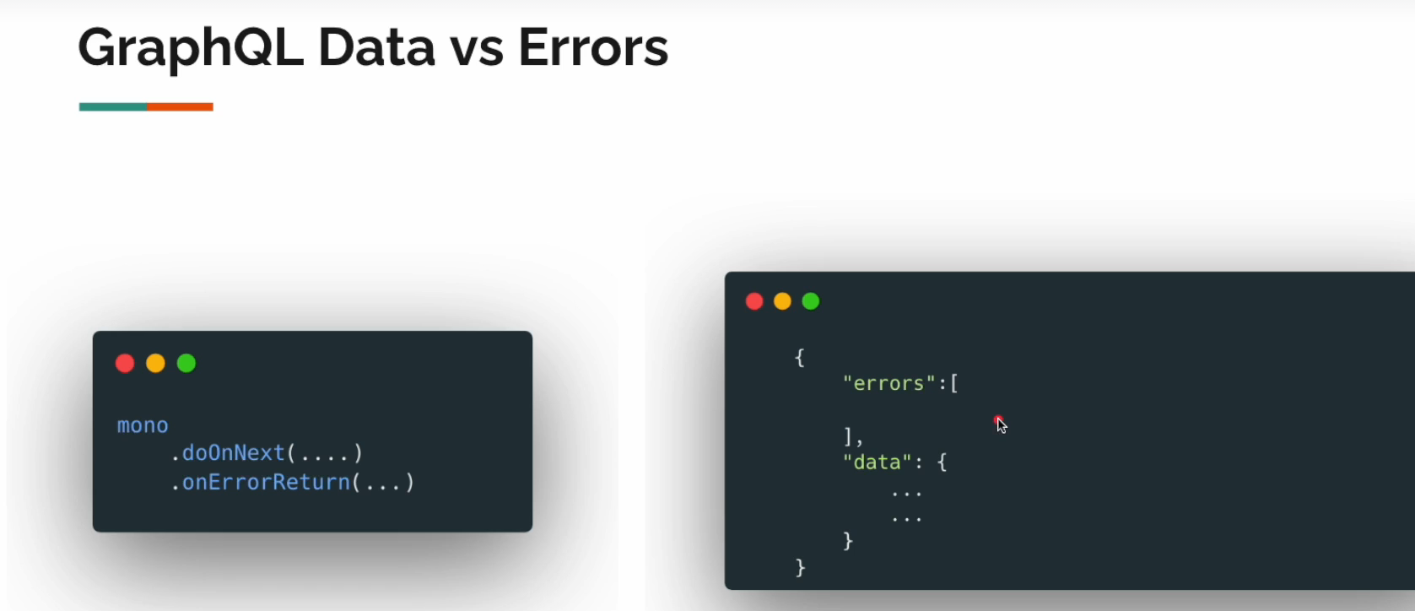**

**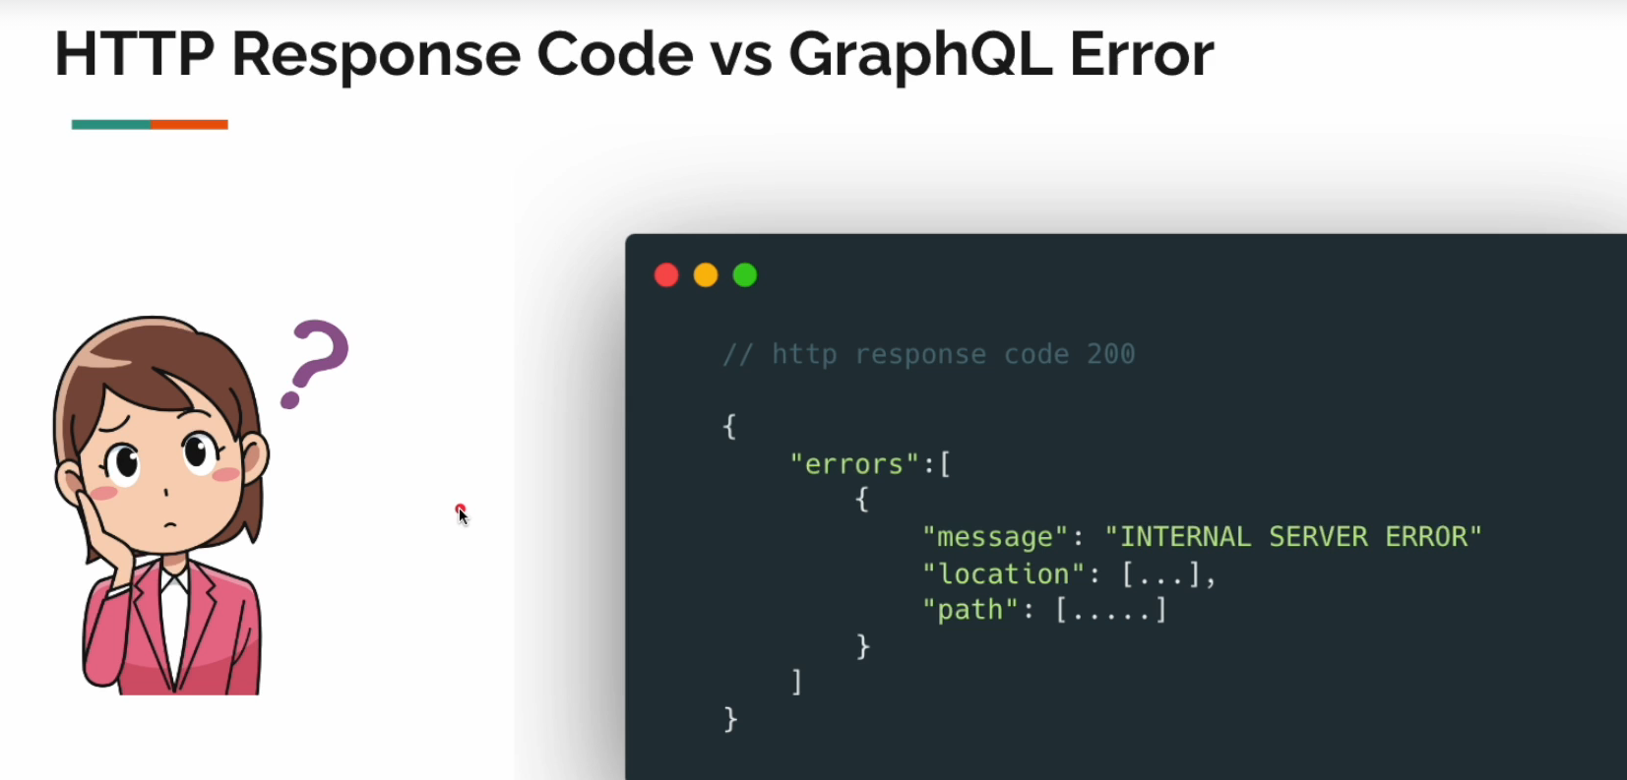**

Okay let us see some unhandled error scenarios in GraphQL:

Example this call will throw and runtime exception and it is not handled.

@QueryMapping  
 public Mono<CustomerDto> customerById(@Argument Integer id){  
 throw new RuntimeException("Some weird issue");  
// return this.service.findById(id);  
 }

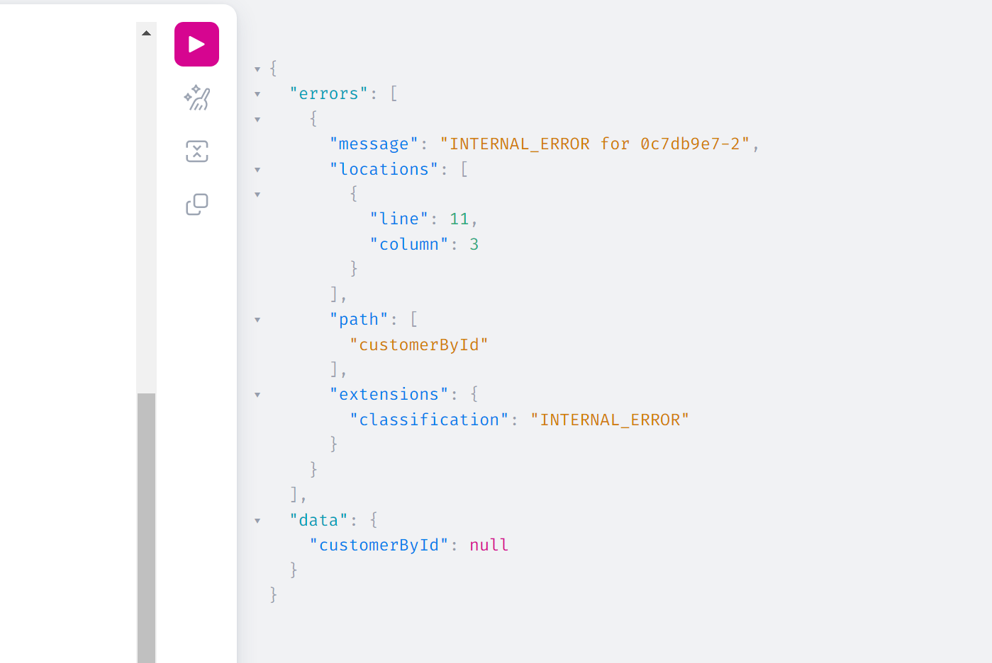

Let us Handle this exceptions:

We can create this handler:

import graphql.GraphQLError;  
import graphql.GraphqlErrorBuilder;  
import graphql.schema.DataFetchingEnvironment;  
import org.springframework.graphql.execution.DataFetcherExceptionResolver;  
import org.springframework.graphql.execution.ErrorType;  
import org.springframework.stereotype.Service;  
import reactor.core.publisher.Mono;  
  
import java.util.List;  
  
*/\*\*  
 \* This is similar to ControllerAdvice  
 \*/*@Service  
public class ExceptionResolver implements DataFetcherExceptionResolver {  
 @Override  
 public Mono<List<GraphQLError>> resolveException(Throwable exception, DataFetchingEnvironment environment) {  
 return Mono.*just*(  
 List.*of*(  
 GraphqlErrorBuilder.*newError*()  
 .message(exception.getMessage())  
 .errorType(ErrorType.*INTERNAL\_ERROR*)  
 .build()  
 )  
 );  
 }  
}

When called method with exception:  
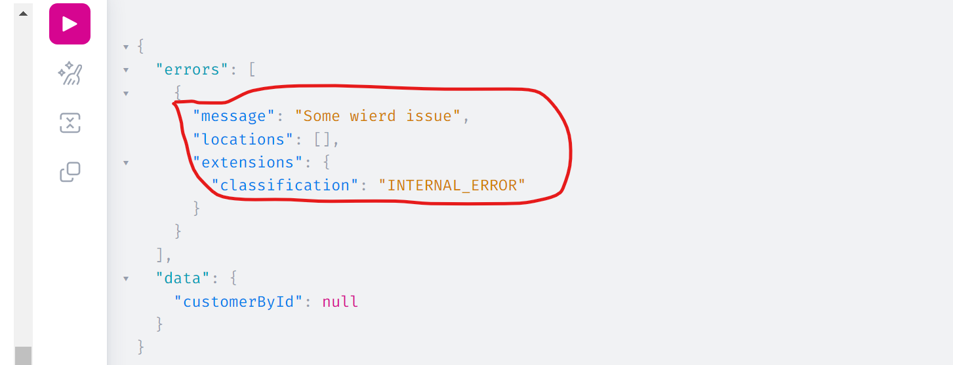

Adding extension field into Error – Exception Resolver:

We can add fields like:

@Service  
public class ExceptionResolver implements DataFetcherExceptionResolver {  
 @Override  
 public Mono<List<GraphQLError>> resolveException(Throwable exception, DataFetchingEnvironment environment) {  
 return Mono.*just*(  
 List.*of*(  
 GraphqlErrorBuilder.*newError*()  
 .message(exception.getMessage())  
 .extensions(Map.*of*(  
 "customer123", 123,  
 "timestamp", LocalDateTime.*now*(),  
 "a", "b"  
 ))  
 .errorType(ErrorType.*INTERNAL\_ERROR*)  
 .build()  
 )  
 );  
 }  
}

And you call:  
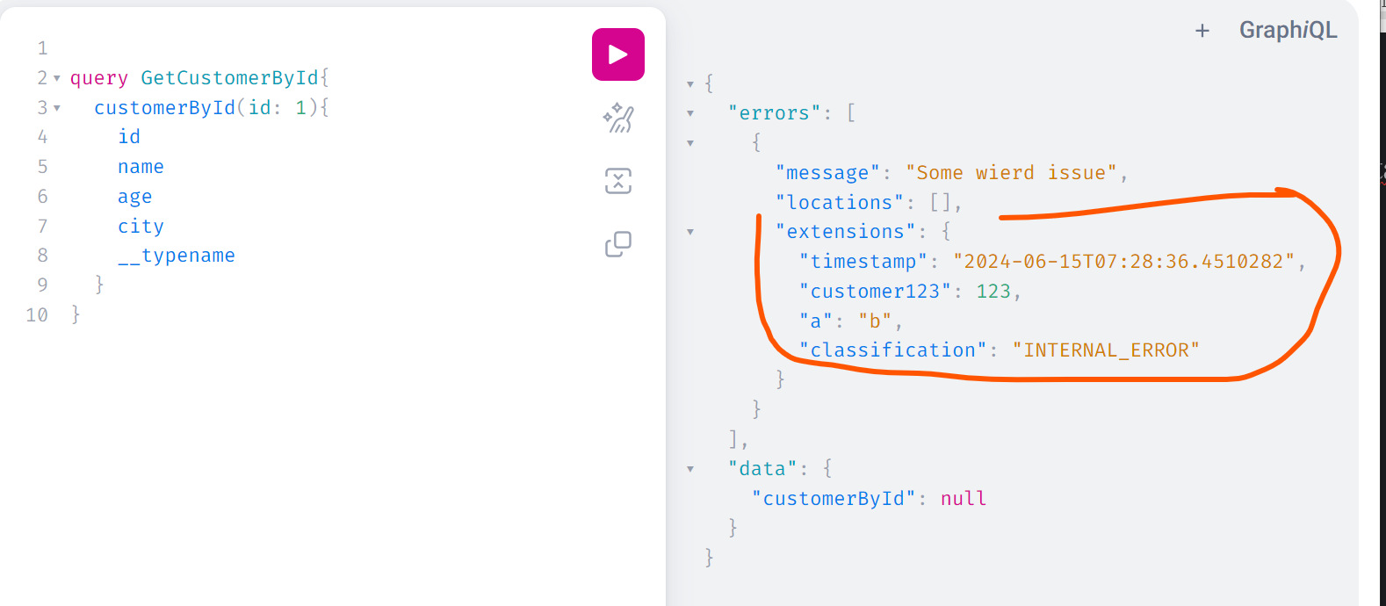

Let us create some generic application exception class (ex. If customer does not exist throw an exception)

Here we are changing the ExceptionResolver.class to this:

import com.graphql.praphqlplay.lec15.exceptions.ApplicationException;  
import graphql.GraphQLError;  
import graphql.GraphqlErrorBuilder;  
import graphql.schema.DataFetchingEnvironment;  
import org.springframework.graphql.execution.DataFetcherExceptionResolver;  
import org.springframework.graphql.execution.ErrorType;  
import org.springframework.stereotype.Service;  
import reactor.core.publisher.Mono;  
  
import java.util.Collections;  
import java.util.List;  
  
*/\*\*  
 \* This is similar to ControllerAdvice  
 \*/*@Service  
public class ExceptionResolver implements DataFetcherExceptionResolver {  
 @Override  
 public Mono<List<GraphQLError>> resolveException(Throwable exception, DataFetchingEnvironment environment) {  
 var ex = toApplicationException(exception);  
 return Mono.*just*(  
 List.*of*(  
 GraphqlErrorBuilder.*newError*()  
 .message(ex.getMessage())  
 .extensions(ex.getExtensions())  
 .errorType(ex.getErrorType())  
 .build()  
 )  
 );  
 }

//Here we are converting if the exception class is not Throwable.class  
 private ApplicationException toApplicationException(Throwable throwable) {  
 return ApplicationException.class.equals(throwable.getClass()) ?  
 (ApplicationException)throwable :  
 new ApplicationException(ErrorType.*INTERNAL\_ERROR*, throwable.getMessage(), Collections.*emptyMap*());  
 }  
}

Not let us change our Controller class: Where find by Id can throw exception if the customer is not found:

import com.graphql.praphqlplay.lec15.dto.CustomerDto;  
import com.graphql.praphqlplay.lec15.dto.DeleteResponseDto;  
import com.graphql.praphqlplay.lec15.exceptions.ApplicationErrors;  
import com.graphql.praphqlplay.lec15.service.CustomerService;  
import org.springframework.beans.factory.annotation.Autowired;  
import org.springframework.graphql.data.method.annotation.Argument;  
import org.springframework.graphql.data.method.annotation.MutationMapping;  
import org.springframework.graphql.data.method.annotation.QueryMapping;  
import org.springframework.stereotype.Controller;  
import reactor.core.publisher.Flux;  
import reactor.core.publisher.Mono;  
  
@Controller  
public class CustomerController {  
  
 @Autowired  
 private CustomerService service;  
  
 @QueryMapping  
 public Flux<CustomerDto> customers(){  
 return this.service.allCustomers();  
 }  
  
 @QueryMapping  
 public Mono<CustomerDto> customerById(@Argument Integer id){  
 return this.service.findById(id)  
 .switchIfEmpty(ApplicationErrors.*noSuchUser*(id));  
 }  
  
 @MutationMapping  
 public Mono<CustomerDto> createCustomer(@Argument CustomerDto customer){  
 return this.service.createCustomer(customer);  
 }  
  
 @MutationMapping  
 public Mono<CustomerDto> updateCustomer(@Argument Integer id, @Argument("customer") CustomerDto dto){  
 return this.service.updateCustomer(id, dto);  
 }  
  
 @MutationMapping  
 public Mono<DeleteResponseDto> deleteCustomer(@Argument Integer id){  
 return this.service.deleteCustomer(id);  
 }  
}



Create AplicationException.class:

import lombok.Getter;  
import org.springframework.graphql.execution.ErrorType;  
  
import java.util.Map;  
  
@Getter  
public class ApplicationException extends RuntimeException {  
  
 private final ErrorType errorType;  
 private final String message;  
 private final Map<String, Object> extensions;  
  
 public ApplicationException(ErrorType errorType, String message, Map<String, Object> extensions) {  
 this.errorType = errorType;  
 this.message = message;  
 this.extensions = extensions;  
 }  
}

And ApplicationErrors.class:

import org.springframework.graphql.execution.ErrorType;  
import reactor.core.publisher.Mono;  
  
import java.util.Map;  
  
public class ApplicationErrors {  
  
 public static <T> Mono<T> noSuchUser(Integer id) {  
 return Mono.*error*(new ApplicationException(ErrorType.*BAD\_REQUEST*, "No such user", Map.*of*("customerId", id)));  
 }  
}

Now when we call: findUserBy ID with customerId wherId id does not exist:

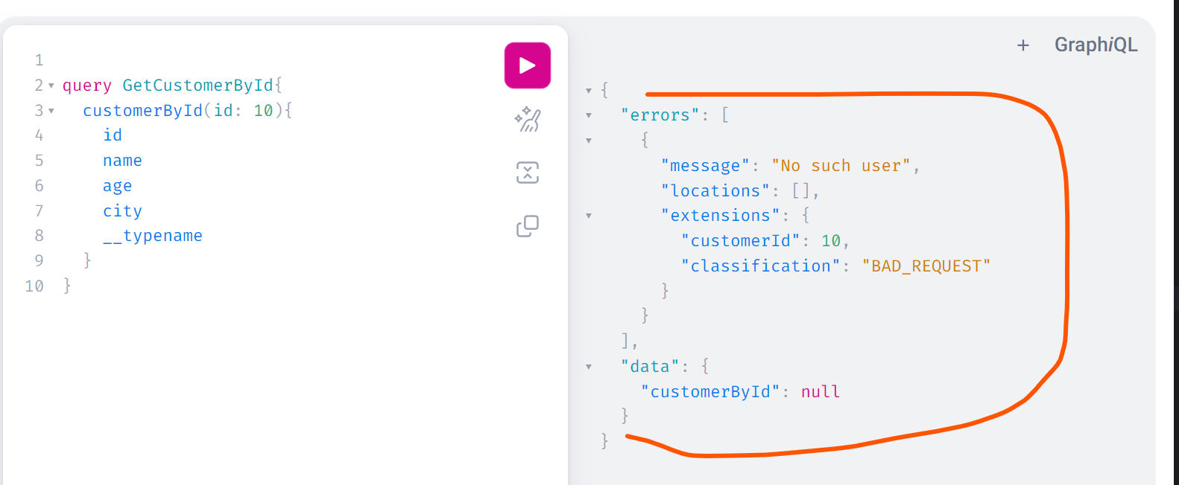

If we call the query for 2 customers with one has but 2nd doesn’t exist:  
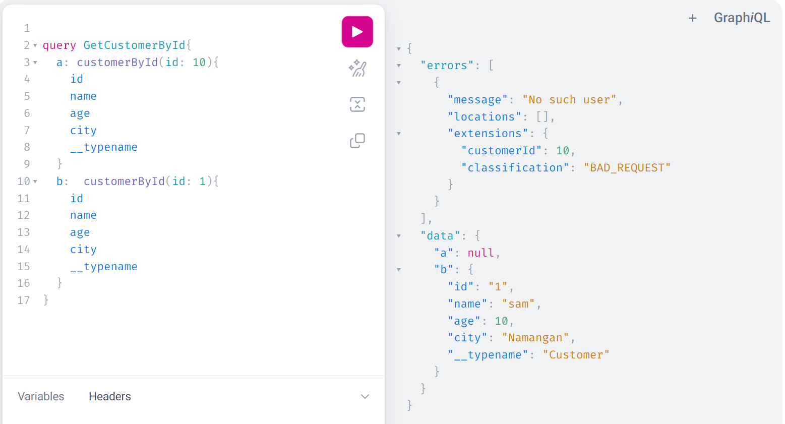

Now Assignment:

Add validation in creation of user: if the age is between 18 and above then allow the creation otherwise throw exception

Easy:

Just change the controller of Mutation first:

@MutationMapping  
public Mono<CustomerDto> createCustomer(@Argument CustomerDto customer){  
 return  
 Mono.*just*(customer)  
 .filter(c -> c.getAge()>=18)  
 .flatMap(this.service::createCustomer)  
 .switchIfEmpty(ApplicationErrors.*ageNotAllowed*(customer));  
}

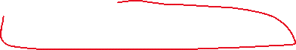

Then create new Error in ApplicationErrors:

import com.graphql.praphqlplay.lec15.dto.CustomerDto;  
import org.springframework.graphql.execution.ErrorType;  
import reactor.core.publisher.Mono;  
  
import java.util.Map;  
  
public class ApplicationErrors {  
  
 public static <T> Mono<T> noSuchUser(Integer id) {  
 return Mono.*error*(new ApplicationException(ErrorType.*BAD\_REQUEST*, "No such user", Map.*of*("customerId", id)));  
 }  
  
 public static <T> Mono<T> ageNotAllowed(CustomerDto dto) {  
 return Mono.*error*(new ApplicationException(ErrorType.*BAD\_REQUEST*, "Age must be 18 or older", Map.*of*("input", dto)));  
 }  
}



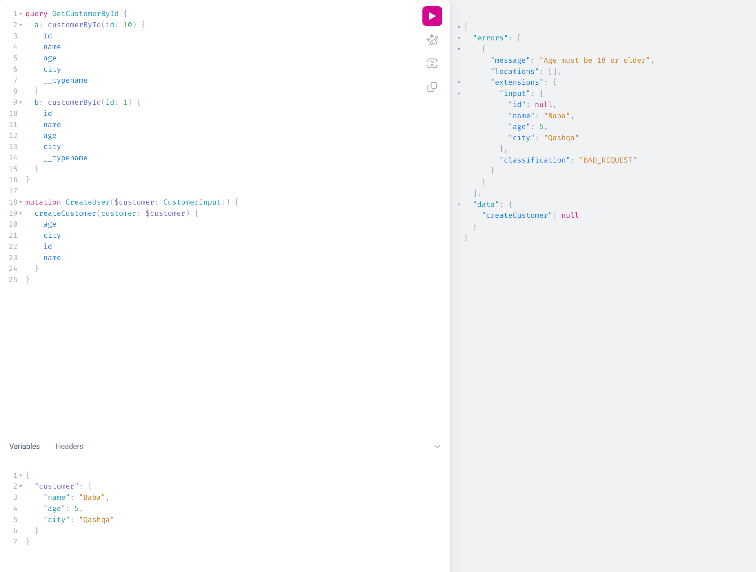



This is old type of work. However, we can properly convey that message instead of throwing that particular error message differently: Using union for ItemNotFound

We can use UNION type for that:

Let us create UNION type:

type Query{  
 customers: [Customer]!  
 """Here return is union type: which is whether returns Customer if found, otherwise CustomerNotFound"""  
 customerById(id: ID!): CustomerResponse!  
}  
  
type Mutation{  
 createCustomer(customer: CustomerInput!): Customer  
 updateCustomer(id: ID!, customer: CustomerInput): Customer  
 deleteCustomer(id: ID!): DeleteResponse!  
}  
  
type Customer{  
 id: ID!  
 name: String  
 age: Int  
 city: String  
}  
  
input CustomerInput{  
 name: String  
 age: Int  
 city: String  
}  
type DeleteResponse{  
 id: ID!  
 status: Status  
}  
  
enum Status{  
 *SUCCESS  
 FAILURE*}  
  
"""returns Customer or CustomerNotFound"""  
union CustomerResponse = Customer | CustomerNotFound  
  
type CustomerNotFound{  
 id: ID!  
 message: String  
}

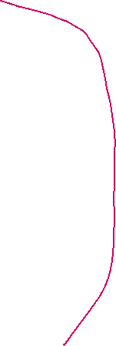

Now let us change the code as well: Create **CustomerNotFound.class**

@Data  
@NoArgsConstructor  
@AllArgsConstructor(staticName = "create")  
public class CustomerNotFound {  
 private Integer id;  
 private final String message = "user not found";  
}

Then change our Controller class for getCustomerBy id Query:

@QueryMapping  
public Mono<Object> customerById(@Argument Integer id){  
 return this.service.findById(id)  
 .cast(Object.class)  
 .switchIfEmpty(Mono.*just*(CustomerNotFound.*create*(id)));  
}

Then create TypeResolverConfig.class for Resolving the types:\

import com.graphql.praphqlplay.lec15.dto.CustomerDto;  
import graphql.schema.TypeResolver;  
import org.springframework.context.annotation.Bean;  
import org.springframework.context.annotation.Configuration;  
import org.springframework.graphql.execution.ClassNameTypeResolver;  
import org.springframework.graphql.execution.RuntimeWiringConfigurer;  
  
@Configuration  
public class TypeResolverConfig {  
  
 @Bean  
 public TypeResolver typeResolver() {  
 ClassNameTypeResolver resolver = new ClassNameTypeResolver();  
 resolver.addMapping(CustomerDto.class, "Customer");  
 return resolver;  
 }  
  
 @Bean  
 public RuntimeWiringConfigurer configurer(TypeResolver typeResolver){  
 return c ->c.type("CustomerResponse", b ->b.typeResolver(typeResolver));  
 }  
}

now we need to change the format of our query: We need to use fragment:  
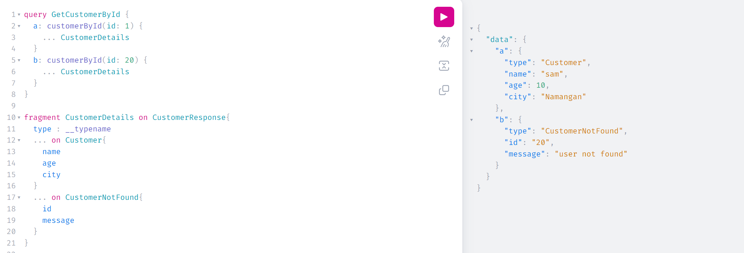

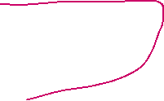

\_\_\_\_\_\_\_\_\_\_\_\_\_\_\_\_\_\_\_\_\_\_\_\_\_\_\_\_\_\_\_\_\_\_\_\_\_

**GraphQL Interceptor**

How to access to the header information so based on the header to make a decision:

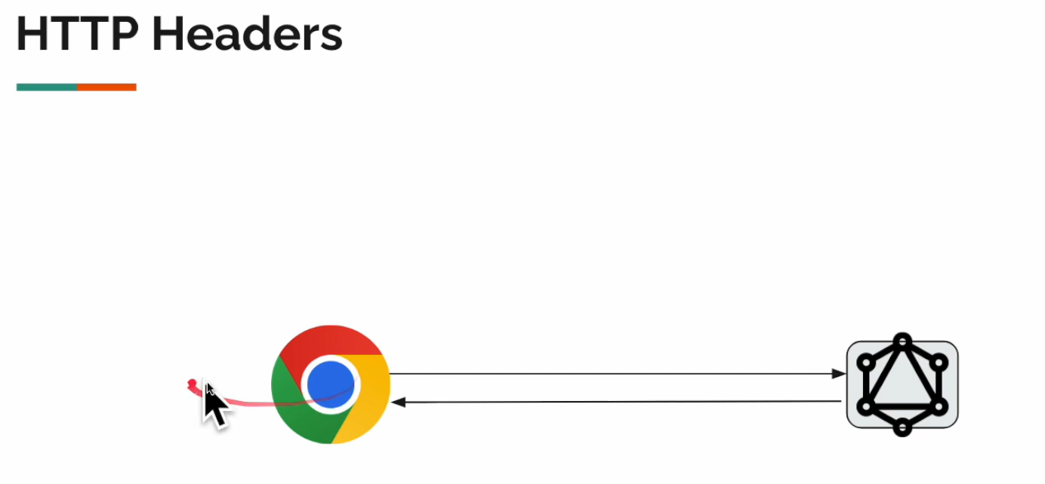

We can use @RequestHeader in RestController but in GraphQl it is different: using WebIntercepter

Let us create class: RequestInterceptor.class that implements WebGraphQLInterceptor

import org.springframework.graphql.server.WebGraphQlInterceptor;  
import org.springframework.graphql.server.WebGraphQlRequest;  
import org.springframework.graphql.server.WebGraphQlResponse;  
import org.springframework.stereotype.Service;  
import reactor.core.publisher.Mono;  
  
import java.util.Map;  
  
@Service  
public class RequestInterceptor implements WebGraphQlInterceptor {  
  
 @Override //If client has to pass header  
 public Mono<WebGraphQlResponse> intercept(WebGraphQlRequest request, Chain chain) {  
  
 var headers = request.getHeaders().getOrEmpty("caller-Id");  
 var callerId = headers.isEmpty() ? "" : headers.get(0);  
 request.configureExecutionInput((e, b) -> b.graphQLContext(Map.*of*("caller-Id", callerId)).build());  
 return chain.next(request);  
 }  
}

If we change our controller to receive the headers and log the header:

@QueryMapping  
public Flux<CustomerDto> customers(DataFetchingEnvironment environment){

var callerId = environment.getGraphQlContext().get("caller-Id");

*log*.info("callerId: {}", callerId);  
 return this.service.allCustomers();  
}



and if we call the getAllCustomers query:

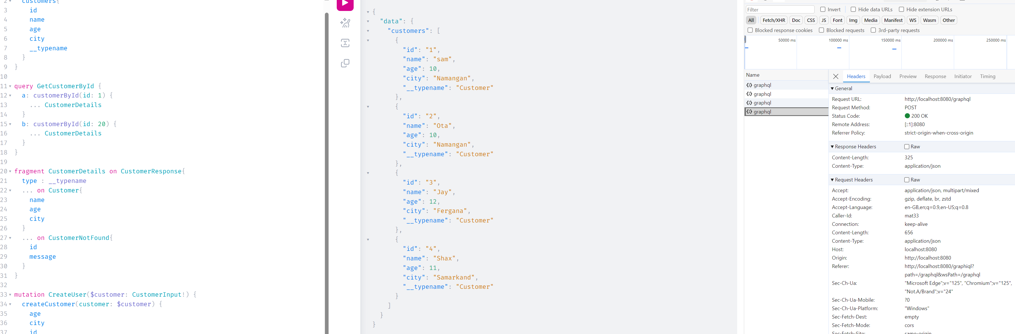







REJECTING requests with WEBFilter

Similar to Authentication filter. Reject the query before handling the headers (before coming to GraphQL interceptor) with Springs own WebFilter interface for example .

For example let us configure the application to response BAD\_REQUEST if the request doesn’t have header = “caller-id”

Otherwise well return the response.

Let us create new class HeaderCheckFilter.class:

import org.springframework.http.HttpStatus;  
import org.springframework.stereotype.Component;  
import org.springframework.web.server.ServerWebExchange;  
import org.springframework.web.server.WebFilter;  
import org.springframework.web.server.WebFilterChain;  
import reactor.core.publisher.Mono;  
  
@Component  
public class HeaderCheckFilter implements WebFilter{  
  
 @Override // client has to pass caller-id  
 public Mono<Void> filter(ServerWebExchange exchange, WebFilterChain chain) {  
  
 var isEmpty = exchange.getRequest().getHeaders().getOrEmpty("caller-id").isEmpty();  
  
 return !isEmpty ? chain.filter(exchange) :  
 Mono.*fromRunnable*(() -> exchange.getResponse().setStatusCode(HttpStatus.*BAD\_REQUEST*));  
 }  
}

Now if you request get All customers ar any request without header “caller-id” then it will response bad request

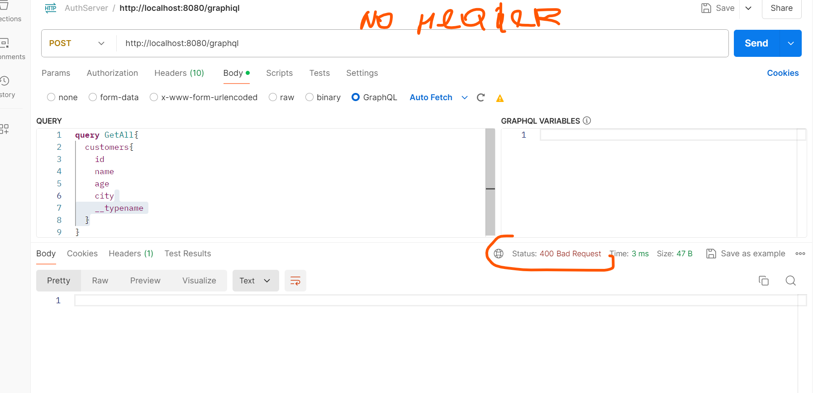

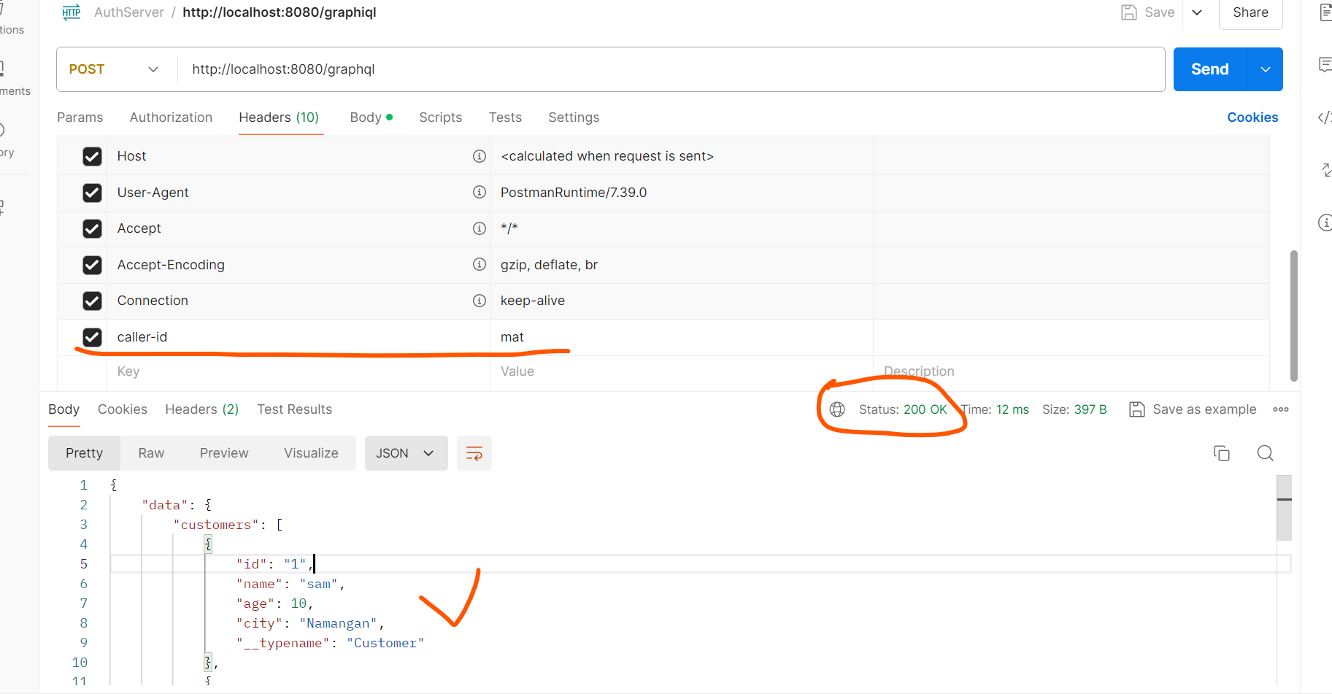

So what is happening here is , before executing the query it checks with Spring WebFilter on check the header before going to GraphQL.

Regarding the GraphQl security – it only working with Spring security (FilerChain)

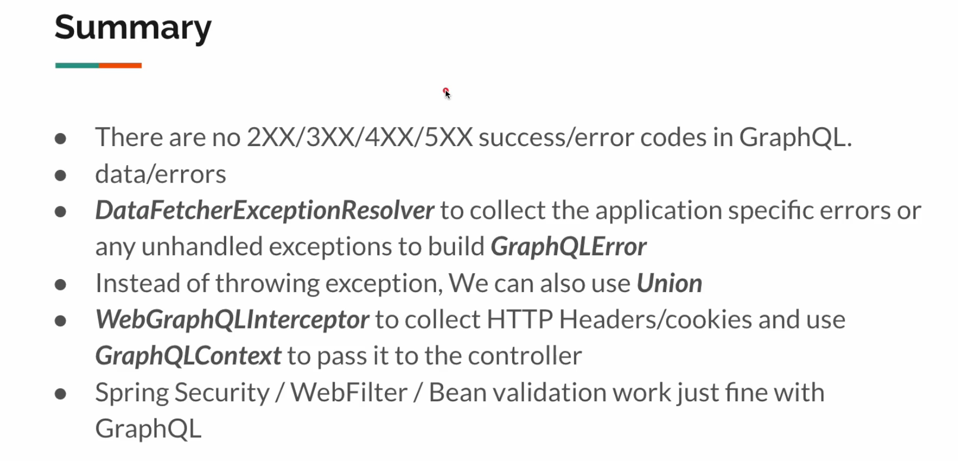

New section: **GraphQL Client**

In this section we will talk about the client to the service that has GraphQL.

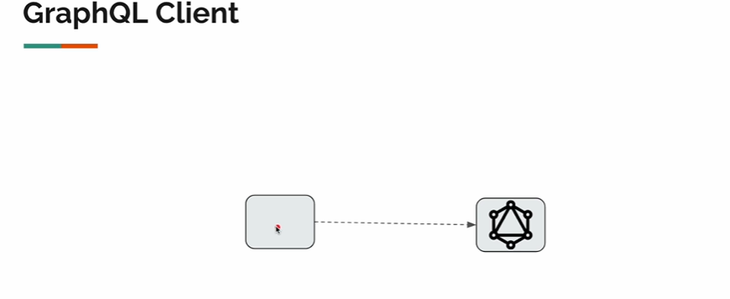

Let us have create new package lec16 and also create 2 packages: serverapp and clientapp inside this package.

For serverapp: We will copy the package from lec14: make dto package common for both client and server

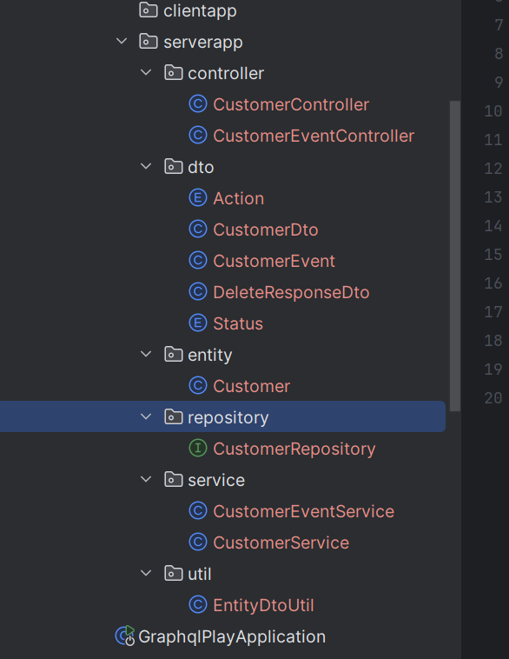 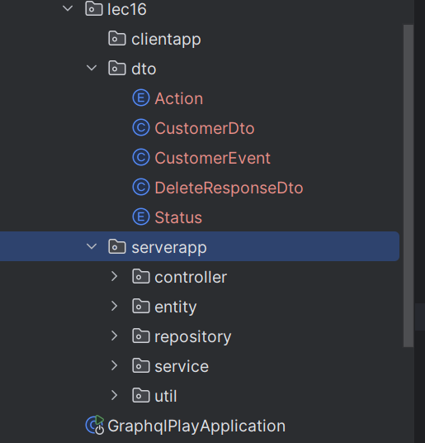

We have created CustomerClient.class:

import org.springframework.beans.factory.annotation.Value;  
import org.springframework.graphql.client.ClientGraphQlResponse;  
import org.springframework.graphql.client.HttpGraphQlClient;  
import org.springframework.stereotype.Service;  
import reactor.core.publisher.Mono;  
  
@Service  
public class CustomerClient {  
  
 private final HttpGraphQlClient client;

//The value (url) comes in the application.yml   
 public CustomerClient(@Value("${customer.service.url}") String baseUrl){  
 this.client = HttpGraphQlClient.*builder*()  
 .webClient(b -> b.baseUrl(baseUrl))  
 .build();  
 }

//Here we calling the graphql query   
 public Mono<ClientGraphQlResponse> rawQuery(String query){  
 return this.client.document(query)  
 .execute();  
 }  
}

Now our Customer query Demo class:

import com.graphql.praphqlplay.lec16.dto.CustomerDto;  
import com.graphql.praphqlplay.lec16.clientapp.client.CustomerClient;  
import org.springframework.beans.factory.annotation.Autowired;  
import org.springframework.boot.CommandLineRunner;  
import org.springframework.stereotype.Service;  
import reactor.core.publisher.Mono;  
  
import java.time.Duration;  
import java.util.List;  
  
@Service  
public class ClientDemo implements CommandLineRunner {  
  
 @Autowired  
 private CustomerClient client;  
  
 @Override  
 public void run(String... args) throws Exception {  
 rawQueryDemo().subscribe();  
 }  
  
 private Mono<Void> rawQueryDemo(){  
// String query = " {\n" +  
// " customers{\n" +  
// " id\n" +  
// " name\n" +  
// " age\n" +  
// " city\n" +  
// " }\n" +  
// " }";

// this is the same as above. In java17 it can be used  
 String query = """   
 {  
 customers{  
 id  
 name  
 age  
 city  
 }  
 }  
 """;  
  
 Mono<List<CustomerDto>> mono = this.client.rawQuery(query)  
 //Here we are asking only for the field "customers"  
 //And converting it to CustomerDto class  
 .map(cr -> cr.field("customers").toEntityList(CustomerDto.class));  
  
 //We are calling the query to get all the customers: and waiting 1 second  
 return Mono.*delay*(Duration.*ofSeconds*(1))  
 .doFirst(()-> System.*out*.println("RAW QUERY DEMO"))  
 .then(mono)  
 .doOnNext(System.*out*::println)  
 .then();  
 }  
}

Wen we run the app: we will get the response after 1 second delay:

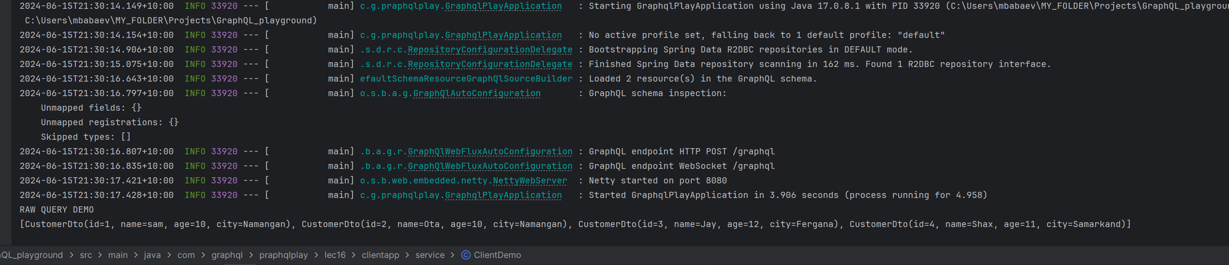



If we use query with field alias like:

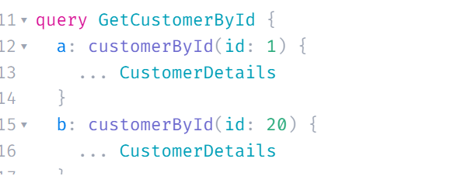



@Service  
public class ClientDemo implements CommandLineRunner {  
  
 @Autowired  
 private CustomerClient client;  
  
 @Override  
 public void run(String... args) throws Exception {  
 rawQueryDemo().subscribe();  
 }  
 private Mono<Void> rawQueryDemo(){  
 String query = """   
 {  
 a: customers{  
 id  
 name  
 age  
 city  
 }  
 }  
 """;  
  
 Mono<List<CustomerDto>> mono = this.client.rawQuery(query)   
 .map(cr -> cr.field("customers").toEntityList(CustomerDto.class));  
  
 return Mono.*delay*(Duration.*ofSeconds*(1))  
 .doFirst(()-> System.*out*.println("RAW QUERY DEMO"))  
 .then(mono)  
 .doOnNext(System.*out*::println)  
 .then();  
 }  
}



Then we will get empty response because there is no such a data customers now:



If we change the filtering field:

String query = """   
 {  
 a: customers{  
 id  
 name  
 age  
 city  
 }  
 }  
 """;  
  
Mono<List<CustomerDto>> mono = this.client.rawQuery(query)   
 .map(cr -> cr.field("a").toEntityList(CustomerDto.class));

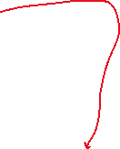

Then we will get the expected response:  


**QUERY DOCUMENT**

So, above example, we have added String value of the query in the ClientDemo.class:

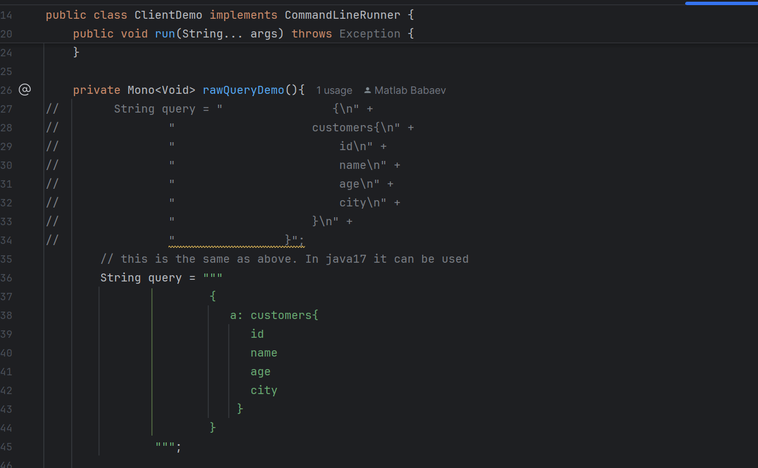



However, we can do it in the document of .graphql file under resources folder:

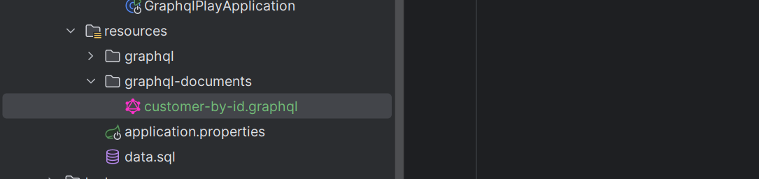

query GetCustomerById($id: ID!){  
 customerById(id: $id){  
 ... customerDetails  
 }  
}  
fragment customerDetails on Customer{  
 id  
 name  
 age  
 city  
}

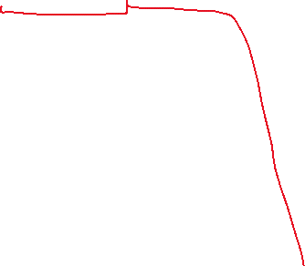

And call this in the Client:

import com.graphql.praphqlplay.lec16.dto.CustomerDto;  
import org.springframework.beans.factory.annotation.Value;  
import org.springframework.graphql.client.ClientGraphQlResponse;  
import org.springframework.graphql.client.HttpGraphQlClient;  
import org.springframework.stereotype.Service;  
import reactor.core.publisher.Mono;  
  
@Service  
public class CustomerClient {  
  
 private final HttpGraphQlClient client;  
  
 public CustomerClient(@Value("${customer.service.url}") String baseUrl){  
 this.client = HttpGraphQlClient.*builder*()  
 .webClient(b -> b.baseUrl(baseUrl))  
 .build();  
 }  
  
 public Mono<ClientGraphQlResponse> rawQuery(String query){  
 return this.client.document(query)  
 .execute();  
 }  
  
 //Using the document under resources  
 public Mono<CustomerDto> getCustomerById(Integer id){  
  
 //here we can refer the graphql document to query  
 return this.client.documentName("customer-by-id")  
 .variable("id", id)  
 .retrieve("customerById")  
 .toEntity(CustomerDto.class);  
 }  
}

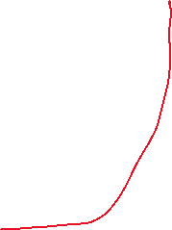

And in the demo class:

@Service  
public class ClientDemo implements CommandLineRunner {  
  
 @Autowired  
 private CustomerClient client;  
  
 @Override  
 public void run(String... args) throws Exception {  
 rawQueryDemo()  
 .then(this.getCustomerById())  
 .subscribe();  
 }  
  
 private Mono<Void> rawQueryDem   
 String query = """   
 {  
 a: customers{  
 id  
 name  
 age  
 city  
 }  
 }  
 """;  
  
 Mono<List<CustomerDto>> mono = this.client.rawQuery(query)  
 //Here we are asking only for the field "customers"  
 //And converting it to CustomerDto class  
 .map(cr -> cr.field("a").toEntityList(CustomerDto.class));  
  
 //We are calling the query to get all the customers: and waiting 1 second  
 return Mono.*delay*(Duration.*ofSeconds*(1))  
 .doFirst(()-> System.*out*.println("RAW QUERY DEMO"))  
 .then(mono)  
 .doOnNext(System.*out*::println)  
 .then();  
 }  
  
 //Here we are doing the similar the above, but we have already created document in the resources file  
 //So we are calling already ready query  
 private Mono<Void> getCustomerById(){  
 return Mono.*delay*(Duration.*ofSeconds*(1))  
 .doFirst(()-> System.*out*.println("---GetCustomer by ID: ---"))  
 .then(this.client.getCustomerById(1))  
 .doOnNext(System.*out*::println)  
 .then();  
 }  
}



Assignment: if the call is with alias: one record is with id $ and other is given:

query GetCustomerById($id: ID!){  
 a: customerById(id: $id){  
 ... customerDetails  
 }  
 b: customerById(id: 2){  
 ... customerDetails  
 }  
}  
fragment customerDetails on Customer{  
 id  
 name  
 age  
 city  
}



How to call in this case? There are 2 ways 1. Using the retriev and other is using the execute:

Let us create dto for MultiCustomerDto:

@Data  
public class MultiCustomerAssignment {  
  
 private CustomerDto a;  
 private CustomerDto b;  
}

//2. Assignment using the execute method  
public Mono<MultiCustomerAssignment> getCustomerById(Integer id){  
  
 //Assignment: using the execute method  
 return this.client.documentName("customer-by-id")  
 .variable("id", id)  
 .execute()  
 .map(cr -> cr.toEntity(MultiCustomerAssignment.class));  
}

//1. Assignment using the retrieve method  
public Mono<MultiCustomerAssignment> getCustomerById(Integer id){  
  
 //Assignment: using the retrieve method  
 return this.client.documentName("customer-by-id")  
 .variable("id", id)  
 .retrieve("")// gives the whole object  
 .toEntity(MultiCustomerAssignment.class);  
}

**Handling errors in client**:

What will happen if the response is giving Error instead of data:

If controller throws exception when there Is no customer found:

@QueryMapping  
public Mono<CustomerDto> customerById(@Argument Integer id){  
 return this.service.findById(id)  
 .switchIfEmpty(Mono.*error*(new RuntimeException("Customer not found")));  
}

We will see this:

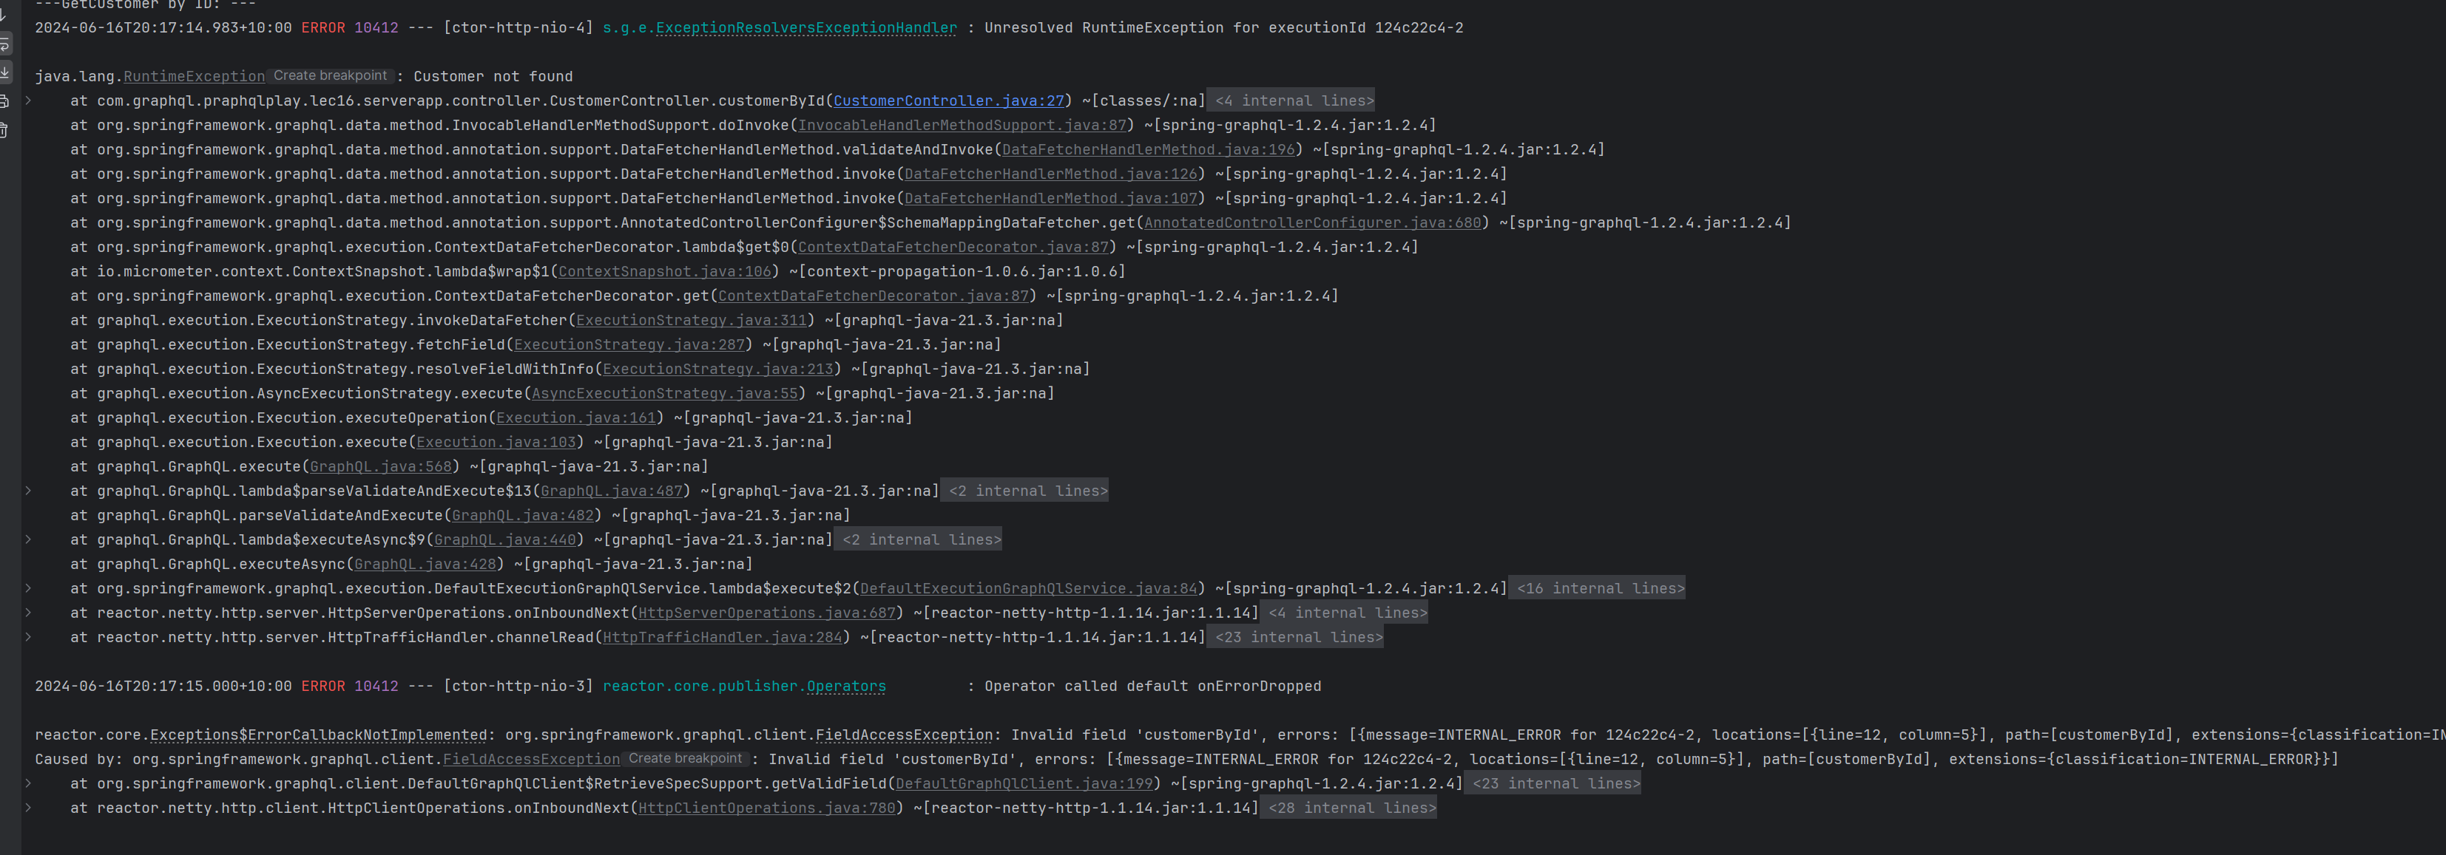

We can handle it:

* 1. Let us create generic response class:
* import lombok.Getter;  
  import lombok.ToString;  
  import org.springframework.graphql.ResponseError;  
    
  @ToString  
  @Getter  
  public class GenericResponse<T> {  
    
   private final T data;  
   private final ResponseError error;  
   private final boolean dataPresent;  
    
   public GenericResponse(T data) {  
   this.data = data;  
   this.dataPresent = true;  
   this.error = null;  
   }  
    
   public GenericResponse(ResponseError error) {  
   this.data = null;  
   this.dataPresent = false;  
   this.error = error;  
   }  
  }

2. Change the CustomerClient.class where we are calling customerById:

public Mono<GenericResponse<CustomerDto>> getCustomerById(Integer id){  
  
 return this.client.documentName("customer-by-id")  
 .variable("id", id)  
 .execute()

.map(cr ->{

var field = cr.field("customerById");

//If the response has value return response othervise return error;  
 return field.hasValue() ? new GenericResponse<>(field.toEntity(CustomerDto.class)) :

new GenericResponse<>(field.getError());  
 });  
}



Now we will see this error when there is no found exception. We also can add extensions in the message.



-----------------------------------

**Decoding union type: How to handle union type here in exceptions like above**?

So let us create dto same as from lec-15 :

package com.graphql.praphqlplay.lec16.dto;  
  
import lombok.AllArgsConstructor;  
import lombok.Data;  
import lombok.NoArgsConstructor;  
  
@Data  
@NoArgsConstructor  
@AllArgsConstructor(staticName = "create")  
public class CustomerNotFound implements CustomerResponse {  
 private Integer id;  
 private final String message = "user not found";  
}



and also create TypeResolverConfig:

import com.graphql.praphqlplay.lec16.dto.CustomerDto;  
import graphql.schema.TypeResolver;  
import org.springframework.context.annotation.Bean;  
import org.springframework.context.annotation.Configuration;  
import org.springframework.graphql.execution.ClassNameTypeResolver;  
import org.springframework.graphql.execution.RuntimeWiringConfigurer;  
  
@Configuration  
public class TypeResolverConfig {  
  
 @Bean  
 public TypeResolver typeResolver() {  
 ClassNameTypeResolver resolver = new ClassNameTypeResolver();  
 resolver.addMapping(CustomerDto.class, "Customer");  
 return resolver;  
 }  
  
 @Bean  
 public RuntimeWiringConfigurer configurer(TypeResolver typeResolver){  
 return c ->c.type("CustomerResponse", b ->b.typeResolver(typeResolver));  
 }  
}

Let us also use Interface controller approach as well:

package com.graphql.praphqlplay.lec16.dto;  
  
//This is just marker interface  
public interface CustomerResponse {  
}



so, change the customerDTO class as well to implement the interface:

import lombok.Data;  
  
@Data  
public class CustomerDto implements CustomerResponse {  
 private Integer id;  
 private String name;  
 private Integer age;  
 private String city;  
}



Let us change our schema.graphl as well to introduce union type to add CustomerNotFound type:

type Query{  
 customers: [Customer]!  
 customerById(id: ID!): CustomerResponse!  
}  
  
type Mutation{  
 createCustomer(customer: CustomerInput!): Customer  
 updateCustomer(id: ID!, customer: CustomerInput): Customer  
 deleteCustomer(id: ID!): DeleteResponse!  
}  
  
type Customer{  
 id: ID!  
 name: String  
 age: Int  
 city: String  
}  
  
input CustomerInput{  
 name: String  
 age: Int  
 city: String  
}  
type DeleteResponse{  
 id: ID!  
 status: Status  
}  
  
enum Status{  
 *SUCCESS  
 FAILURE*}  
"""returns Customer or CustomerNotFound"""  
union CustomerResponse = Customer | CustomerNotFound  
  
type CustomerNotFound{  
 id: ID!  
 message: String  
}



and in the server controller of CustomerController chage:

@QueryMapping  
public Mono<Object> customerById(@Argument Integer id){  
 return this.service.findById(id)  
 .cast(Object.class)  
 .defaultIfEmpty(CustomerNotFound.*create*(id));  
}



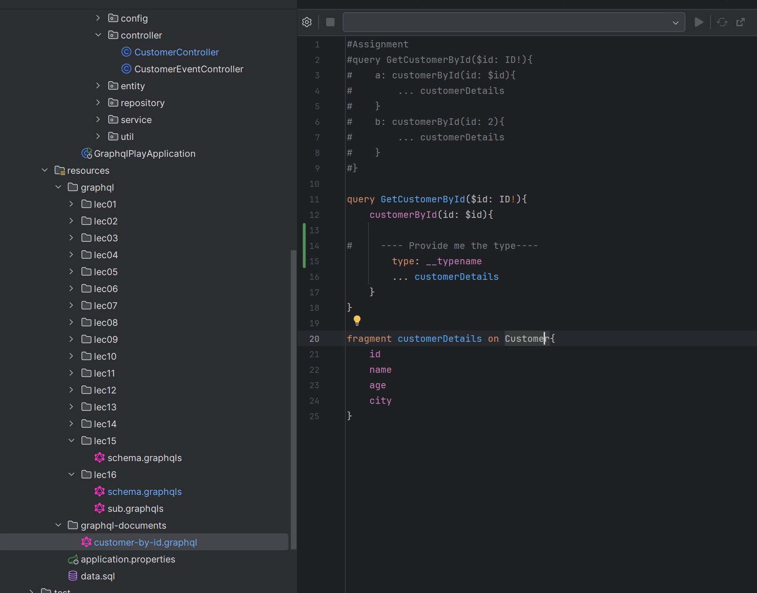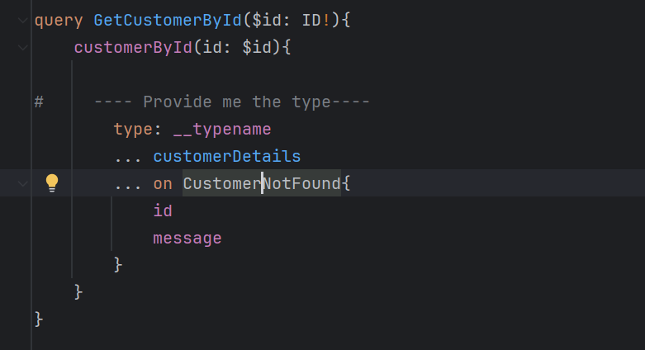We also need to know the type of our graphql document that we are using in our client:

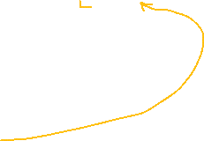

Now we can change our clients’ CustomerClient.class:

public Mono<CustomerResponse> getCustomerByIdWithUnion(Integer id){  
  
 return this.client.documentName("customer-by-id")  
 .variable("id", id)  
 .execute()  
 .map(cr ->{  
  
 var field = cr.field("customerById");  
  
 //here we are checking what is the type  
 var isCustomer = "Customer".equals(cr.field("customerById.type").getValue().toString());  
  
 return isCustomer ? field.toEntity(CustomerDto.class) : field.toEntity(CustomerNotFound.class);  
 });  
}



now change the clientDemo to call the getCustomerByIdWithUnion() type

1st scenario for existing customer and second is for not existing customer to fetch the union CustomerNotfound scenario:

1: when called existing customer:



2. when called not existing customer:  




**Now work on CRUD operations for Client:**

Now create new .graphql document:

query GetAll{  
 response: customers{  
 ...customerDetails  
 }  
}  
  
query GetCustomerById($id: ID!){  
 response: customerById(id: $id){  
 ...customerDetails  
 }  
}  
  
mutation CreateCustomer($customer: CustomerInput!){  
 response: createCustomer(customer: $customer){  
 ...customerDetails  
 }  
}  
  
mutation UpdateCustomer($id: ID!, $customer: CustomerInput!){  
 response: updateCustomer(id: $id, customer: $customer){  
 ...customerDetails  
 }  
}  
  
mutation DeleteCustomer($id: ID!){  
 response: deleteCustomer(id: $id){  
 id,  
 status  
 }  
}  
  
fragment customerDetails on Customer{  
 id  
 name  
 age  
 city  
}



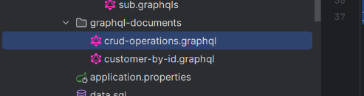

Then use this in the query:

In Client class:  
package com.graphql.praphqlplay.lec16.clientapp.client;  
  
  
import java.util.List;  
  
@Service  
public class CustomerClient {  
  
 private final HttpGraphQlClient client;  
  
 public CustomerClient(@Value("${customer.service.url}") String baseUrl){  
 this.client = HttpGraphQlClient.*builder*()  
 .webClient(b -> b.baseUrl(baseUrl))  
 .build();  
 }  
  
  
 public Mono<List<CustomerDto>> allCustomers(){  
 return this.client.documentName("crud-operations")  
 .operationName("GetAll")  
 .retrieve("response")  
 .toEntityList(CustomerDto.class);  
 }  
}

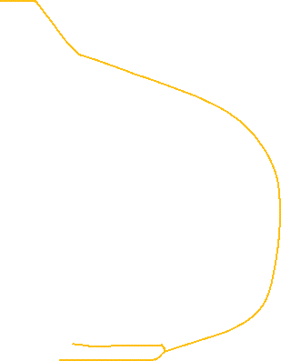

and clientdemo.class:

import com.graphql.praphqlplay.lec16.dto.CustomerDto;  
import com.graphql.praphqlplay.lec16.clientapp.client.CustomerClient;  
import org.springframework.beans.factory.annotation.Autowired;  
import org.springframework.boot.CommandLineRunner;  
import org.springframework.stereotype.Service;  
import reactor.core.publisher.Mono;  
  
import java.time.Duration;  
import java.util.List;  
  
@Service  
public class ClientDemo implements CommandLineRunner {  
  
 @Autowired  
 private CustomerClient client;  
  
 @Override  
 public void run(String... args) throws Exception {  
 allCustomersDemo()  
 .subscribe();  
  
 private <T> Mono<Void> executor(String message, Mono<T> publisher){  
 return Mono.*delay*(Duration.*ofSeconds*(1))  
 .doFirst(()-> System.*out*.println(message))  
 .then(publisher)  
 .doOnNext(System.*out*::println)  
 .then();  
 }  
  
 private Mono<Void> allCustomersDemo(){  
  
 return this.executor("---all Customers demo: ---", this.client.allCustomers());  
  
 }  
}

if I run: I will get all the customers:

  
Same way we can call customer By Id:

private Mono<Void> customersDemoById(){  
 return this.executor("---Customer By Id demo: ---", this.client.getCustomerById(2));  
}

public Mono<CustomerDto> getCustomerById(Integer id){  
 return this.client.documentName("crud-operations")  
 .operationName("GetCustomerById")  
 .variable("id",id)  
 .retrieve("response")  
 .toEntity(CustomerDto.class);  
}

Some refactoring and also creation of customer process:

@Service  
public class ClientDemo implements CommandLineRunner {  
  
 @Autowired  
 private CustomerClient client;  
  
 @Override  
 public void run(String... args) throws Exception {

allCustomersDemo()  
 .then(this.customersDemoById())   
 .then(this.creeateCustomersDemo())  
 .then(this.updateCustomersDemo())  
 .then(this.deleteCustomerDemo())  
 .subscribe();

}  
  
 private <T> Mono<Void> executor(String message, Mono<T> publisher){  
 return Mono.*delay*(Duration.*ofSeconds*(1))  
 .doFirst(()-> System.*out*.println(message))  
 .then(publisher)  
 .doOnNext(System.*out*::println)  
 .then();  
 }  
  
 private Mono<Void> allCustomersDemo(){  
 return this.executor("---all Customers demo: ---", this.client.allCustomers());  
 }  
 private Mono<Void> customersDemoById(){  
 return this.executor("---Customer By Id demo: ---", this.client.getCustomerById(2));  
 }  
  
  
private Mono<Void> creeateCustomersDemo(){  
 return this.executor("---Customer create demo: ---", this.client.createCustomer(CustomerDto.*create*(null, "Samandar", 35, "Andizhan")));  
}  
private Mono<Void> updateCustomersDemo(){  
 return this.executor("---Customer update demo: ---", this.client.updateCustomer(  
 3,  
 CustomerDto.*create*(null, "Jurobek", 15, "Qarshi")));  
}  
private Mono<Void> deleteCustomerDemo(){  
 return this.executor("---Customer deletion demo: ---", this.client.deleteCustomer(55));  
}

}

@Service  
public class CustomerClient {  
  
 private final HttpGraphQlClient client;  
  
 public CustomerClient(@Value("${customer.service.url}") String baseUrl){  
 this.client = HttpGraphQlClient.*builder*()  
 .webClient(b -> b.baseUrl(baseUrl))  
 .build();  
 }  
  
 public Mono<List<CustomerDto>> allCustomers(){  
 return crud("GetAll", Collections.*EMPTY\_MAP*, new ParameterizedTypeReference<List<CustomerDto>>(){});  
 }  
  
 public Mono<CustomerDto> getCustomerById(Integer id){  
 return crud("GetCustomerById", Map.*of*("id", id), new ParameterizedTypeReference<CustomerDto>() {  
 });  
 }

public Mono<CustomerDto> createCustomer(CustomerDto customerDto){  
 return this.crud("CreateCustomer", Map.*of*("customer", customerDto), ParameterizedTypeReference.*forType*(CustomerDto.class));  
 }

public Mono<CustomerDto> updateCustomer(Integer id, CustomerDto customerDto){  
 return this.crud("UpdateCustomer", Map.*of*("customer", customerDto, "id", id), ParameterizedTypeReference.*forType*(CustomerDto.class));  
}

public Mono<CustomerDto> deleteCustomer(Integer id){  
 return this.crud("DeleteCustomer", Map.*of*("id", id), ParameterizedTypeReference.*forType*(DeleteResponseDto.class));  
}  
  
private <T> Mono <T> crud(String operationName, Map<String, Object> variables, ParameterizedTypeReference<T> type){  
 return this.client.documentName("crud-operations")  
 .operationName(operationName)  
 .variables(variables)  
 .retrieve("response")  
 .toEntity(type);  
}

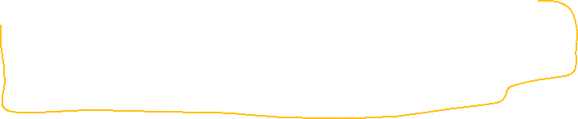

}

In customer creation, we are sending CustomerDto with Id is null so it will throw an exception, there are 2 ways :

* 1. Create another cto class for customer creation
  2. oR add @JsonInclude annotation that only will include in the serialization non null fields that we need

@Data  
@NoArgsConstructor  
@AllArgsConstructor(staticName = "create")  
@JsonInclude(JsonInclude.Include.*NON\_NULL*) //this guy will send field that are not null  
//if example, field id is null then it will send 3 fields  
public class CustomerDto implements CustomerResponse {  
 private Integer id;  
 private String name;  
 private Integer age;  
 private String city;  
}

We can also add client Subscription part:

For that let us create Subscription Client Class:

import com.graphql.praphqlplay.lec17.dto.CustomerEvent;  
import org.springframework.beans.factory.annotation.Value;  
import org.springframework.graphql.client.WebSocketGraphQlClient;  
import org.springframework.stereotype.Component;  
import org.springframework.web.reactive.socket.client.ReactorNettyWebSocketClient;  
import reactor.core.publisher.Flux;  
  
@Component  
public class SubscriptionClient {  
  
 private final WebSocketGraphQlClient client;  
  
 public SubscriptionClient(@Value("${customer.events.subscription.url}") String baseUrl) {  
 this.client = WebSocketGraphQlClient.*builder*(baseUrl, new ReactorNettyWebSocketClient()).build();  
 }  
  
 /\*  
 subscription{  
 customerEvents{  
 id  
 action  
 }  
 }  
 \* \*/  
  
 public Flux<CustomerEvent> customerEvents() {  
 var doc = " subscription{\n" +  
 " customerEvent{\n" +  
 " id\n" +  
 " action\n" +  
 " }\n" +  
 " }";  
 return this.client.document(doc)  
 .retrieveSubscription("customerEvent")  
 .toEntity(CustomerEvent.class);  
 }  
}

then add websoket url in the application.properies:

customer.events.subscription.url=ws://localhost:8080/graphql

Then in ClientDemo.class add our Subscription as well :

@Service  
public class ClientDemo implements CommandLineRunner {  
  
 @Autowired  
 private CustomerClient client;  
  
 @Autowired  
 private SubscriptionClient subscriptionClient;  
  
 @Override  
 public void run(String... args) throws Exception {  
  
 subscriptionClient  
 .customerEvents()  
 .doOnNext(e -> System.*out*.println("\*\*\* " + e.toString() + " \*\*\*"))  
 .subscribe();  
  
 allCustomersDemo()  
 .then(this.customersDemoById())  
 .then(this.creeateCustomersDemo())  
 .then(this.updateCustomersDemo())  
 .then(this.deleteCustomerDemo())  
 .subscribe();  
 }  
  
 private <T> Mono<Void> executor(String message, Mono<T> publisher){  
 return Mono.*delay*(Duration.*ofSeconds*(1))  
 .doFirst(()-> System.*out*.println(message))  
 .then(publisher)  
 .doOnNext(System.*out*::println)  
 .then();  
 }  
  
 private Mono<Void> allCustomersDemo(){  
 return this.executor("---all Customers demo: ---", this.client.allCustomers());  
 }  
 private Mono<Void> customersDemoById(){  
 return this.executor("---Customer By Id demo: ---", this.client.getCustomerById(2));  
 }  
   
 private Mono<Void> creeateCustomersDemo(){  
 return this.executor("---Customer create demo: ---", this.client.createCustomer(CustomerDto.*create*(null, "Samandar", 35, "Andizhan")));  
 }  
 private Mono<Void> updateCustomersDemo(){  
 return this.executor("---Customer update demo: ---", this.client.updateCustomer(  
 3,  
 CustomerDto.*create*(null, "Jurobek", 15, "Qarshi")));  
 }  
 private Mono<Void> deleteCustomerDemo(){  
 return this.executor("---Customer deletion demo: ---", this.client.deleteCustomer(55));  
 }  
}



When we run application we will get this:

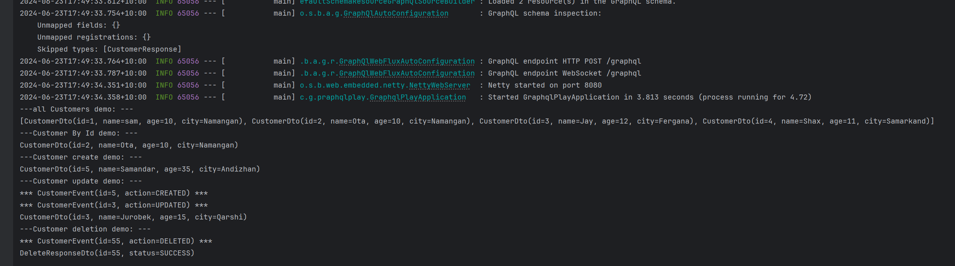



--------

Passing header:

If you need to add header in the query we can add like this:

public Mono<GenericResponse<CustomerDto>> getCustomerById(Integer id){  
  
 return this.client  
 .mutate().header("someHeadre", "token1", "headre2", "token2").build()  
   
 .documentName("customer-by-id")  
 .variable("id", id)  
 .execute()  
 .map(cr ->{  
 var field = cr.field("customerById");  
 return field.hasValue() ? new GenericResponse<>(field.toEntity(CustomerDto.class)) :  
 new GenericResponse<>(field.getError());  
 });  
}



or

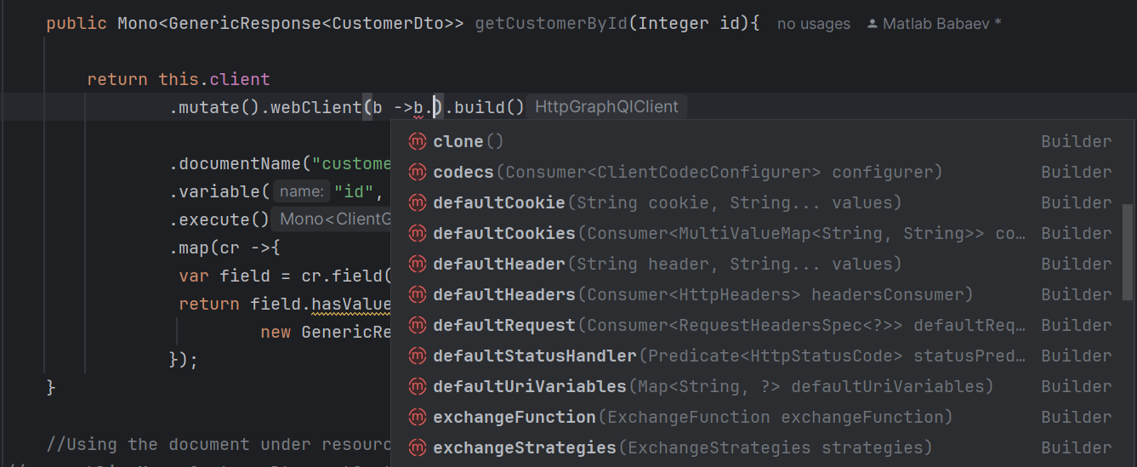



Summarize for GraphQL client:

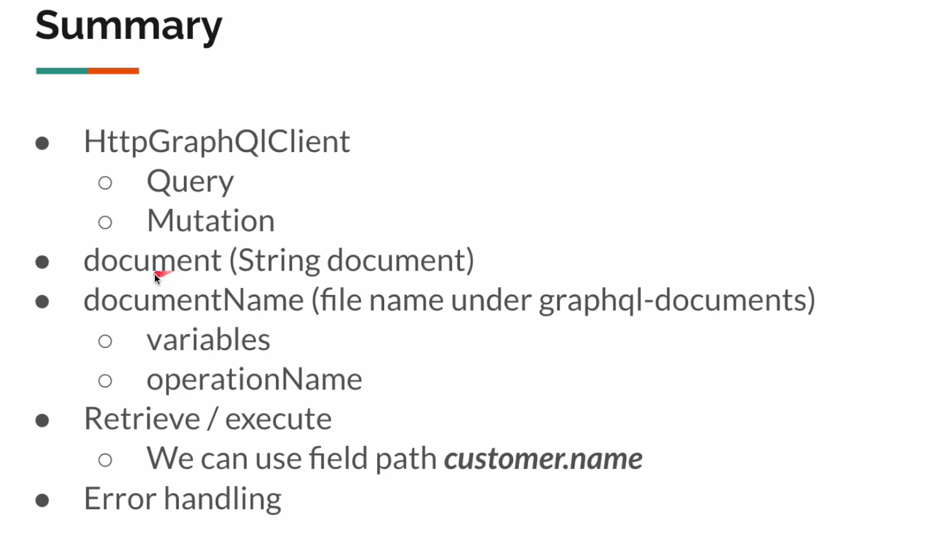

Movie Application